**Version 1.0 – 11/18/10**



**Florida Department of Health**

**All-Hazards**

**Dark Pages**

**Standard Operations Guidelines**

**Dark Pages Process**

***Executive Summary***

Developing and implementing event specific internal and external web pages during a response assists the members of a joint information center (JIC) in addressing issues as they arise, disseminating messages directly to affected audiences, and pinpointing messaging to target audiences in a easily accessible format. Information posted to internal pages can directly affect the speed and functionality of local responders to requests for resources. The external page expresses the need to know information to the public and stakeholders as well as addressing emerging issues and rumor control.

The use of this process is appropriate during an ESF-8 event or a targeted activation at the state level. The process takes place in coordination with the Joint Information Center (JIC) or the Information Management Branch and other branches of the Incident Command structure.

These Standard Operating Guidelines are to be used during a response with and align to the DOH Crisis and Emergency Risk Communication (CERC) Annex and the state JIC/JIS Guidelines.

***Overview***

During a response or activation, communication of information is crucial to support job functions internally and provide the public with pertinent facts and knowledge affecting individuals, families, and communities. Event specific web pages for both Florida Department of Health staff and the public are critical communication vehicles to steer media, stakeholders, and concerned residents and visitors with the most accurate and current relevant information. By posting information to these sites, local health departments and the Office of Communications can direct individuals to this information as their capacity becomes overwhelmed.

These internal and external web page activation standard operations guidelines (SOG) provide procedures for populating and “going live” with a dedicated internal and/or external web page within the scope of a given response. The scope of the process is event and location specific with focus on the state of Florida.

For this report, the process for state level internal and external web page activation will be clarified with advisement for events and activations.

***Process***

During an event or activation, the Lead PIO will determine the need for an internal and external web presence and will provide the delegated IT representative with the information to populate the pages. These will include but are not limited to the following:

Event Name

Event Banner (graphic)

Event Topics

Key Event Websites

Briefing & Situation Updates

Plans, Protocols and Guidance

Documents

Health Impacts and Surveillance

Data

Public Information Resources

ESF8 Organizational Information

.

All uploaded PDF documents should be less than 500kb in size. All links to other websites will open in a new window. The Lead PIO in conjunction with the Incident Commander will approve the “go live” for the pages to be visible to the targeted audiences.

The use of this process is appropriate during an ESF-8 event or a targeted activation at the state level. The process takes place in coordination with the Joint Information Center (JIC) or the Information Management Branch and other branches of the Incident Command structure.

***Staffing***

The Lead PIO or delegated authority will approve all updates and changes to the internal and external pages upon posting. The designated IT representative or delegated authority will incorporate revisions and work with the Lead PIO or delegated authority for approval before “going live.”

***Internal Dark Page***

The internal dark page (Attachment 1) should only be populated with information of interest to the local and state employees of the Florida Department of Health. Information will include but will not be limited to the following items:

Event Name

Event Banner (graphic)

Event Topics

Key Event Websites

Briefing & Situation Updates

Plans, Protocols and Guidance

Documents

Health Impacts and Surveillance

Data

Public Information Resources

ESF8 Organizational Information

Additional items must be approved by the Lead PIO and the Incident Commander.

***External Dark Page***

The external dark page (Attachment 2) should only be populated with information of interest to the public and should not include information for internal administration of agency functions or of internal interest only. Information will include but not be limited to the following items:

Event Name

Event Banner (graphic)

Event Topics

Key Event Websites

Briefing & Situation Updates

Plans, Protocols and Guidance

Documents

Health Impacts and Surveillance

Data

Public Information Resources

ESF8 Organizational Information

Additional items must be approved by the Lead PIO and the Incident Commander.

**Additional Attachments:**

Attachment 1: Internal Dark Page Template

Attachment 2: External Dark Page Template

Attachment 3: Sample Internal Response Page

Attachment 4: Sample External Response Page

**Attachment 1: Internal Dark Page Template**

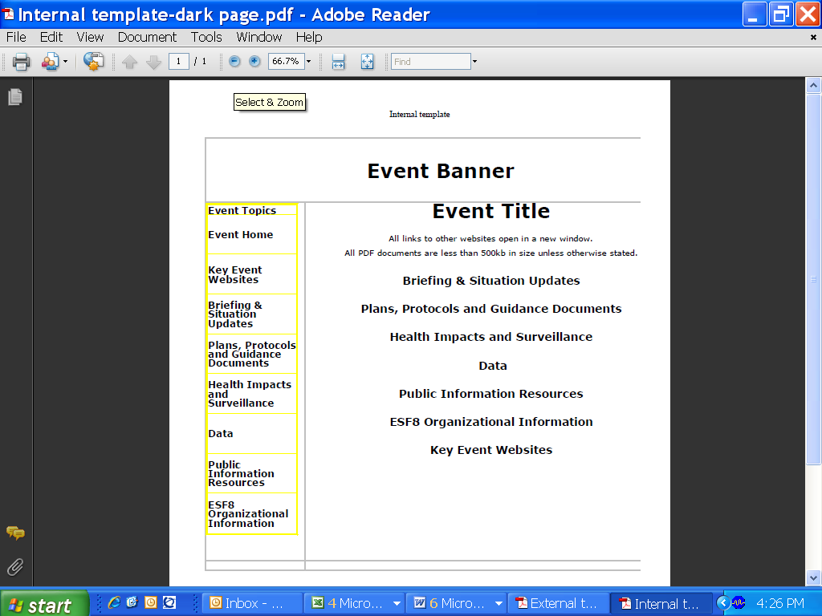

**Attachment 2: External Dark Page Template**

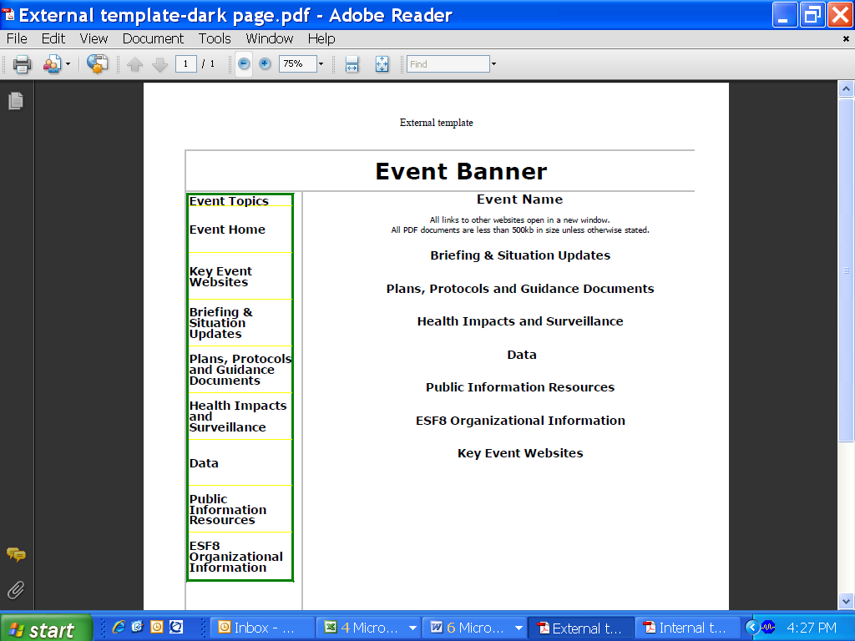

**Attachment 3: Sample Internal Event Page**

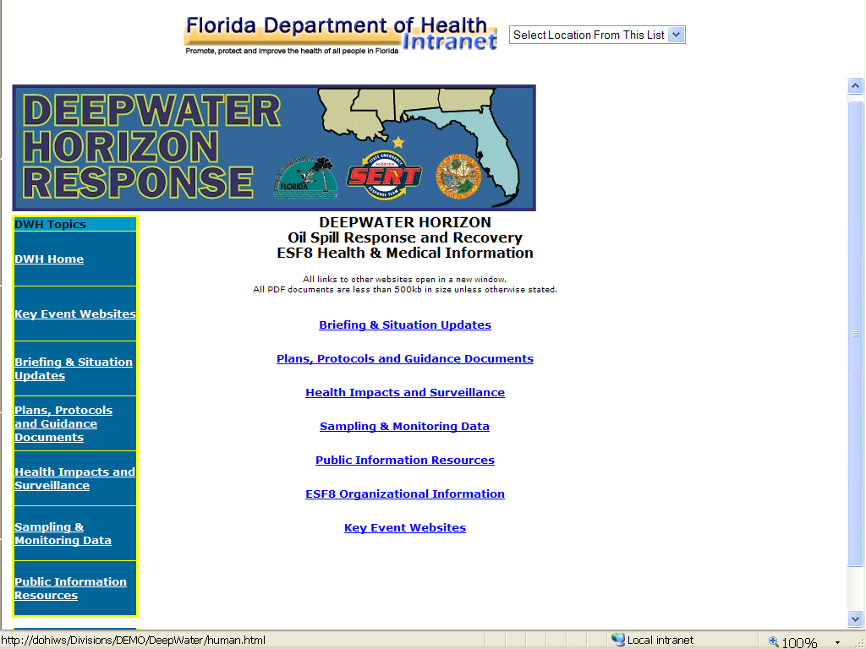

**Attachment 4: Sample External Event Page**

