001636_NO50_02-B2003

Media Forums on Preparedness
for Pandemic Influenza

August 2006

Prepared for:


NEW YORK STATE DEPARTMENT OF HEALTH
Office of Science and Public Health
2040 Corning Tower
Albany, New York 12237

Prepared by:

Ecology and Environment, Inc.
368 Pleasant View Drive
Lancaster, New York 14086

©2006 Ecology and Environment, Inc.

able of Contents
T

Section Page
1 Work Performed 1-1
2 Results 2-1
2.1 Plattsburgh Region Forum 2-2
2.2 Albany Region Forum 2-6
2.3 Lower Hudson Region Forum 2-10
2.4 Watertown Region Forum 2-14
2.5 Binghamton Region Forum 2-18
2.6 Syracuse Region Forum 2-22
2.7 Rochester Region Forum 2-25
2.8 Buffalo Region Forum 2-29
3 Summary 3-1

Appendix
A Handouts Provided at Media Forums A-1
B Summary of All Media Questionnaires on Pandemic Flu B-1

L

ist of Tables

Table Page

1-1 Media Invited to Forums 1-3
1-2 Schedule for Media Forums 1-10
2-1 Plattsburgh Region Forum Attendees 2-2
2-2 Albany Region Forum Attendees 2-6
2-3 Lower Hudson Region Forum Attendees 2-10
2-4 Watertown Region Forum Attendees 2-14
2-5 Binghamton Region Forum Attendees 2-18
2-6 Syracuse Region Forum Attendees 2-22
2-7 Rochester Region Forum Attendees 2-25
2-8 Buffalo Region Forum Attendees 2-29

L

ist of Figures

Figure Page

1-1 Example of Invitation Letter 1-9
1-2 Annotated Agenda for Forums 1-11
1-3 General Room Set-up for Media Forums 1-12
2-1 Summary of Media Questionnaires – Plattsburgh Region Forum 2-5
2-2 Summary of Media Questionnaires – Albany Region Forum 2-9
2-3 Summary of Media Questionnaires – Lower Hudson Region Forum 2-13
2-4 Summary of Media Questionnaires – Watertown Region Forum 2-17
2-5 Summary of Media Questionnaires – Binghamton Region Forum 2-21
2-6 Summary of Media Questionnaires – Syracuse Region Forum 2-24
2-7 Summary of Media Questionnaires – Rochester Region Forum 2-28
2-8 Summary of Media Questionnaires – Buffalo Region Forum 2-32

L

ist of Abbreviations and Acronyms

BT bioterrorism
COOP continuity of operations
DOH Department of Health
EOC emergency operations center
FTP file transfer protocol
JIC joint information center
NYSDOH New York State Department of Health
PIO public information officer
PSA public service announcement
SEMO (New York) State Emergency Management Office
SUNY State University of New York
WHO World Health Organization

Work Performed

1

The New York State Department of Health (NYSDOH), in cooperation with the New York State Emergency Management Office (SEMO), conducted a series of forums for news media in various regional areas throughout New York State in August 2006. The primary purposes of the forums were to:

■ Provide basic information on pandemic influenza to the news media;

■ Determine if news media organizations have continuity of operations (COOP) plans and procedures in place;

■ Determine if news media organizations are knowledgeable of and prepared to follow risk communication principles when delivering their message to the public in events such as a health emergency; and

■ Provide an opportunity for news media, local health departments, and NYSDOH and SEMO to meet, exchange ideas, and foster continued coordination and cooperation.

NYSDOH was assisted by its contractor, Ecology and Environment, Inc. (E & E), for this work. The following nine regional areas of New York State were selected for the forum series:

■ Plattsburgh;

■ Albany;

■ Lower Hudson Valley;

■ Long Island;

■ Watertown;

■ Binghamton;

■ Syracuse;

■ Rochester; and

■ Buffalo.

The news media that were of interest for the forums were daily newspapers, news radio, and television and cable outlets that perform a significant news service. The primary news media organizations in the regional areas were initially researched using Bacon’s MediaLists Online and the Internet. MediaLists Online is a fee-based online database that generates up-to-date media contact lists using a wide range of search criteria. The criteria that were used for the database searches were:

■ Daily newspapers – editor;

■ Radio stations – news director, news format; and

■ Television and cable stations– news director.

The market areas available for the database search matched the regional areas of interest with the exception that Lower Hudson Valley and Long Island were represented by the entire market area of New York City; therefore, regional results for those areas had to be fine-tuned. General internet searching was used to refine and augment the results from the MediaLists Online search.

NYSDOH and E & E then reviewed the master contact list and removed entries such as media outlets based in neighboring states and Canada, and radio and television stations without a news director or significant local news service. The master list was further adjusted using NYSDOH’s, the local health departments’, and E & E’s personal knowledge of the primary media outlets in the regional areas. The final media contact list is summarized in Table 1-1.

The resulting media contacts were invited by mail to the forum in their area. An example invitation letter is included as Figure 1-1. Media outlets in larger regional areas were invited to send one representative to the forum and outlets in smaller regional areas, such as Watertown and Plattsburgh, were invited to send up to two representatives.

E & E tracked the responses and made confirmation calls to nonrespondents beginning about one-and-a-half weeks before each forum. The confirmation calls functioned to determine projected attendance as well as ensure that the original invitation was received by the designated invitee. The invitation was re-sent in cases where the invitee or media outlet had for some reason not seen it. In cases

Table 1-1 Media Invited to Forums
Media Name | Media Type | Contact Name | Title | City (Mailing Address)
Plattsburgh Region Forum – July 31, 2006
Adirondack Daily Enterprise | Daily Newspaper | Peter Crowley | Managing Editor | Saranac Lake
Malone Telegram | Daily Newspaper | Darcy Fargo | Acting Editor | Malone
Press-Republican | Daily Newspaper | Lois Clermont | Managing Editor | Plattsburgh
Valley News | Daily Newspaper | Jeffrey Good | Editor | White River Junction, VT (added by LHD)
Lake Placid News | Weekly Newspaper | Ed Forbes | Editor | Lake Placid
Denton Publications | Non-Daily Newspaper | John Gereau | Managing Editor | Elizabethtown
WNBZ-AM | AM Radio Station | Chris Knight | News Director | Saranac Lake
WIPS-AM | AM Radio Station | Chris Ingram | News Director | Crown Point
WIRY-AM | AM Radio Station | Bob Pooler | News Director | Plattsburgh
WVNV-FM | FM Radio Station | Drew Scott | Program Director | Malone
WYUL-FM | FM Radio Station | Neil Drew | News Director | Malone
WCAX-TV (Plattsburgh bureau) | Television Station | Jack LaDuke | News Director | Plattsburgh
WPTZ-TV | Television Station | Kyle Grimes | News Director | Plattsburgh
Albany Region Forum – August 1, 2006
Catskill Mail | Daily Newspaper | Raymond Pignone | Editor | Catskill
The Daily Gazette | Daily Newspaper | Tom Woodman | Managing Editor | Schenectady
Leader-Herald | Daily Newspaper | Tim Fonda | Managing Editor | Gloversville
The Post-Star | Daily Newspaper | Ken Tingley | Managing Editor | Glens Falls
The Record | Daily Newspaper | Lisa Lewis | Managing Editor | Troy
The Recorder | Daily Newspaper | Kevin Mattison | Managing Editor | Amsterdam
Register Star | Daily Newspaper | Theresa Hyland | Managing Editor | Hudson
The Saratogian | Daily Newspaper | Barbara Lombardo | Managing Editor | Saratoga Springs
Times Union | Daily Newspaper | Rex Smith | Managing Editor | Albany
The Business Review of Albany | Weekly Newspaper | Neil Springer | Managing Editor | Latham
The Chronicle | Weekly Newspaper | Mark Frost | Editor | Glens Falls
WAMC-FM | FM Radio Station | Clarence Fanto | News Director | Albany
WCSS-AM | AM Radio Station | Brian Rowe | News Director | Amsterdam
WENT-AM | AM Radio Station | Tom Roehl | News Director | Gloversville
WGY-AM | AM Radio Station | Chuck Custer | News Director | Latham
WROW-AM | AM Radio Station | Mike Carey | News Director | Latham
WWSC-AM | AM Radio Station | Jim Scott | News Director | Glens Falls
WIZR-AM | AM Radio Station | Joey Caruso | News Director | Johnstown
WBUG-AM | AM Radio Station | Jason Aiello | News Director | Amsterdam
ADK Broadcasting | Broadcast Group | Clay Ashworth |  | Queensbury
WNCE-TV | Television Station | David Storey | News Director | Glens Falls
WNYT-TV | Television Station | Paul Conti | News Director | Albany
WRGB-TV | Television Station | William Duffy | News Director | Niskayuna
WTEN-TV | Television Station | Dana Dieterle | News Director | Albany
WXXA-TV | Television Station | Gene Ross | News Director | Albany
Capital News 9 | Cable station | Chris Brunner | News Director | Albany
Lower Hudson Valley Region Forum – August 2, 2006
New York Times (Lower Hudson Bureau) | Daily Newspaper | Jennifer Preston | Bureau Editor | New York
The Journal News | Daily Newspaper | Henry Freeman | Editor | White Plains
The Journal News (Putnam Bureau) | Daily Newspaper | Kathy Moore | Putnam Bureau Chief | White Plains
Times Herald Record | Daily Newspaper | Mike Levine | Managing Editor | Middletown
Putnam County Courier | Weekly Newspaper | Eric Gross | Managing Editor | Carmel
Poughkeepsie Journal | Daily Newspaper | Richard L. Kleban | Managing Editor | Poughkeepsie
The Weekly Beat | Weekly Newspaper | Matt Ruhr | Managing Editor | Poughkeepsie
The Journal News – Rockland Edition | Daily Newspaper | Tony Davenport | Managing Editor | West Nyack
Westchester County Business Journal | Weekly Newspaper | B. Z. Khasru | Managing Editor | White Plains
MidHudsonNews.com | Daily e-paper | Hank Gross | Editor | Middletown
Kiryas Joel Bulletin | Newspaper (freq unknown) | Jacob Steinmetz | Managing Editor | Monroe
Hudson Valley Black Press | Newspaper (freq unknown) | Chuck Stewart | Managing Editor | Newburgh
Periodico Hispanico | Newspaper (freq unknown) | Ramon Soto | Managing Editor | Haverstraw
Daily Freeman | Daily Newspaper | Sam Daleo | Managing Editor | Kingston
Ulster Publishing | Publication | Geddy Sveikauskas | Publisher | Kingston
Ulster County Press | Publication | Rich Thomaselli | Managing Editor | High Falls
WCBS-AM (Lower Hudson Bureau) | AM Radio Station | Tim Scheld | News Director | New York
WVOX-AM | AM Radio Station | Larry Goldstein | News Director | New Rochelle
WHUC-AM | AM Radio Station | Ed Weir | News Director | Poughkeepsie
Clear Channel news group (multiple stations) | News Group | Cameron Hendrix | News | Poughkeepsie
WRCR-AM | AM Radio Station | Sophia Salis | News Director | Nanuet
WWLE-AM | AM Radio Station | Charlie Phillips | News Director | Newburgh
WHUD-FM | FM Radio Station | Jason Finkelberg | General Manager | Peekskill
WKNY-AM | AM Radio Station | Linda Rosner | News Director | Kingston
News 12 Westchester | Cable Station | Janine Rose | News Director | Yonkers
WABC-TV (Lower Hudson Bureau) | Television Station | Susan McGoldrich | Bureau Manager | White Plains
WCBS-TV (Lower Hudson Bureau) | Television Station | Sandy Daronco | Bureau Manager | White Plains
WNBC-TV (Lower Hudson Bureau) | Television Station | Kendra Farn | Bureau Reporter | via phone
Regional News Network –  Westchester Studio | Cable Station | Sean Herbert | News Director | Rye Brook
Cable Six News | Cable Station | Tracy Baxter | News Director | Middletown
Long Island Region Forum – August 3, 2006
New York Daily News (Long Island Bureau) | Daily Newspaper | Richard Weir | Bureau Editor | Garden City
Newsday | Daily Newspaper | John Mancini | Editor | Melville
New York Times (Long Island Bureau) | Daily Newspaper | Patrick Lyons | Bureau Editor | New York
Dan's Papers | Weekly Newspaper | Robin Smith | Managing Editor | Bridgehampton
WCBS-AM (Long Island Bureau) | AM Radio Station | Tim Scheld | News Director | New York
WHLI-AM | AM Radio Station | Frank Brinka | News Director | Farmingdale
WLNY-TV | Television Station | Richard Rose | News Director | Melville
News 12 Long Island | Cable Station | Patrick Dolan | Newsroom Coordinator | Woodbury
WNBC-TV (Long Island Bureau) | Television Station | Greg Cergol | Bureau Reporter | Plainview
WCBS-TV (Long Island Bureau) | Television Station | Michael Brick | Bureau Manager | Hempstead
WABC-TV (Long Island Bureau) | Television Station | Vickie Metz | Bureau Manager | via fax
Watertown Region Forum – August 7, 2006
Daily Courier-Observer | Daily Newspaper | Ryne Martin | Managing Editor | Massena
Ogdensburg Journal | Daily Newspaper | Charles W. Kelly | Editor | Ogdensburg
Watertown Daily Times | Daily Newspaper | John Johnson, Jr. | Editor | Watertown
WATN-AM | AM Radio Station | John Moore | News Director | Watertown
WMSA-AM | AM Radio Station | Bob LaRue | News Director | Massena
WSLU-FM | FM Radio Station | Martha Foley Smith | News Director | Canton
WYBG-AM | AM Radio Station | Bob Kay | News Director | Massena
WTNY-AM | AM Radio Station | Nathan Lehman | News Director | Watertown
WNYF-TV, WWNY-TV | Television Station | Scott Atkinson | News Director | Watertown
WWTI-TV | Television Station | John Moore | News Director | Watertown
Binghamton Region Forum – August 8, 2006
The Evening Sun | Daily Newspaper | Jeff Genung | Managing Editor | Norwich
Press & Sun-Bulletin | Daily Newspaper | Calvin Stovall | Managing Editor | Binghamton
The Daily Star | Daily Newspaper | Sam Pollak | Editor | Oneonta
Cortland Standard | Daily Newspaper | Kevin Conlon | Managing Editor | Cortland
The Ithaca Journal | Daily Newspaper | Bruce Estes | Managing Editor | Ithaca
WEBO-AM | AM Radio Station | Terry Coleman | News Director | Owego
WNBF-AM, WYOS-AM | AM Radio Station | Bernard Fionte | News Director | Binghamton
WHCU-AM (Cayuga Radio Group) | AM Radio Station | Geoff Dunn | News Director | Ithaca
WKRT-AM | AM Radio Station | Ryan Dean | News Director | Cortland
Central New York Radio Group | Radio Group | George Wells |  | Oneonta
WXHC-FM | FM Radio Station | Eric Mulvihill | News Director | Homer
WCDO-AM/FM | AM and FM Radio Station | Rob Ray | News Director | Sidney
WBGH-TV, WIVT-TV | Television Station | Jim Ehmke | News Director | Binghamton
WBNG-TV | Television Station | Greg Catlin | News Director | Johnson City
WICZ-TV | Television Station | Kent Garret | News Director | Vestal
Syracuse Region Forum – August 9, 2006
The Citizen | Daily Newspaper | Jeremy Boyer | Managing Editor | Auburn
The Oneida Daily Dispatch | Daily Newspaper | Kurt Wanfried | Managing Editor | Oneida
The Palladium-Times | Daily Newspaper | Gary Catt | Editor | Oswego
The Post-Standard | Daily Newspaper | Stephen A. Rogers | Editor | Syracuse
Fulton Daily News, Oswego Daily News | Daily Newspaper | Dave Bullard | Managing Editor | Fulton
Rome Daily Sentinel | Daily Newspaper | David Swanson | Managing Editor | Rome
Utica Observer-Dispatch | Daily Newspaper | John Broadbooks | Managing Editor | Utica
The Evening Telegram | Daily Newspaper | Richard Petrillo | Managing Editor | Herkimer
WMCR-FM | FM Radio Station | Joel Meltzer | News Director | Oneida
WRVO-FM | FM Radio Station | Chris Ulanowski | News Director | Oswego
WSYR-AM | AM Radio Station | Dave Bullard | News Director | Syracuse
WIBX-AM | AM Radio Station | George Tharalson | News Director | Marcy
WSTM-TV | Television Station | Cathy Younkin | News Director | Syracuse
WSYR-TV | Television Station | Jim Tortora | News Director | East Syracuse
WTVH-TV | Television Station | Frank Kracher | News Director | Syracuse
News 10 | Cable Station | Ron Lombard | News Director | Syracuse
WKTV-TV | Television Station | Steve MacMurray | News Director | Utica
Rochester Region Forum – August 10, 2006
The Daily Messenger | Daily Newspaper | George Ewing, Jr. | Editor | Canandaigua
Finger Lakes Times | Daily Newspaper | Anne Shuhle | Managing Editor | Geneva
Rochester Democrat and Chronicle | Daily Newspaper | Karen Magnuson | Editor | Rochester
Town Crier | Daily Newspaper | Lisa Marshall | Editor | Geneva
WEOS-FM | FM Radio Station | Liz Cost | News Director | Geneva
WGVA-AM, WSFW-AM, WCGR-AM | AM Radio Station | Ted Baker | News Director | Geneva
WHAM-AM | AM Radio Station | Randy Gorbman | News Director | Rochester
WXXI-AM | AM Radio Station | Peter Iglinski | News Director | Rochester
WYSL-AM | AM Radio Station | J.C. DeLass | News Director | Avon
WROC-AM | AM Radio Station | Bob Kirk | News Director | Rochester
WHAM-TV | Television Station | Steve Dawe | News Director | Rochester
WHEC-TV | Television Station | Dave Overacker | News Assignment Editor | Rochester
WROC-TV, WUHF-TV | Television Station | Lee Eldridge | News Director | Rochester
R News | Cable Station | Ed Buttaccio | News Director | Rochester
Buffalo Region Forum – August 11, 2006
Batavia Daily News | Daily Newspaper | Mark Graczyk | Managing Editor | Batavia
The Buffalo News | Daily Newspaper | Gerald Goldberg | Managing Editor | Buffalo
Journal-Register | Daily Newspaper | Mike Regan | Editor | Medina
Lockport Union-Sun & Journal | Daily Newspaper | Tim Marren | Editor | Lockport
Niagara Gazette | Daily Newspaper | Lisa Kozarovich | Editor | Niagara Falls
Observer | Daily Newspaper | John D'Agostino | Editor | Dunkirk
The Post-Journal | Daily Newspaper | Cristie Herbst | Editor | Jamestown
Salamanca Press | Daily Newspaper | Laura Howard | Managing Editor | Salamanca
Times Herald | Daily Newspaper | Jim Eckstrom | Editor | Olean
Tonawanda News | Daily Newspaper | Carlene Peterson | Managing Editor | North Tonawanda
Wellsville Daily Reporter | Daily Newspaper | John Anderson | Editor | Wellsville
Westfield Republican | Daily Newspaper | Jim Rush | Editor | Westfield
Business First of Buffalo | Weekly Newspaper | Jeff Wright | Managing Editor | Buffalo
WBEN-AM, WWKB-AM | AM Radio Station | Monica Wilson | News Director | Buffalo
WBFO-FM | FM Radio Station | Mark Scott | News Director | Buffalo
WJTN-AM | AM Radio Station | Terry Frank | News Director | Jamestown
WLVL-AM | AM Radio Station | John Raymond | News Director | Lockport
WNED-AM | AM Radio Station | Jim Ranney | News Director | Buffalo
WOEN-AM | AM Radio Station | Chris Hicks | News Director | Olean
WGRZ-TV | Television Station | Ellen Crooke | News Director | Buffalo
WIVB-TV | Television Station | Joe Schlaerth | News Director | Buffalo
WKBW-TV | Television Station | Bill Payer | News Director | Buffalo

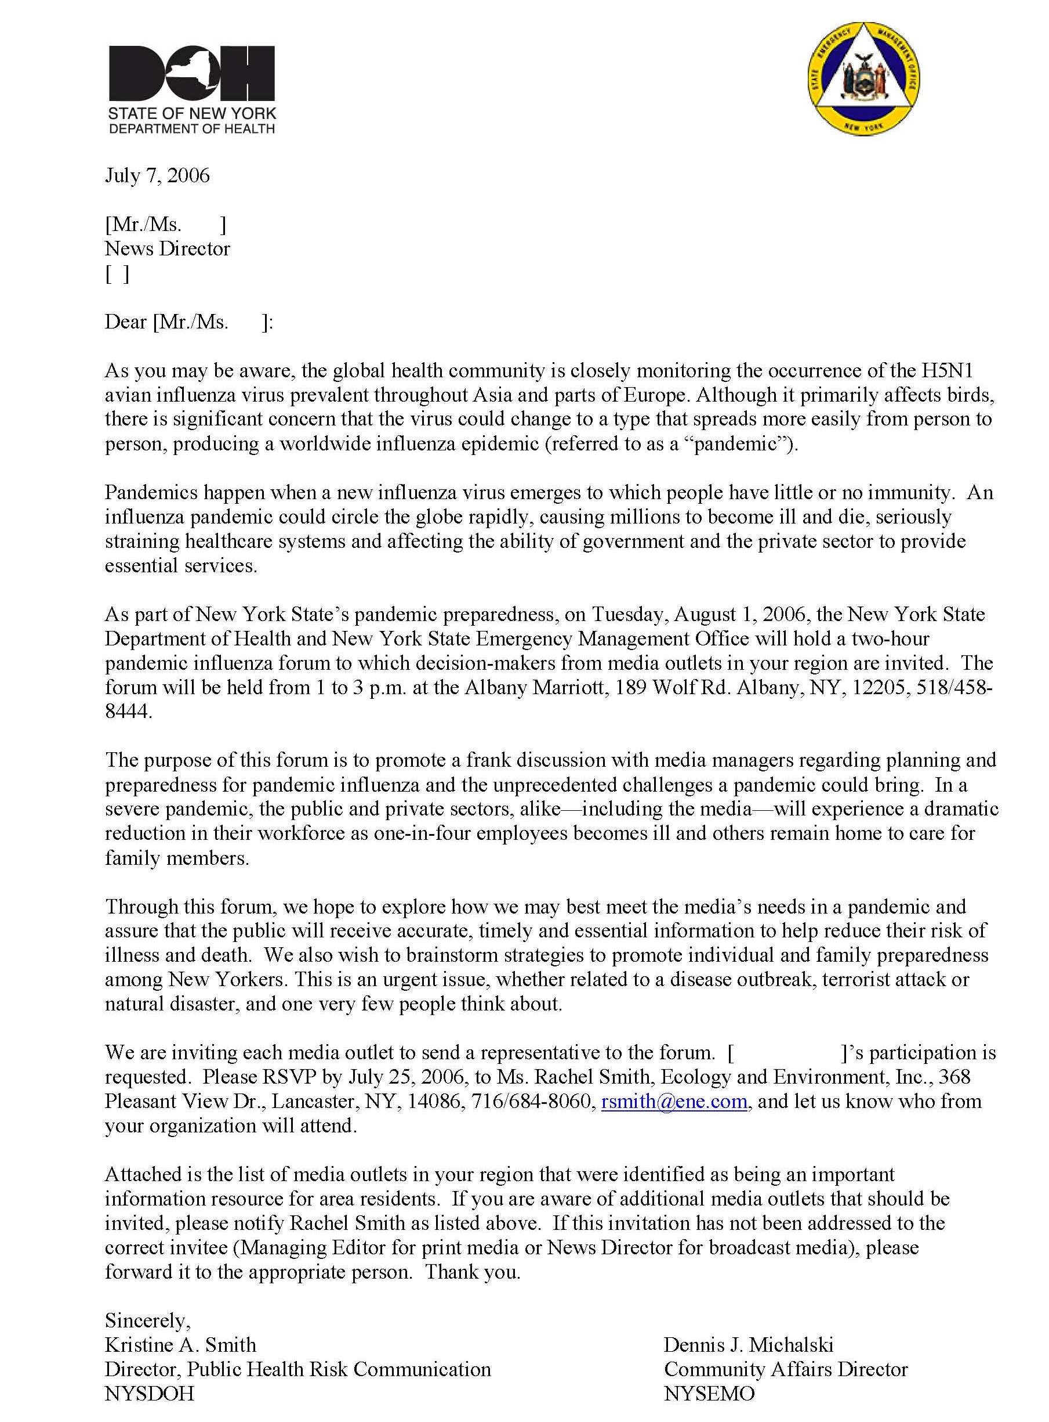
Figure 1-1 Example of Invitation Letter
where the original invitee was not responsive and could not be contacted to confirm, E & E verified the contact information and attempted to find a replacement invitee. It is of note that many of those who declined to attend due to conflicts or short-staffing expressed an interest in the forum series and some asked for further information. NYSDOH invited representatives from local health departments to each forum.

Each forum was held from 1:00 to 3:00 p.m. according to the schedule in Table 1-2. The forum scheduled for Long Island was ultimately cancelled due to the low number of acceptances received.

Table 1-2 Schedule for Media Forums
Regional Area | Date | Location
Plattsburgh | July 31, 2006 | Holiday Inn, Plattsburgh
Albany | August 1 | Albany Marriott, Albany
Lower Hudson | August 2 | Holiday Inn, Suffern
Long Island | August 3 (eventually cancelled) | –
Watertown | August 7 | Best Western Carriage House, Watertown
Binghamton | August 8 | Holiday Inn Arena,  Binghamton
Syracuse | August 9 | Syracuse Convention Center, Syracuse
Rochester | August 10 | Radisson Hotel Rochester Airport, Rochester
Buffalo | August 11 | E & E offices, Lancaster

The annotated agenda for the forums is provided in Figure 1-2. Attendees at each forum received a summary agenda and a handout of the two slide presentations. Attendees from the media additionally received:

■ A questionnaire on pandemic flu awareness, preparedness, and communication;

■ A pandemic flu preparedness checklist;

■ A media contact information form; and

■ A World Health Organization (WHO) article entitled WHO Handbook for Journalists: Influenza Pandemic (December 2005).

Copies of these materials are included in Appendix A, with the exception of the WHO article. Attendees from the media were asked to complete and turn in the questionnaire and contact information form sometime before the end of the forum.

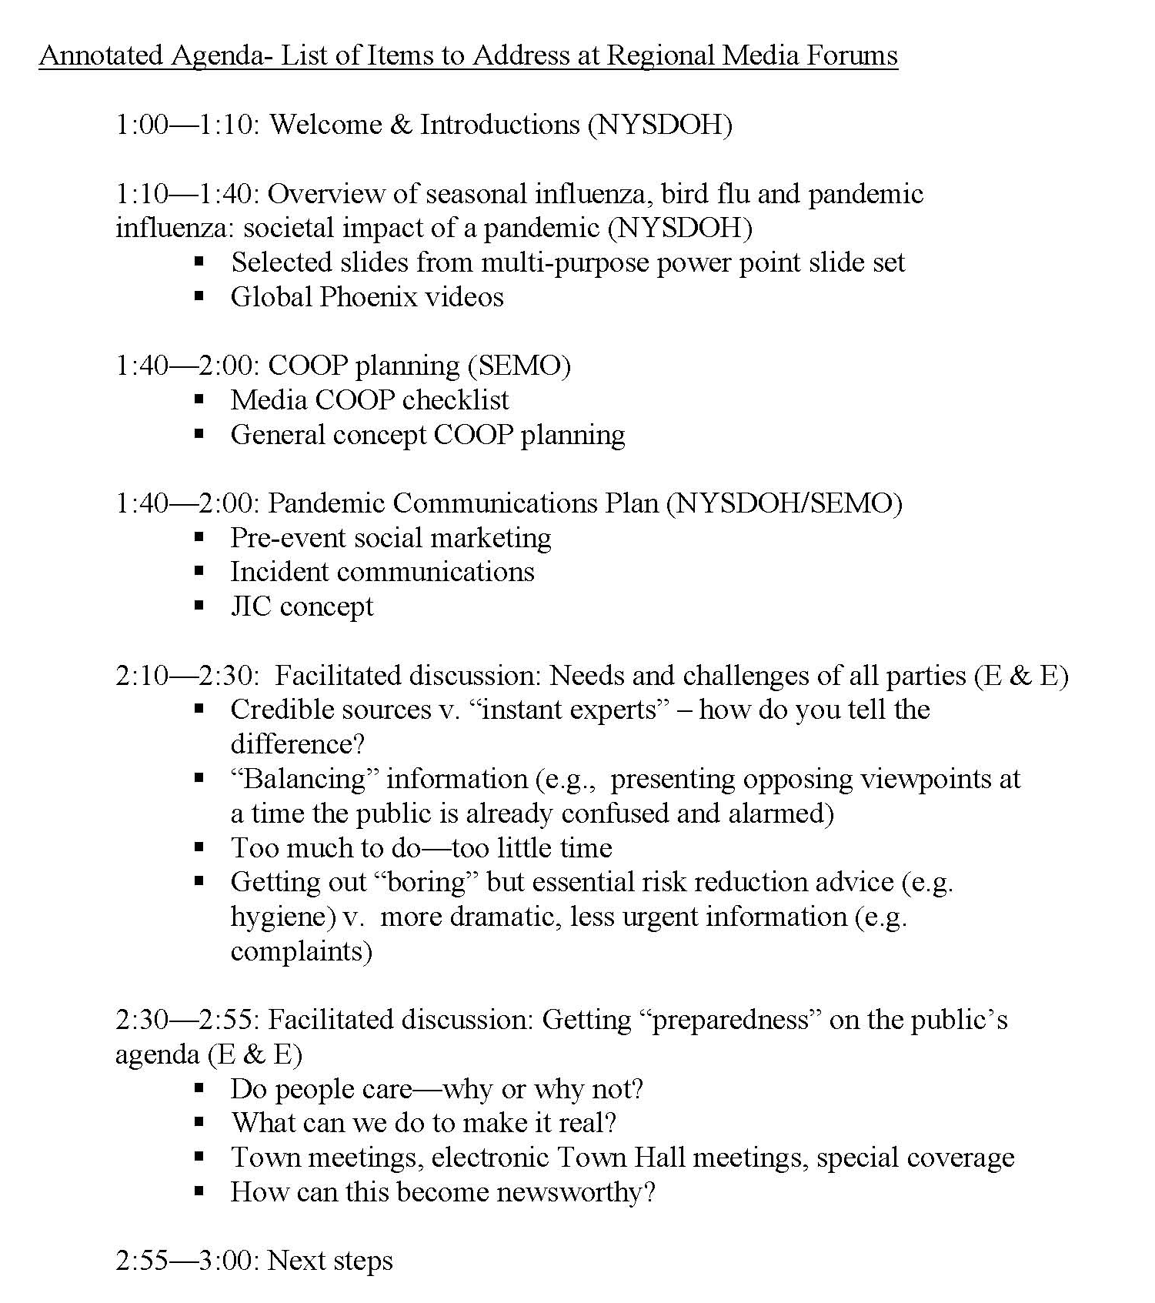
Figure 1-2 Annotated Agenda for Forums
A general sketch of the room set-up for each forum is included in Figure 1-3. The NYSDOH Director of Public Health Risk Communication conducted each forum, with assistance from the SEMO Community Affairs Director for segments on COOP planning. Participants were invited to make comments, pose questions, and share thoughts and ideas throughout the forum. E & E helped NYSDOH conduct the facilitated discussions and documented the comments made and feedback provided at each forum. Due to time constraints and the individuality of each forum, the facilitated discussions varied somewhat in content between forums.

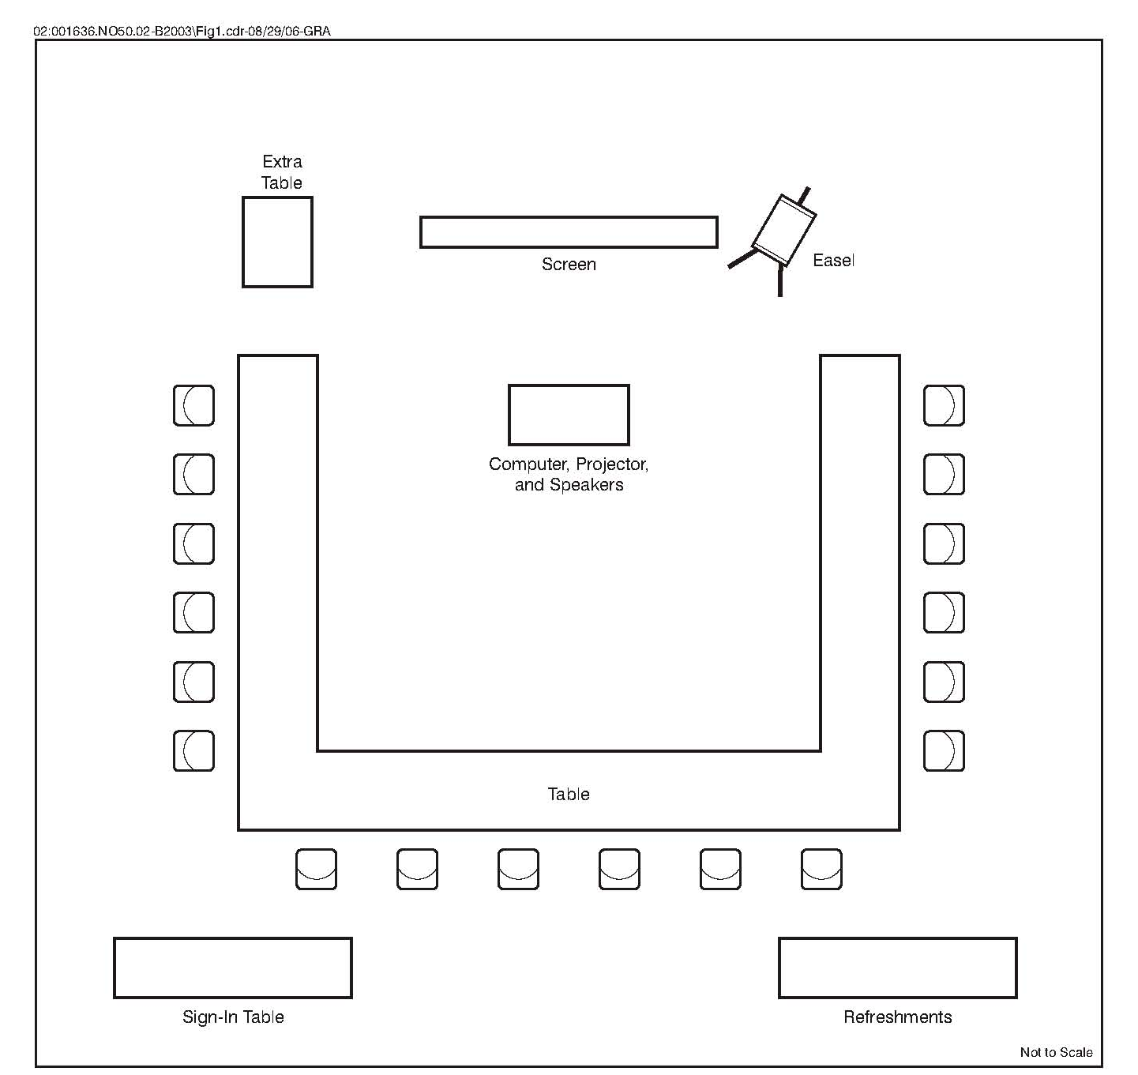
1-3 General Room Set-up for Media Forums

Results

2

The results from each of the eight forums are included in the sections below. Significant comments and exchanges of information that were made at each forum are listed. The comments have been loosely grouped into the following categories for ease of reading and to allow some comparison with NYSDOH’s objectives for the forums:

■ Comments related to COOP planning;

■ Comments related to communications and risk communication;

■ Comments related to other needs and challenges pertinent to the news media;

■ Comments related to getting preparedness on the public’s agenda; and

■ Other general comments of interest.

There is some obvious overlap in the categories and it is recognized that certain comments could fit in more than one category. The best choice was made. To retain the original flavor and intent of the comments, most of them have been reported using much the same wording in which they were said. Some words have been added for clarity.

A summary of the questionnaires on pandemic flu completed by media attendees at each forum is also included below. A summary of all of the questionnaires received for the forum series is included in Appendix B.

2.1 Plattsburgh Region Forum
The attendees at the Plattsburgh region forum are listed in Table 2-1. They consisted of six from the media, six from local health departments, and one from the state university.

Table 2-1 Plattsburgh Region Forum Attendees
Name | Position/Title | Affiliation
Lois Clermont | News Editor | Press Republican
Mike Lynch | Writer | Adirondack Daily Enterprise
Peter Crowley | Managing Editor | Adirondack Daily Enterprise
Orrin Schonfeld | Assistant News Director | WPTZ-TV
Matt Morin | Assignment Editor | WPTZ-TV
Jennifer Meschinelli | Editor | Denton Publications
Phyllis Light | Bioterrorism (BT) Coordinator | Essex County Public Health
Kathryn Abernethy | Public Health Director | Essex County Public Health
Deborah Endsley | Director of Patient Services | Essex County Public Health
Laurie Williams | Health Ed Coordinator | Clinton County Health
Sue Patterson | Health Ed | Franklin County Public Health
Lorraine Kourofsky | BT Nurse | Franklin County Public Health
Frances Hagen Dumenci | Director of PR | State University of New York (SUNY) at Plattsburgh

Comments Related to COOP Planning
Some of the media are used to working with limited staff; therefore, this would be the least of their worries.

Comments Related to Communications and Risk Communication
One media representative said they are suspicious when they hear plans for a one-voice approach.

Designating one person as the contact person can overwhelm the contact person and result in information not being transferred to people in a timely manner.

NYSDOH is moving toward having updates for local health departments via a central website area. The media would be able to access this and see what all agencies are doing.

SEMO is working on bringing the joint information center (JIC) approach statewide. The intent is to feed information to the JIC, where media can get it. Clinton County Health said they will have JIC stakeholders at the emergency operations center (EOC). In most cases, Essex County Public Health will not be going to a regional JIC.

The media is interested in a very local JIC or equivalent. They want local information for their stories. But don’t make a JIC or EOC the only source of credible information.

It might be better to coordinate regular times when to reach people and share information so the media can schedule it in.

Audio and video files, including teleconference videocasts and podcasts, can be put on public health and/or news websites to allow both the media and the public to obtain information at their convenience. For example, the Ethan Allen boating incident report from the National Transportation Safety Board was an electronic feed.

Will still need the ability to talk to real people; don’t make all information transfers electronic.

Most of the media currently have good procedures to access local health departments for information (e.g., the Press Republican does call the local health department for information and does not rely solely on press releases). They ideally would like to have a series of people to talk with to get information. They want to report accurately. Some of the media present do not have health reporters. It’s useful to have contacts at hospitals, too.

At times, the media shares material from other media sources and use information gained from sources other than local or state government.

During an emergency such as a pandemic, distribution of print media will be a challenge. Perhaps the newspapers’ websites will be used more then.

Comments Related to Other Needs and Challenges Pertinent to the News Media
The duration of the emergency event could be a problem if the advertiser base drops and the media organization cannot meet payroll.

Would NYSDOH pay for certain advertising to offset the loss of general advertising? An example would be NYSDOH purchasing a two-page pamphlet with information on pandemic influenza.

One newspaper commented that they have a moral obligation to provide the news; therefore, a smaller paper may be put out, but at least it will be published.

Comments Related to Getting Preparedness on the Public’s Agenda
To get people to read a story, it needs to have a personal or dramatic aspect, such as a family with a pet that died.

Need to combine dry information with exciting stories.

Some thought that young adults (20- to 30-year-old range) were not particularly well informed.

The current terror-aware climate makes people more conducive to preparedness messages in general, but the public, including the media, are still in a complacency phase regarding serious health emergencies like pandemic flu.

One media organization suggested enhanced use of websites to share information and make it easier to get the message to the public. Online newspapers are popular with many people.

Perhaps the media could promote state preparedness month (September) on their websites, for example, by linking to SEMO’s site.

SUNY Plattsburgh is not currently actively informing students about pan flu.

Perhaps use web polls and surveys to gather information on preparedness. Add a web segment on the topic. However, a problem with web-based surveys is you cannot tell where the people participating in the survey are from. Also, many people would like to see information more conclusive than a poll.

Increase awareness through the use of lawn signs and billboards, public service announcements (PSAs), and advertising in media sources.

Other General Comments of Interest
Need to get buy-in from the public on the personal protection process (e.g., masks, social distancing).

There is a significant number of prisons in Franklin County, which constitutes a special-needs population with unique needs for a large health emergency. Of note, corrections officers currently attend meetings and train with the county health staff.

The close border with Canada would provide unique challenges in this region.

Summary of Questionnaires on Pandemic Flu Completed by Media Attendees
The results of the questionnaires on pandemic flu completed by media attendees are summarized in Figure 2-1. The attendees were knowledgeable about what pandemic flu is but were not, in general, familiar with state and local pandemic flu plans, COOP planning, and general pandemic flu preparedness.

Half of the attendees thought that their organization had established procedures for receiving and disseminating accurate information during a pandemic flu emergency.

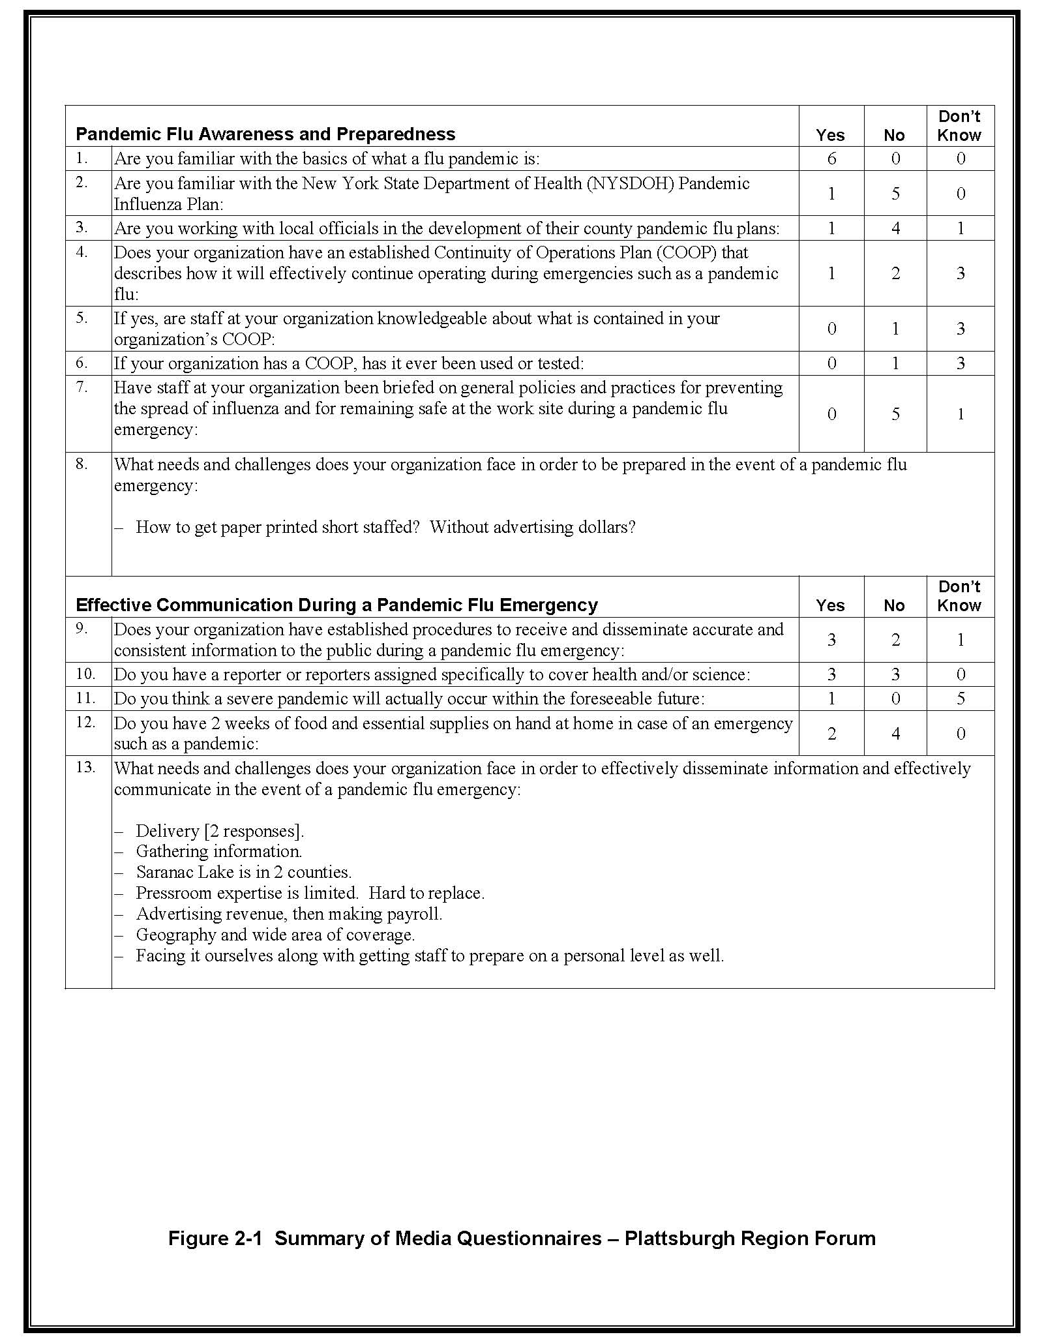
2-1 Summary of Media Questionnaires – Plattsburgh Region Forum

2.2 Albany Region Forum
The attendees at the Albany region forum are listed in Table 2-2. They consisted of six from media, eight from local health departments, and two from NYSDOH.

Table 2-2 Albany Region Forum Attendees
Name | Position/Title | Affiliation
Bob Condon | City Editor | Post-Star
David Galletly | Vice President | WAMC Public Radio
Judy Patrick | Day City Editor | Daily Gazette
Mike Spain | Deputy Managing Editor | Times Union
Beau Duffy | News Director | WRGB-TV
Dana Dieterle | News Director | WTEN-TV
Peggy DiManno | Assistant Commissioner | Albany County Department of Health (DOH)
Terry Powers | Public Health Educator | Albany County DOH
Kerri Battle | Director of Communication | Albany County
Sue Hathaway | Bioterrorism Coordinator | Schoharie County Health Department
Joseph Patterson | Interim PH Director | Schoharie County Health Department
Debbie Voght | Health Educator | Montgomery County Public Health
Chris Meyer | Rensselaer County Public Information Officer (PIO) | Rensselaer County
Pat Abitabile | PIO | Columbia County DOH
Bob Kenny | Director of Public Affairs | NYSDOH
Val Weaver | Associate Director PAG | NYSDOH

Comments Related to COOP Planning
SEMO suggested that the media may need to rely on pooled reporting.

Comments Related to Communications and Risk Communication
In the case of a pan flu event, the media will hear about it first from the Centers for Disease Control and Prevention, United States Department of Homeland Security, and NYSDOH and local health departments.

NYSDOH will use e-mail to inform hospitals as news releases are made available.

It will be important to media in an emergency to have a consistent source of reliable information because there will not be a lot of time. Information by phone, regular daily briefings, and a website are good (website was great for the West Nile virus concern).

The credibility of experts the media draws on is based largely on the credentials of the individual.

In general, media representatives have contact numbers and lists for “experts” and sources.

Local experts might not be enough. In a pandemic, reporting will get big and media will get a lot of information from worldwide experts. The media needs to know when the switch is made from the story being one of local significance to one of national significance, and when to turn their focus from local experts toward national-level experts.

It is possible to have a good expert who is not good in front of a camera. You may also have someone who is not a great expert but is great at communicating with people. Need to find a balance.

Most of the experts conflict with each other. The media tries not to take the first information they receive and go with it. Most of the media acts responsibly.

Key people should be made available until someone else becomes a new source. Focus on the most credible sources and give them a higher percentage of the story.

One media representative said they cannot rely on hospital personnel as credible sources.

Possibly use the SUNY SAT transmission system to get video/audio out.

The media could use a file transfer protocol (FTP) website to grab audio- and videocasts and briefings, like the one for the Ethan Allen boating accident on Lake George.

Remote access to information allows the media to stay safer, too, and be less exposed to people in general.

Comments Related to Other Needs and Challenges Pertinent to the News Media
Need to get the message across to the media (and others) that, in such an emergency, public service is more important than the business.

The media are not currently considered to be critical personnel with regard to being granted access to places for such an emergency.

One media attendee wondered whether newspaper carriers would contribute to disease transmission or increase their own chances of getting sick during such an event.

Comments Related to Getting Preparedness on the Public’s Agenda
One media organization said that the media has not to date provided enough coverage on pandemic flu.

Reporting on the topic now would not impact the listeners. People will need and want the information more if “something hits the fan.” There will be a window of time where there will be an overwhelming need for information.

Forum attendees thought the current interest level and preparedness level for pandemic flu in the region is low.

To capture interest, news sources will need to use local, personal stories that relate back to the community.

It would be great to do a story about coughing correctly during flu season. A story is not a good story until there is an immediate impact on news consumers.

SEMO suggested that the media could do a preparedness story and provide a link to the SEMO website.

The media feels there is currently no second-day story, which reduces the likelihood that they would want to cover it.

Need to market preparedness and wage a campaign. Suggestions included surveys and polling (this was suggested to the attendees), using celebrities and contests, and a medical show on Mondays on the public radio station. Need to give the issue context applicable to right now.

Other General Comments of Interest
Some of the media wondered how much notice they and the public would have to know when a flu outbreak becomes a pandemic flu. NYSDOH said the amount of warning could range from a few days to a few months.

Even now, ordering personal protective supplies such as masks will be difficult. There is currently a backorder of several months.

Summary of Questionnaires on Pandemic Flu Completed by Media Attendees
The results of the questionnaires on pandemic flu completed by media attendees are summarized in Figure 2-2. The attendees were knowledgeable about what pandemic flu is and some were familiar with the NYSDOH and local pandemic flu plans. Most did not have a COOP plan or thorough COOP strategies and were not up to speed with general pandemic flu preparedness.

Most of the attendees said that their organization had established procedures for receiving and disseminating accurate information during a pandemic flu emergency, but still need better access to credible sources of information.

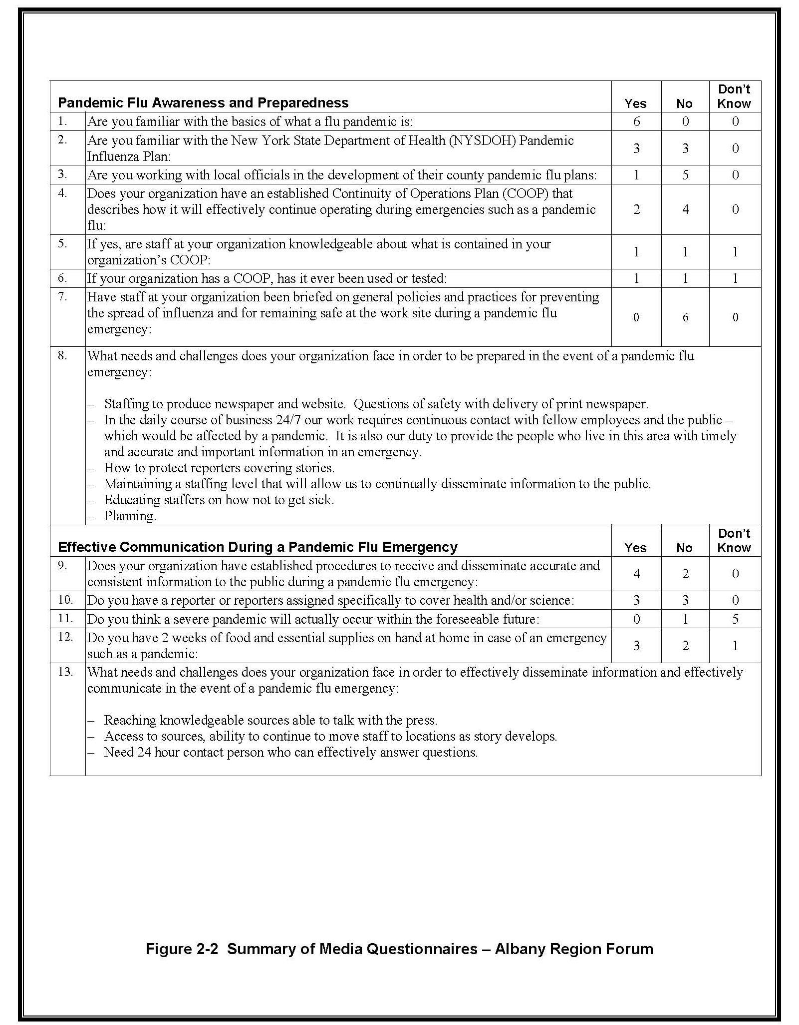
2-2 Summary of Media Questionnaires – Albany Region Forum

2.3 Lower Hudson Region Forum
The attendees at the Lower Hudson region forum are listed in Table 2-3. They consisted of five from media and six from local health departments and county offices.

Table 2-3 Lower Hudson Region Forum Attendees
Name | Position/Title | Affiliation
Sarah Netter | Reporter | The Journal News
Meg McGuire | Managing Editor | Times Herald-Record
Gretchen Pina Breedy | Human Resources Manager | Times Herald-Record
Robert A. Doremus | Building Services Manager | Times Herald-Record
Dylan Skriloff | Reporter | Rockland Business Association
Robert J. Deitrich | Director | Orange County DOH
Carol Ryan | Director of Public Health | Sullivan County DOH
Sabrina Marzouka | Director PHI | Dutchess County DOH
Aisha Phillips | Public Health Educ. Coordinator/Media | Dutchess County DOH
Joan Facelle | Commissioner | Rockland County Health Department
C. J. Miller | Director of Communications | Rockland County Executive’s Office

Comments Related to COOP Planning
None.

Comments Related to Communications and Risk Communication
The media present had not seen the bird flu pamphlet.

The media wants credible information. They need a local health department point of contact. Some of the media are suspicious of PIOs as a rule because they are thought of as mouthpieces for the person who appoints them. Would rather talk to someone connected to the health department that is knowledgeable in the area of flu. PIOs can be useful for general information like locations of clinics.

The media prefers local experts like health commissioner or DOH director. They also like to get an analysis of the problem from grass roots (local health input) to higher levels (like SUNY New Paltz and New York City input). They also look at the availability of people to provide the analysis. The media would like to hear from an expert, but if one is not available, they will make do with what they have.

The credible source of information needs to develop a relationship with the media. And the media must have faith in the person providing and handling the information.

Some of the media currently do not have an expert for pandemic flu.

Comments Related to Other Needs and Challenges Pertinent to the News Media
The media could do a better job in general of science reporting.

Comments Related to Getting Preparedness on the Public’s Agenda
People (and the media) are currently confused about the flu, confuse pandemic flu, with bird flu, have a low level of interest, and do not understand the difference between animal-to-person transmission and person-to-person transmission.

The local health departments are not receiving many inquiries now about flu but expect more calls by October.

Preparedness is likely more in the backs of the minds of the public in this region than in others due to the Indian Point nuclear plant.

Health departments should consider placing ads in newspapers to get the message out. Ads will allow health departments to get out their message the way they want it. The text will not be edited by newsroom writers.

News organizations are working on two to five top priorities at a time. They will need to spend time developing and “charging” the system to make this story newsworthy.

Need to get the public to a point of saturation before people start to take notice and talk about an issue. For example, the Times Herald-Record published 20 to 30 articles about a new power line going into an area and people still did not realize it.

Presently people are numb about terrorism (making it harder to capture their attention with stories on potential future health emergencies).

People tend to go to websites that tell them what they want to hear and not necessarily the truth. The media needs to beat these information sources to the punch to be effective.

Blog websites such as Flu Wiki (http://www.fluwikie.com/) can be effective sources to reach out and provide information to the public. Why not create a pandemic flu blog? Include information on what is happening in New York State and have NYSDOH run it. Make NYSDOH the only group that can post information.

Per the Orange County DOH, consider putting pandemic flu information in the Health Connection guide, which comes out twice yearly.

The Sullivan County DOH set up phone lines in the past [for what health emergency?] but no one called. Need to renew public interest.

Preparedness for pandemic flu will not be of interest unless/until news leads to it, making it an issue. Health departments have to be ready to get the word out at key learning points in time (e.g., if/when the first birds are found in the United States carrying the problem strain).

Other General Comments of Interest
Regarding protective face masks, most suppliers are back-ordered and it may take weeks or months to get them. Cannot expect supply to meet demand. Along with the masks there will have to be education on their proper use. You cannot wear a single mask all day long.

One local health department’s main worry is their limited ability to do much in the face of such an emergency. But they can educate. Calls would overwhelm a local health department.

Summary of Questionnaires on Pandemic Flu Completed by Media Attendees
The results of the questionnaires on pandemic flu completed by media attendees are summarized in Figure 2-3. The attendees were knowledgeable about what pandemic flu is and most were familiar with the NYSDOH pandemic flu plan, although not with local pandemic flu plans. None have a COOP plan and most were familiar with general pandemic flu preparedness.

Most of the attendees did not think that their organization had established procedures for receiving and disseminating accurate information during a pandemic flu emergency.

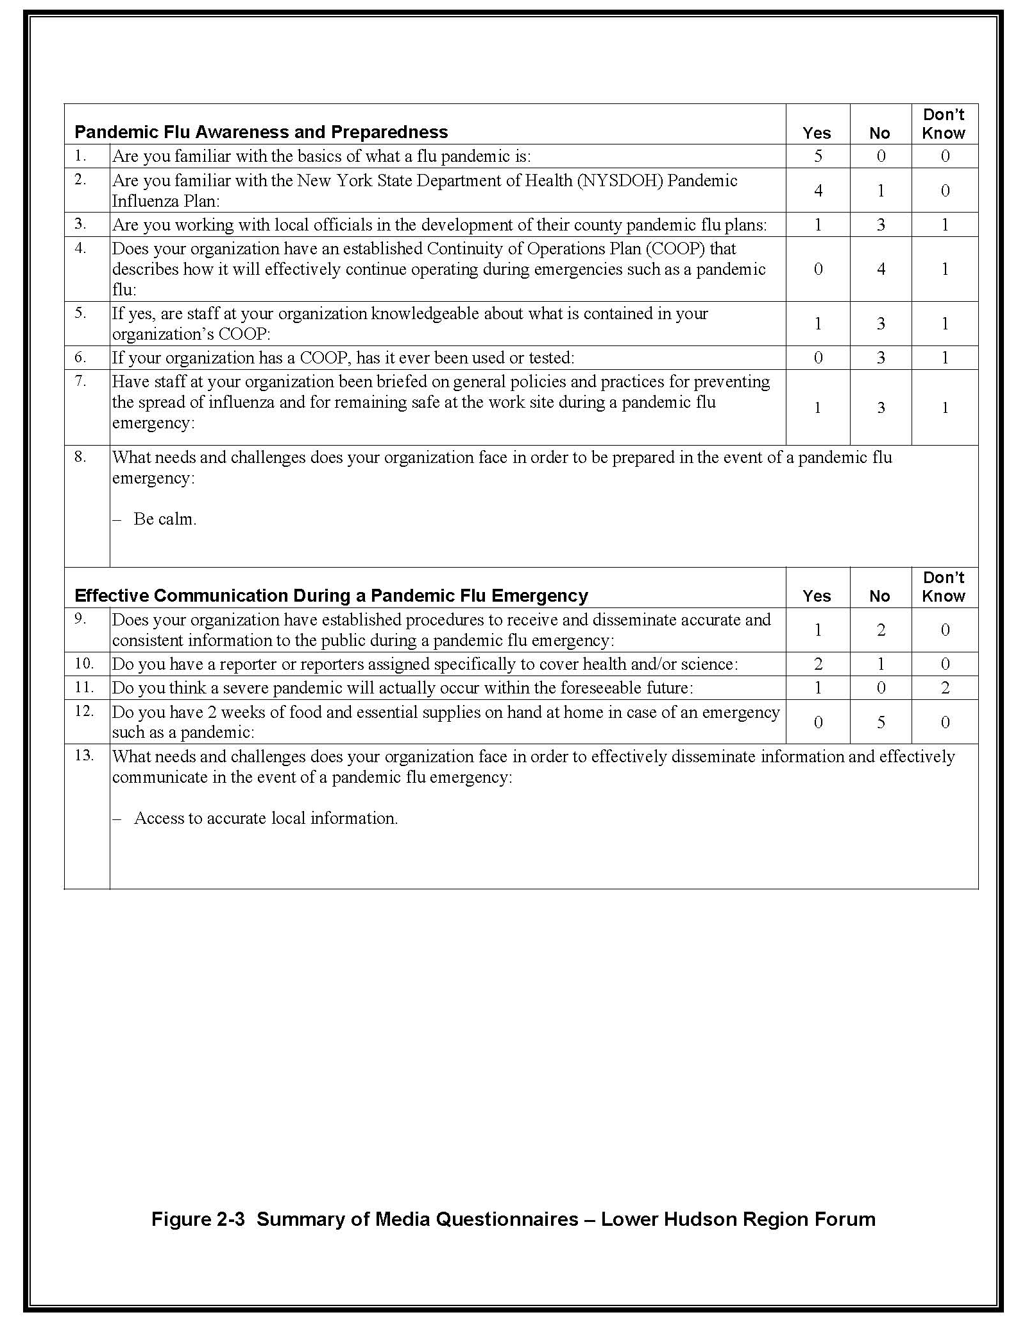
2-3 Summary of Media Questionnaires – Lower Hudson Region Forum

2.4 Watertown Region Forum
The attendees at the Watertown region forum are listed in Table 2-4. They consisted of four from the media and four from local health departments.

Table 2-4 Watertown Region Forum Attendees
Name | Position/Title | Affiliation
Jim Redmond | Photojournalist supervisor | WWNY–TV
G. Pearsall | HR Director | Johnson Newspaper Corp.
Bob Gorman | Managing Editor | Watertown Daily Times
Martha Foley | News Director | North Country Public Radio, WSLU-FM
Diane LaRock | Emergency Preparedness Coordinator | St. Lawrence County Public Health
Laurie Maki | Community Health Educator | St. Lawrence County Public Health
Charles Brenom | EMS Director/BT Coordinator | Jefferson County Public Health Service
Steve J. | Public Health Planner | Jefferson County Public Health Service

Comments Related to COOP Planning
One media organization is currently working on a business continuity plan. No other organizations indicated that they have such a plan.

The media feels that they are good at adapting and working around challenges that are presented. For example, during the response to Hurricane Katrina, news reporters went with the flow in the face of adversity and limited resources.

Comments Related to Communications and Risk Communication
The local health department is usually the media’s first source for health-related information. From that point it varies, and may be hospitals, doctors, or some other.

The media believes that a weak link is local information sharing. In some cases local health departments have information but may not release it to the media until they have obtained approval to do so. The media may seek information from sources other than the local sources because they do not want to wait 8 hours for the local health department to get approval to release information that the media can get from other avenues sooner. As well, at times the media finds out information before the local health departments do.

The media present do not have formal lists of experts to turn to in such an emergency. Each person has their own “internal” list of people with whom they have pre-established relationships.

There are positive relationships between local health departments and local media sources. In an emergency, however, local media may not be running the show, making pre-established relationships of limited value.

The media would like to be able to get to the county and state health departments quickly, which would help to resolve conflicting information.

Most news organizations update their websites regularly and frequently, which are a good source for government to obtain appropriate contacts within news organizations.

NYSDOH inquired whether news organizations would find background (B-roll) video footage or sound bites provided by government useful for news broadcasts. In some cases, media would use such material.

In an emergency it would be beneficial to run a continuous “blue band” with disaster information across the bottom of television programs. The overriding of regular programming to provide emergency information should also be considered.

E-mail addresses of key NYSDOH and SEMO representatives would be beneficial for the media.

Comments Related to Other Needs and Challenges Pertinent to the News Media
The media feels there is a need to reevaluate their mission during an emergency such as a flu pandemic (i.e., the importance of broadcasting information to the public outweighs the business aspect of their service).

The media would like news carriers and staff to be exempt from curfews and travel restrictions in such emergencies. In past emergencies where there had been travel restrictions and curfews (such as during the ice storm), reporters and news carriers were impacted by police who had orders to keep people off the streets. SEMO responded that this is a local issue and should be addressed with local and county government.

Comments Related to Getting Preparedness on the Public’s Agenda
The media and the public are more familiar with the term “epidemic” and are unfamiliar with “pandemic.” Define “pandemic” so media consumers will not be confused.

The lack of a pandemic in the recent past has hurt the public’s sense of urgency on the topic and made it difficult to emphasize the importance of preparedness. Because the media covered stories such as SARS and West Nile virus and the outbreaks did not become as severe as some had warned, the public has become more complacent about diseases. In this region, the public takes stories on ice storms seriously, so it may be possible to spin an ice storm preparedness story pointing out that, if people prepare for an ice storm, they will also be mostly prepared for an influenza pandemic.

One media attendee thought that the issue of pandemic flu is always in the back of the public’s minds but that continuous reminders are needed. Stories on what is being done to prepare are needed, such as a story on this meeting. When seasonal bird migrations begin again the subject will have renewed interest.

It is difficult to sell to the public the potential that a pandemic may be severe without sounding alarmist.

Blogs, opinions, and other unofficial sources may be where the public turns for their information. People are not necessarily getting their news from traditional sources such as television, radio, or print news media anymore.

Although many people will not pay attention to pre-pandemic messages, it is still necessary to put out specific information before a disease hits. Two types of messages would be needed after a pandemic has begun ― one for those who heard and will comply with pre-pandemic messages and another for those who were less prepared for the event.

Other General Comments of Interest
None.

Summary of Questionnaires on Pandemic Flu Completed by Media Attendees
The results of the questionnaires on pandemic flu completed by media attendees are summarized in Figure 2-4. The attendees were knowledgeable about what pandemic flu is but were not, in general, familiar with state and local pandemic flu plans and COOP planning. Most were, however, familiar with general pandemic flu preparedness (e.g., methods to stay safe and limit the spread of infection, stockpiling food and supplies).

Most of the attendees did not know if or think that their organization had established procedures for receiving and disseminating accurate information during a pandemic flu emergency.

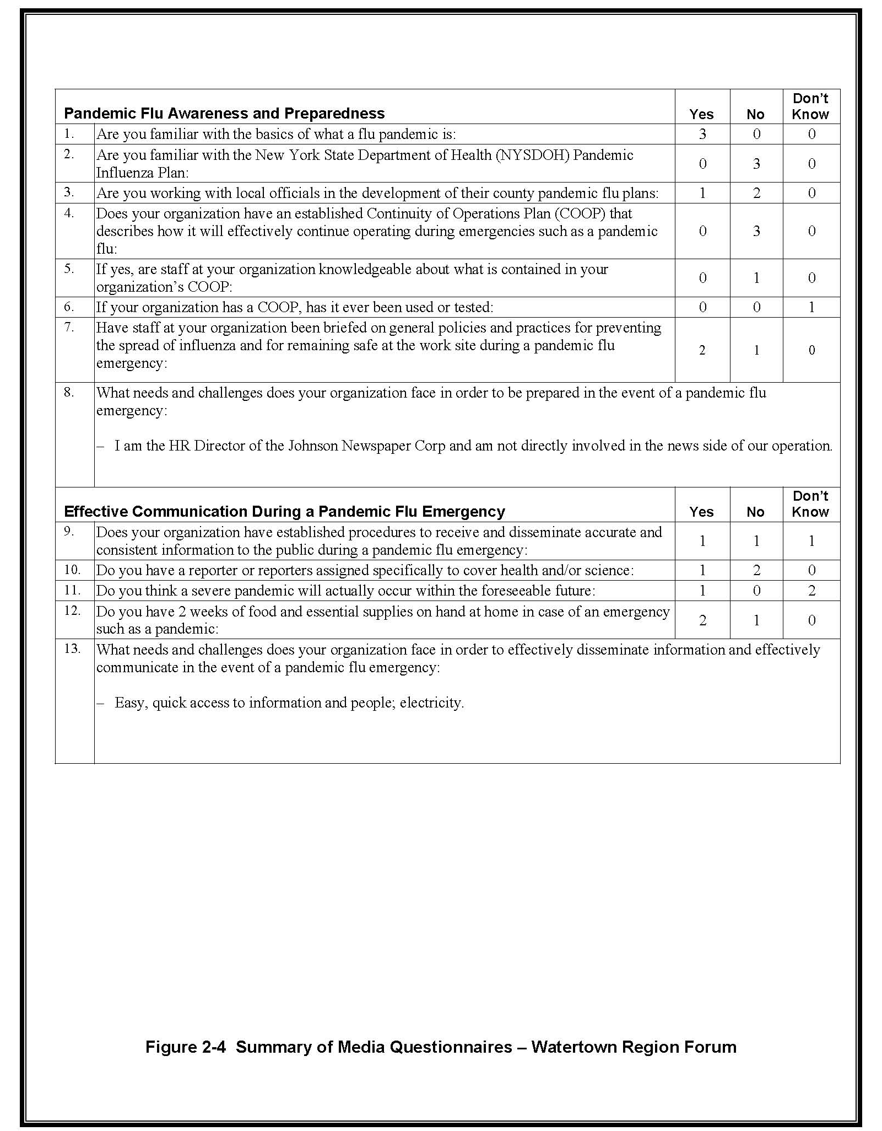
2-4 Summary of Media Questionnaires – Watertown Region Forum

2.5 Binghamton Region Forum
The attendees at the Binghamton region forum are listed in Table 2-5. They consisted of six from media and seven from local health departments.

Table 2-5 Binghamton Region Forum Attendees
Name | Position/Title | Affiliation
Greg Catlin | News Director | WBNG-TV
Ben Colwell | Chief Videographer | WBNG-TV
Roger Neel | Program Director | WNBF Radio
Geoff Dunn | News/Program Director | Cayuga Radio Group
Jim Ehmke | News Director | WIVT-TV, WBGH-TV
Kena Vernon | Reporter | WICZ-TV, Fox 40 News
Deborah Lumia |  | Delaware County Public Health
Amanda Walsh | Public Health Prep. Coordinator | Delaware County Public Health
Marcas Flindt | Public Health Director | Chenango County Health Department
Theresa Lyczko | Director Health Promotion Program (PIO) | Tompkins County Health Department
Claudia Edwards | Public Health Director | Broome County Health Department
Diane O’Hora | PIO | Broome County Health Department
Mary Jane Uttech | Deputy Public Health Director | Cortland County Health Department

Comments Related to COOP Planning
Three of the media representatives have or are working on a COOP plan or comprehensive emergency management plan.

Comments Related to Communications and Risk Communication
During the flooding, it was difficult to assemble all of the small pieces of information that were available from multiple sources into a coherent picture of the true status of the situation.

During the recent flooding, the media did not know whom to call for what problem. Viewers were constantly calling the news to find out how to get from one place to another even though the news usually did not know either.

The media would use the Internet more to get information out in the future. They would also improve their TV crawl technology and allow and encourage telecommuting for their staff. During the recent flooding, they had so much information that they could not get it all out. In the future they will run a crawl 24/7. They received many angry notes from viewers who felt they were being ignored.

One attendee from the media said they access subject matter experts through the county executive’s office. The media might also go to those on their mental list of sources.

The media wants information on what they should tell the public when people call to report that they have a dead bird in their yard. The media also needs to understand that this information may evolve and change.

The media should let NYSDOH know when there has been a pattern of calls to the media so that NYSDOH can add appropriate information to their website in response.

NYSDOH inquired whether news organizations would use background (B-roll) video and audio footage if it were made available by health departments. In some cases, the media would use such material. Potential methods of interest for obtaining such footage include downloading it from the web, getting it via satellite if it is in analog format, as a DVD for information in advance of an emergency, and, for radio, sound bites from telephone briefings.

Comments Related to Other Needs and Challenges Pertinent to the News Media
None.

Comments Related to Getting Preparedness on the Public’s Agenda
The public has a poor understanding of how the disease is spread and the significance or lack of significance of a dead bird.

The public in their area cares about the issue and would like additional information.

Stories have already been done locally on the subject but more needs to be done. Efforts need to be repeated since many potential viewers will not see a TV news story that is shown just once, many would not be paying sufficient attention if they are watching, and many would forget unless they see the story repeated several times. These stories need to be repeated every few months.

The media can do unscientific polls and surveys. Sienna College can do more scientific polls and surveys and distribute their results to the media. This has been done in the past.

Any campaign to increase knowledge and awareness and promote preparedness and prevention should incorporate humor and be sure to target businesses.

Other General Comments of Interest
In the recent flooding, there were numerous news personnel who could not get to work due to high water in the roads or water in their homes. This resulted in difficulty getting information to the public and translated into many negative comments being received by news organizations from the public.

Summary of Questionnaires on Pandemic Flu Completed by Media Attendees
The results of the questionnaires on pandemic flu completed by media attendees are summarized in Figure 2-5. The attendees were knowledgeable about what pandemic flu is and most were familiar with NYSDOH or local pandemic flu plans. Two organizations have a COOP plan but are still concerned about staffing issues in emergencies. Most attendees were not familiar with general pandemic flu preparedness.

Most of the attendees said that their organization had established procedures for receiving and disseminating accurate information during a pandemic flu emergency, but still need better access to credible sources of information.

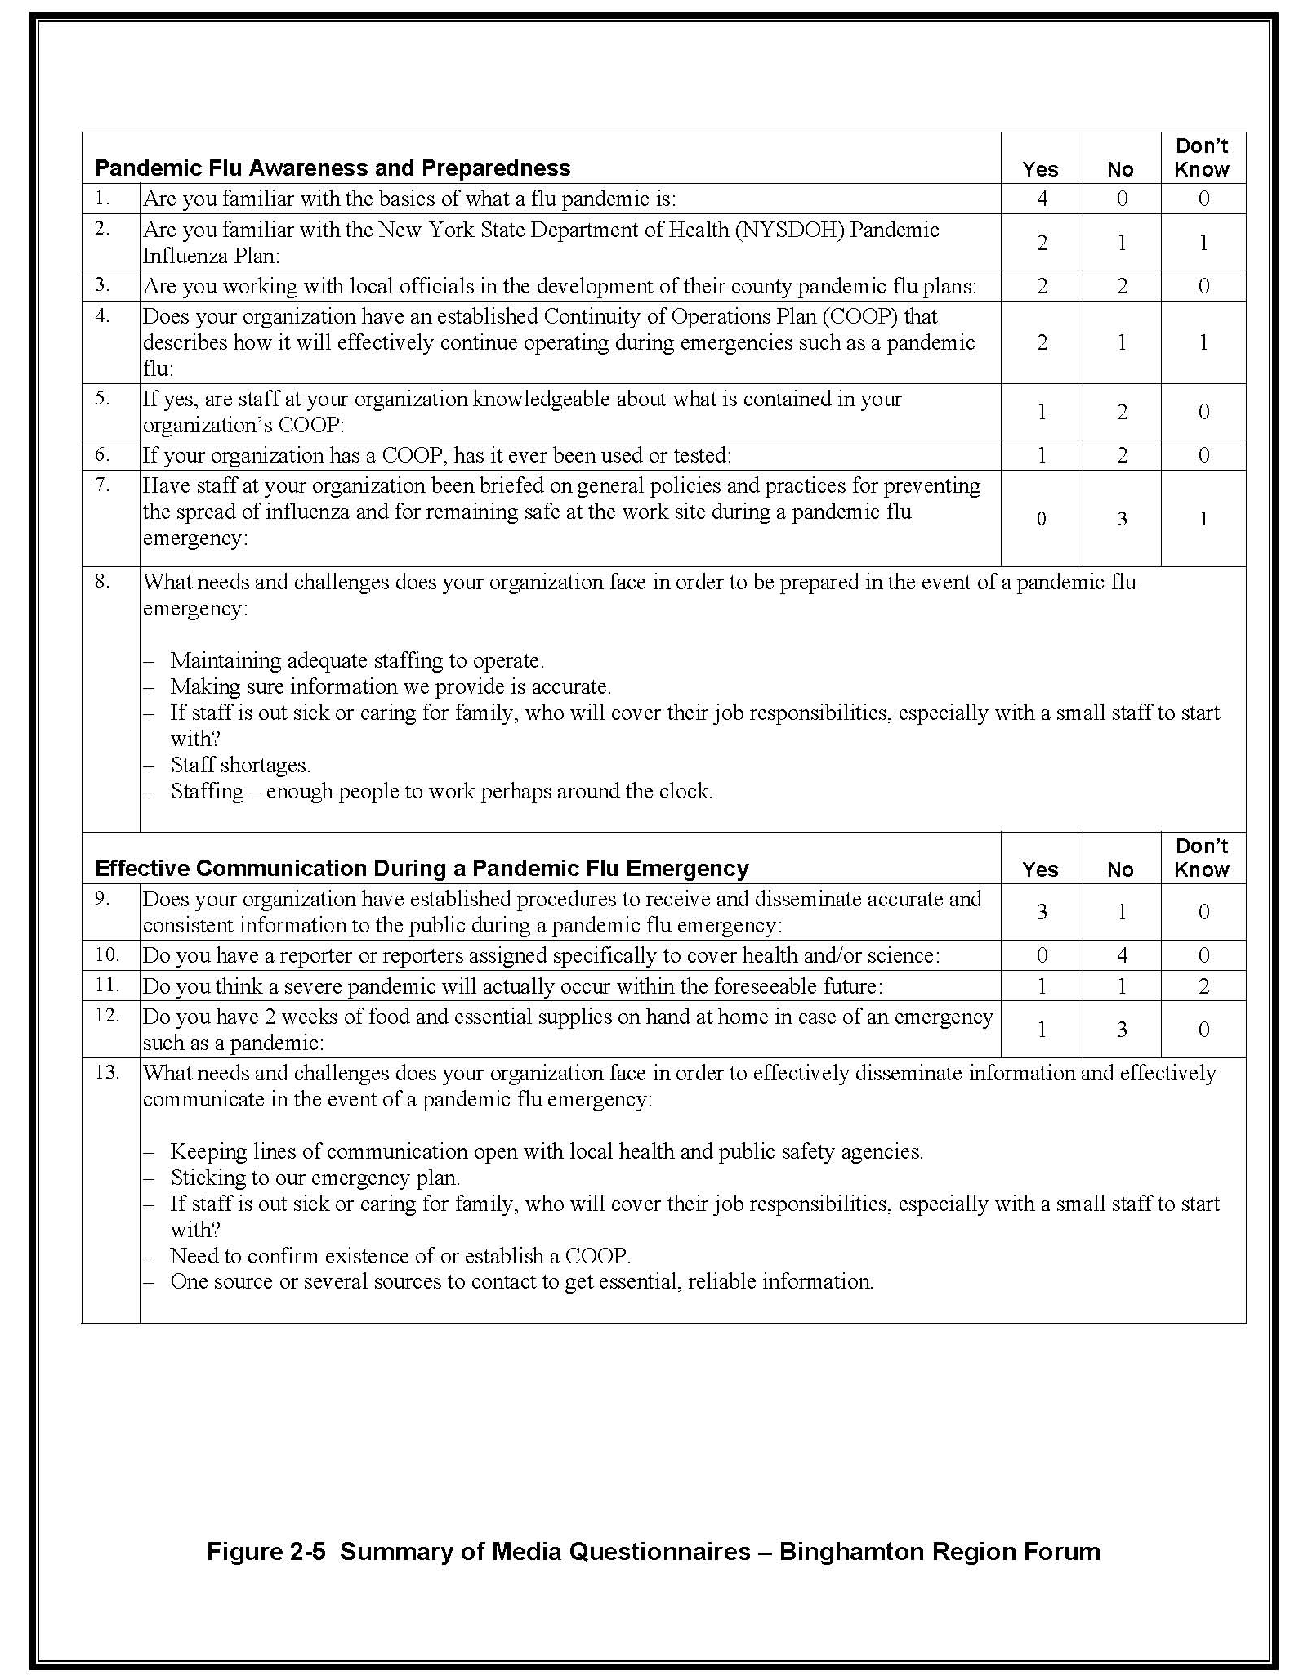
2-5 Summary of Media Questionnaires – Binghamton Region Forum

2.6 Syracuse Region Forum
The attendees at the Syracuse region forum are listed in Table 2-6. They consisted of four from the media and eight from local health departments and county offices.

Table 2-6 Syracuse Region Forum Attendees
Name | Position/Title | Affiliation
Kathy Poliquin | HR | The Post-Standard
Rosemary Robinson | Managing Editor/Metro | The Post-Standard
Joel Meltzer | Operations Manager | WMCR Radio
John Walton | Asst. News Director | News 10 Now
Gregory O’Keefe | Director | Herkimer County Public Health
Kathy Mogle | PIO | Onondaga County Health Department
Farah Hag | Pan Flu Planning Coordinator | Onondaga County Health Department
Diane Oldenburg | Public Health Education | Oswego County Health Department
Janet Clerkin | Public Info Coordinator | Oswego County Promotion and Tourism
Ken Shilkret | BT Coordinator | Oneida County Health Department
Ken Fanelli | Public Education Coordinator | Oneida County Health Department
Kathleen Cuddy | Deputy Health Director | Cayuga County

Comments Related to COOP Planning
Some news organizations offer flu shots to their staff. One person stated that the news company he used to work for required staff to receive a flu shot each year.

Comments Related to Communications and Risk Communication
There is a sense among the public and the media that the government cries wolf too much, such as during the SARS scare.

Comments Related to Other Needs and Challenges Pertinent to the News Media
NYSDOH noted that personnel from the media are currently not high on the priority list to receive vaccination during an emergency such as pandemic flu, but that this might change as it is realized that the media is necessary to help the government communicate with the public.

News organizations are concerned that their staff will get sick when going out to do a story. There is also concern that the public would be afraid of handling a newspaper that is potentially contaminated.

The media would like special arrangements (like special credentials) to allow them physical access when travel restrictions are enforced for an emergency.

Comments Related to Getting Preparedness on the Public’s Agenda
The media and the public need a lesson on the differences between avian flu, pandemic flu, seasonal flu, etc.

The public does not seem to care or be concerned about the flu. Following a recent television movie on bird flu, the local health departments were prepared for a large volume of calls related to the flu but did not receive a single call.

Message fatigue is a problem. The public becomes deaf to a story such as on the flu if they hear it repeated many times but an outbreak does not occur.

One member of the media was skeptical of the large numbers that could be expected to die as a result of an influenza pandemic (remembering that many are predicted to die of flu but their cause of death might not be officially recorded that way).

The county health departments have people available to come and talk about preparedness, which was of interest to some media.

Other General Comments of Interest
None.

Summary of Questionnaires on Pandemic Flu Completed by Media Attendees
The results of the questionnaires on pandemic flu completed by media attendees are summarized in Figure 2-6. Only two completed questionnaires were submitted. One attendee was knowledgeable about what pandemic flu is, one was familiar with their local pandemic flu plan, and neither was familiar with the NYSDOH plan. Neither has a COOP plan or was familiar with general pandemic flu preparedness.

One attendee said that their organization had established procedures for receiving and disseminating accurate information during a pandemic flu emergency.

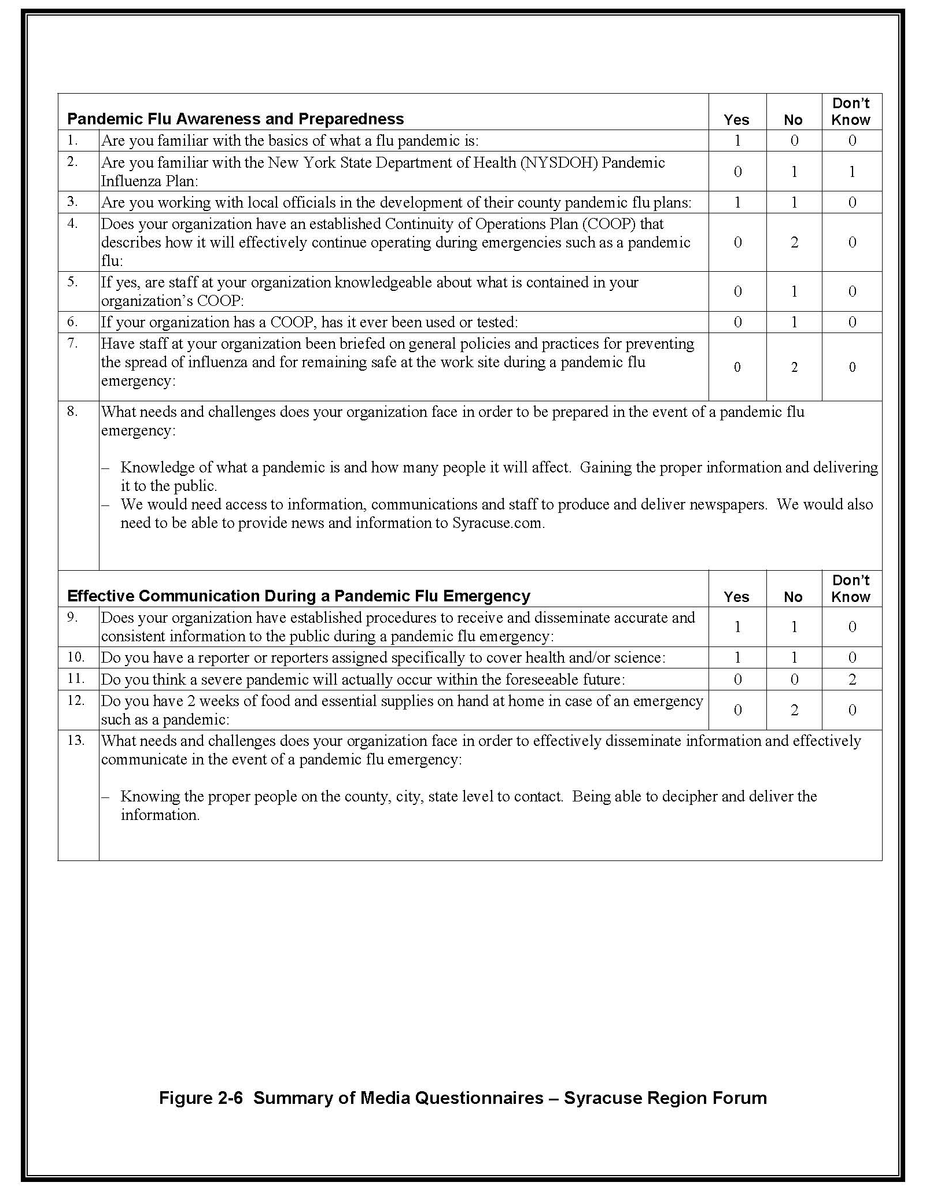
2-6 Summary of Media Questionnaires – Syracuse Region Forum

2.7 Rochester Region Forum
The attendees at the Rochester region forum are listed in Table 2-7. They consisted of six from media and eight from local and state health departments and offices.

Table 2-7 Rochester Region Forum Attendees
Name | Position/Title | Affiliation
Matt Dudek | Asst. Managing Editor/Admin | Democrat & Chronicle
Jacob Tschetter | IT Support | Democrat & Chronicle
Jim Weilert | Assignment Manager | WHAM-TV 13
Allison Watts | Executive Producer | WHAM-TV 13
Jennifer Wedow | Assignment Editor | Messenger Post Newspapers
Lynn Wesley | Assignment Editor | R-News
Nola Goodrich-Kresse | PIO/PHE | Orleans County Health Department
Ginny DiBella | PIO/PHE | Wayne County Public Health
Alice Robeson | PIO/PHE | Ontario County Health Department
Lorellie Clark | PIO/PHE | Steuben County Public Health
Vicki Swinehov | Director of Public Health | Seneca County Health Department
Jeffrey Hammond | PIO | NYSDOH
Joe Rohm | Media Relations | NYSDOH
Paul Wilson | SEMO Reg. V | SEMO

Comments Related to COOP Planning
One newspaper said that they have a COOP plan in place.

SEMO suggested that the media will need to cross-train staff and that pooling of resources among a variety of media outlets may be necessary with limited staff.

Comments Related to Communications and Risk Communication
Different forms of getting the information out, such as podcasts and text messaging, could be beneficial in getting information to a younger generation.

A typical medical reporter will want good visual and sound bites from state and local health departments and other sources.

Comments Related to Other Needs and Challenges Pertinent to the News Media
A media attendee stated that the media is a critical sector that needs to be higher on the priority list for receiving medicine/vaccinations, ideally, first behind first responders and health officials.

One news organization was concerned about how many masks and gloves to keep on hand for staff during a public health crisis.

The media would like to cover training exercises with local municipalities, but are often not invited to attend.

An attendee from the media noted that the state’s work-at-home laws need to be looked at because that could be an issue for news media working at home during a health emergency.

Comments Related to Getting Preparedness on the Public’s Agenda
One media attendee noted that there is public complacency regarding preparedness and that media needs to get out a consistent message of personal responsibility.

The media needs to be consistent with the message to the public of storing a 2-week supply of necessities and the media should actually follow their own message. None of the media attendees currently have a 2-week supply at their home.

Information provided during a crisis should also include actions the public can take to protect themselves, not just stories about death and suffering.

One media attendee stated that local health departments speaking to businesses and schools about preparedness would warrant news coverage. She suggested that the media be invited to these types of events and use them to start the preparedness discussion with the public.

One media attendee thought that PSAs could be used to scare the public into being prepared. NYSDOH cautioned that there is a fine line there and they do not want to sensationalize the issue. A local health department representative mentioned that scare PSAs are often tuned out by the public since they see so many and that a more effective way is needed to get the message out to the public.

A local health department representative thought that the use of something like a PSA could be beneficial for home health aides and other health professionals.

The media could work with the health departments to develop more scientific web polls to gather information about what the public needs or how the public feels.

A local health department representative suggested that they help to educate children in schools about preparedness, resulting in the parents learning from the children.

Other General Comments of Interest
None.

Summary of Questionnaires on Pandemic Flu Completed by Media Attendees
The results of the questionnaires on pandemic flu completed by media attendees are summarized in Figure 2-7. The attendees were knowledgeable about what pandemic flu is and some were familiar with the NYSDOH pandemic flu plan, although not with local pandemic flu plans. One organization has a COOP plan and some attendees were familiar with general pandemic flu preparedness (e.g., methods to stay safe and limit the spread of infection, stockpiling food and supplies).

Most of the attendees said that their organization had established procedures for receiving and disseminating accurate information during a pandemic flu emergency.

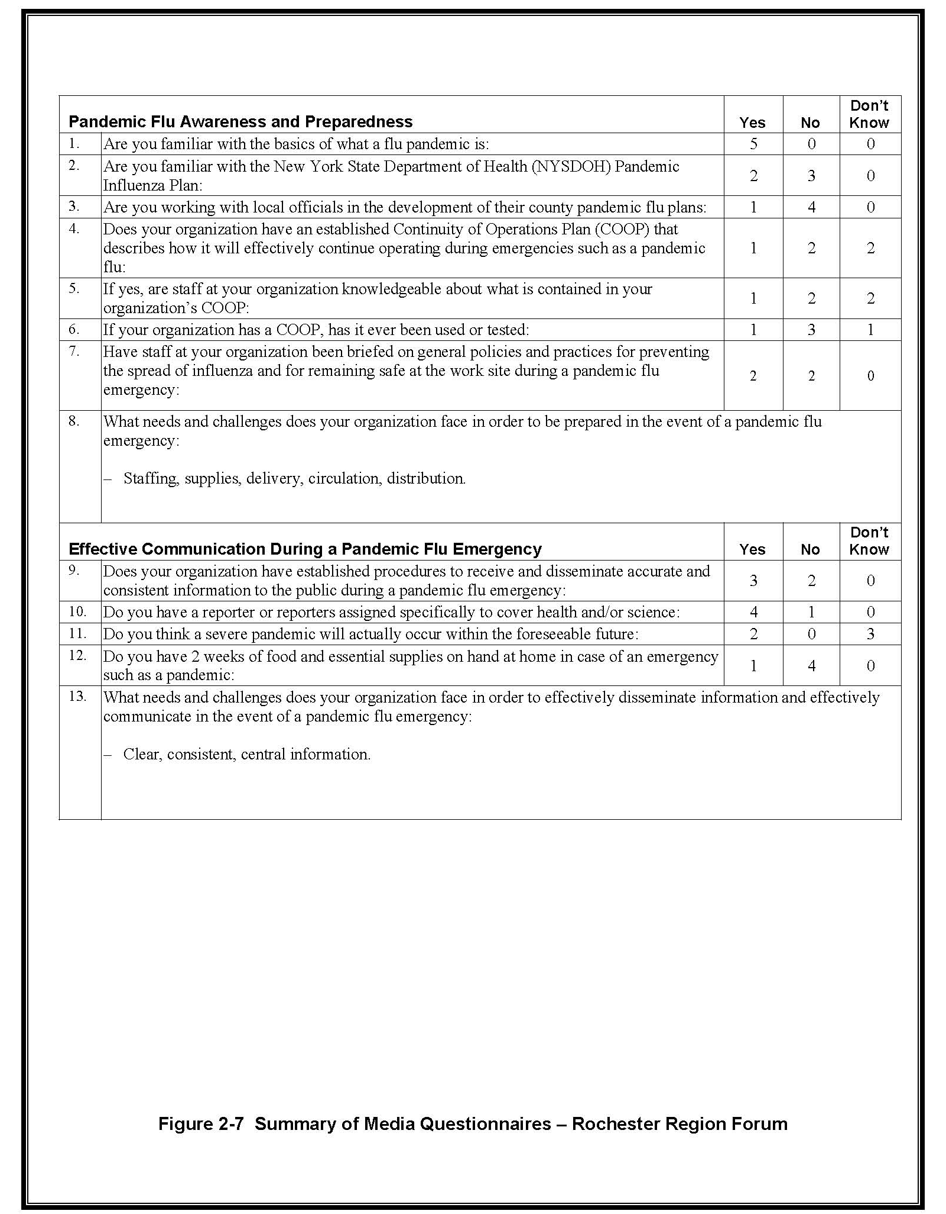
2-7 Summary of Media Questionnaires – Rochester Region Forum

2.8 Buffalo Region Forum
The attendees at the Buffalo region forum are listed in Table 2-8. They consisted of five from the media and two from local health departments.

Table 2-8 Buffalo Region Forum Attendees
Name | Position/Title | Affiliation
Tom Garlick | Operations Manager | WIVB-TV
Jeff Sabato | Executive Producer | WIVB-TV
Monica Wilson | News Director | WBEN-AM
Steve Cichon | Reporter | WBEN-AM
Eileen Buckley | Assistant News Director | WBFO-FM
Carol Cosgrove | Emergency Preparedness Nurse | Cattaraugus County Health Department
Deb Nichols | PHE | Cattaraugus County Health Department

Comments Related to COOP Planning
One media attendee wanted to know if the SUNY system had a COOP plan and, if they did, would it cover their radio station since they are owned by SUNY. If they are to be relying on SUNY’s plan, they are not aware of it.

Comments Related to Communications and Risk Communication
Podcasts are huge among radio listeners and should be used as another method to get information to the public.

The media needs to stay in close contact with the local health departments in order to stay up-to-date and have the most current information regarding a possible flu pandemic and during a pandemic event. A local health department representative said that they could help coordinate with media for information.

Comments Related to Other Needs and Challenges Pertinent to the News Media
The media needs information on proper cleaning and disinfecting products to use to minimize the spread of infection.

Several media attendees were concerned over the sharing of microphones/screens among staff and interviewees, which will include the public. NYSDOH suggested that phone interviews could eliminate the concern of virus-sharing with interviewees.

Comments Related to Getting Preparedness on the Public’s Agenda
One problem with preparedness is that the public does not know the difference between pandemic flu and bird flu. This should be the starting point for the message to the public. NYSDOH said that the state and local health departments would give the media any information sources they might need to make the clarifications.

One media attendee felt that the lack of medicine for at least six months after the discovery of the pandemic flu virus is a critical message for the public. Teaching basic hygiene methods to the public will be better received if this is part of the message.

One tool the media can use to reach the public is to cite recent preparedness failures, such as the power grid failure of 2003 and Hurricane Katrina, as well as other serious events (where preparedness was arguably a factor), such as 9/11.

The media’s websites could have a link to local health department flu vaccination information.

The media could link pandemic flu preparedness with routine media coverage of seasonal (free) flu vaccination sites.

SEMO said that the Department of Homeland Security website will have a one-stop shop for preparedness that the media can refer to and tell the public about.

Live news will sell preparedness to the public. Timing is critical in getting information to the public.

A media attendee said that dentists are being overlooked as a target audience.

Other General Comments of Interest
Several media outlets were interested in the effectiveness of Lysol to kill the seasonal flu virus as well as other flu viruses.

One media attendee wanted to know what procedures are in place for border control during a pandemic event. The local health department representative discussed the recent communicable disease exercise for pandemic flu, which tested the regional response, and that the Canadian government is working with the Western New York Public Health Alliance on this situation.

Special populations in western New York need to be addressed, including the Amish.

Summary of Questionnaires on Pandemic Flu Completed by Media Attendees
The results of the questionnaires on pandemic flu completed by media attendees are summarized in Figure 2-8. The attendees were knowledgeable about what pandemic flu is but were not familiar with state and local pandemic flu plans. One organization has a COOP plan, another has one in progress, and most attendees were not familiar with general pandemic flu preparedness.

Most of the attendees said that their organization has established procedures for receiving and disseminating accurate information during a pandemic flu emergency.

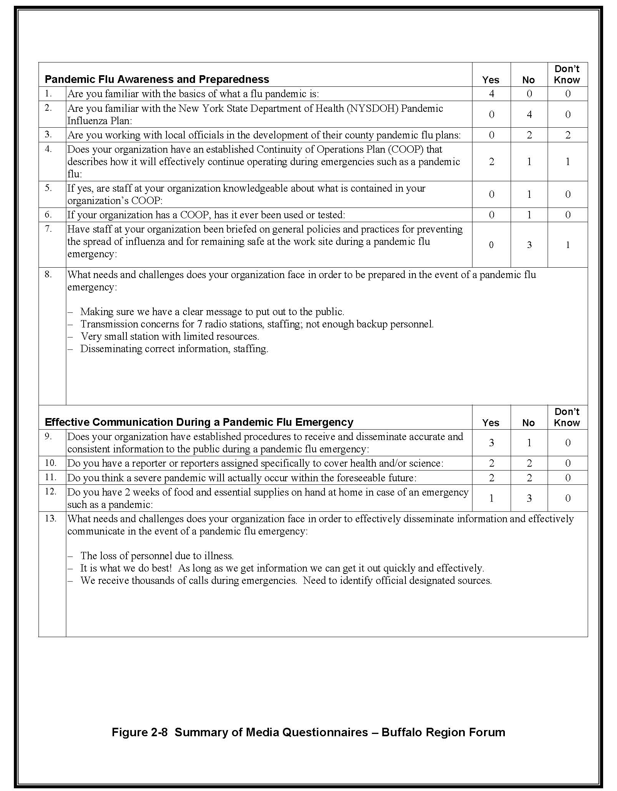
2-8 Summary of Media Questionnaires – Buffalo Region Forum

Summary

3

NYSDOH successfully accomplished its objectives for the series of forums provided for news media in various regional areas throughout New York State. Substantially more media representatives were invited than attended, indicating that additional effort will be needed to reach the remaining news providers. NYSDOH, in cooperation with SEMO:

■ Provided basic information on pandemic influenza to the news media;

■ Determined if attending news media organizations have COOP plans and procedures in place;

■ Determined if news media organizations are knowledgeable of and prepared to follow risk communication principles when delivering their message to the public in events such as a health emergency; and

■ Provided an opportunity for news media, local health departments, and NYSDOH and SEMO to meet, exchange ideas, and foster continued coordination and cooperation.

The common themes, ideas, and suggestions that resulted from the forum series are summarized below. They were obtained from both the exchange of ideas at the forums and the questionnaires completed by the media attendees.

COOP Planning

■ Most of the media organizations that attended the forums either do not have COOP plans or the attendees did not know whether their organization had one.

■ Regardless of whether a media organization has a COOP plan, many attendees believe they will have serious staffing problems in a pandemic flu event.

Communications and Risk Communication

■ All of the media attendees stated on their questionnaires that they are familiar with the basics of what pandemic flu is.

■ The media is very receptive to electronic and automated ways to access state and local health department information and updates in a timely manner. Suggestions included:
– A central website area managed by NYSDOH that media can visit and download files from, including text, video, and audio files,
– E-mail updates (e.g., from health departments to media),
– Using SUNY SAT,
– FTP sites, and
– A state or local pandemic flu blog.

■ Many of these same methods could also be used by health departments and the media to provide information on pandemic flu to the public. In fact, web-based news and podcasts are increasingly popular among most age groups.

■ Electronic/automated information dissemination is intended to augment, not replace, traditional communications used in emergencies such as press releases and briefings, JICs, personal interviews, and phone conversations.

■ Most of the media attendees currently have credible technical experts they would access in the event of a flu pandemic and most already include state and local health department personnel on their contact lists. However, the majority of attendees do not think that their organization has established effective procedures for receiving and disseminating accurate information during a pandemic flu emergency. They are not confident that they can quickly obtain clear, consistent, and accurate information and get it out to the public.

Other Needs and Challenges Pertinent to the News Media

■ Several media organizations made a point of noting that their organization would put their public-service ethic above their business obligations in the event of a serious health emergency.

■ Most of the media attendees have not been provided with extensive information on pandemic flu preparedness, such as practices for occupational safety, disease transmission prevention, and maintaining a 2-week stockpile of food and essential supplies.

■ Most of the media attendees expressed concern about not being considered essential personnel for the purpose of access to do their job in an emergency and would like to be exempt from curfews and travel restrictions. As well, many were concerned about not being considered essential personnel for receiving medicine/vaccinations.

Getting Preparedness on the Public’s Agenda

■ Most of the attendees, both media and public health, believe that current public interest in pandemic flu and preparedness is low due to factors such as past history, other more pressing concerns, and the non-stories that other diseases such as SARS and West Nile virus have become in this country. As a result, most media are not inclined to report on pandemic flu preparedness but, if pressed to do so, had ideas for making the story as interesting and immediate as possible.

■ The public as a whole is confused about the flu, confuses pandemic flu with bird flu, and does not understand the difference between animal-to-person transmission and person-to-person transmission.

■ Several attendees mentioned the potential use of surveys, polls, and outright campaigns to both gauge and stimulate awareness but, overall, the media goes where the news already is.

■ Even if/when stories on pandemic flu preparedness are issued, messages will need to be excessively repeated before making an impact on the populace.

General Comments of Interest

■ Most of the media attendees stated on their questionnaires that they did not know whether a severe pandemic will occur in the foreseeable future.

Handouts Provided at Media Forums

A

Summary of All Media Questionnaires on Pandemic Flu

B

