Closed Point of Dispensing (POD)
Field Operations Guide (FOG)

Public Health Emergency Preparedness
Minnesota Cities Readiness Initiative
Mass Prophylaxis – 100% of population in 36 hours

Closed POD Field Operations Guide
Table of Contents

Topic | Page
Abbreviation Glossary | 2
SECTION 1: INTRODUCTION | 3
Closed POD Strategy | 3
Closed POD Organizational Chart and descriptions of jobs | 4
SECTION 2: ACTIVATION OF CLOSED POD PLANS | 5
Notification | 5
SECTION 3: Closed POD Site Set Up | 5
Closed POD Agency Set Up Checklist | 6
Determine size (based on #’s see attachment) | 7
Site Set-up and areas required | 8-9
Obtaining Medications | 9
SECTION 4: Opening of Closed POD Site | 9
Closed POD Workforce Briefing | 10
SECTION 5: Closing of Closed POD Site (Demobilization) | 10
Closed POD Agency Checklist | 11

ABBREVIATIONS GLOSSARY
CDC Centers for Disease Control and Prevention
CRI Cities Readiness Initiative
DOC Department Operations Center
EOC Emergency Operations Center
FOG Field Operations Guide
HOH Head of Household
ICS Incident Command System
JAS Job Action Sheets
LDN Local Distribution Node
LEOC Local Emergency Operations Center
LPH Local Public Health
MDH Minnesota Department of Health
MDS Mass Dispensing Site
NACCHO National Association of County and City Health Officials
PIO Public Information Officer
POD Point of Dispensing
PPE Personal Protective Equipment
RSS Receiving, Staging & Storing Site
SEOC State Emergency Operations Center
SNS Strategic National Stockpile
SOP Standard Operating Procedures
Section 1: Introduction
***NOTE: ALL FORMS REFERRED TO IN THIS DOCUMENT CAN BE FOUND IN THE ACCOMPANYING CLOSED POD FORMS BOOK FOR OPERATING POD.

Many organizations throughout the state have partnered with local public health agencies to be Closed Point of Dispensing (POD) Partners and have agreed to assist in dispensing preventive antibiotics (prophylaxis) to their staff, families of staff and clients. In the event of a large scale Public Health Emergency involving the prophylaxis into 100% of the population within 36 hours, local public health agencies would notify Closed POD partners and request that they activate their Closed POD Plans. Upon activation of Closed PODs this Field Operation Guide (FOG) is used by the Closed POD Site manager to effectively set-up, open, operate and deactivate the Closed POD.

Dispensing Strategy
The purpose of mass dispensing is to quickly and accurately dispense medication to a targeted population in response to natural or man-made public health emergencies. The Minnesota Department of Health (MDH) defines the targeted population and provides prophylaxis protocols, educational materials, and other forms for staff and public. Local Public Health (LPH) Departments are responsible for assuring that medications are distributed and dispensed. Mass Dispensing will be accomplished through Open PODs (Mass Dispensing Sites) and Closed PODs.

PODs do not offer treatment or extensive medical evaluation. Depending on the situation, and authorization from the State Commissioner of Health, non-medical personnel may be utilized for positions normally requiring a medical license/certificate.

Closed POD Organizational Structure
The Health Departments will be operating under the Incident Command System. The Closed POD may operate under the Incident Command System or your current organizational structure.

The Logistics Section will assign staff to the site as appropriate. Direction of onsite command and general staff is provided by the Closed POD Coordinator at the site.

See Organizational chart for Incident Command System. Certain job titles may not be filled, depending on the response, but it is important for those in leadership positions to know the functions of each to ensure that the functions are performed as needed even if the job is not filled.

Overview of Roles:
For more details on each role see Job Action Sheets (Closed POD Forms Book, Attachments 26-40).

Incident Commander (Closed POD Coordinator) oversees the entire Closed POD operation, communicates with Local Public Health (LPH) representative, and communicates as needed with the Licensed Practitioner Consultant (LPC).
Public Information Officer/Spokesperson acts as the spokesperson for the organizational internal and external messages.
Site Safety Officer is responsible to ensure entire operation runs safely.
Operations Chief oversees entire dispensing operation of Closed POD.
Triage (Registration Group) triages those attending Closed POD to ensure they are in the target group, assess if they have any special needs and if they are ill.
Usher/Greeter (Forms Group) greets people as they enter Closed POD and gives them a screening form.
Medication Screener Group screens form using the MDH algorithm to determine which antibiotic is most appropriate.
Medication Dispenser Group labels and dispenses appropriate antibiotic based on screening form.
Education Group provides education and related materials.
Logistics Chief/Set-up oversees entire set-up, supply source and take down of Closed POD.
Inventory Unit assures adequate supplies are available for operation of Closed POD.
Security Officer provides traffic flow and security as needed.
Human Resource Unit assures staffing for Closed POD is available.
Courier picks up supplies from LPH.
Licensed Practitioner Consultant (LPC) provides consultation related to symptom triage and dispensing/vaccination. The LPC may be available in person or by phone.

Section 2: Activation of Closed POD Plans

Upon agreeing to become a Closed POD, organizations will develop a Closed POD Plan which will be updated and submitted to LPH representative annually. This will help to ensure that at the time of the response LPH will have the most accurate counts. The estimated number of employees, employees’ household members, and clients will determine how many courses of medications the organization will receive. If these estimates are accurate, the Closed POD site will receive a more than an adequate supply. If it is clear that demand is surpassing supply, additional medications may be requested from the Local Distribution Node (LDN) Manager through the Department Operations Center (DOC). It will be important for the inventory manager to make the request before the supply runs out to prevent being in a position where you must stop operations until more medication can be picked up. If you need to request any additional medications, estimate the number of courses you will need and call LPH representative to make arrangements.

Notification
When an incident occurs, Closed POD partners will be notified by Local Public Health (LPH) staff. This notification may come through in the form of a phone call, fax, and/or email. During this initial notification, the Closed POD will receive an email attachment which will need to be completed and returned by email or fax prior to coming to the LDN to pick up medications. Closed POD partners will be asked to confirm their ability to participate in dispensing medications by responding to the notification. Another notification will be sent when the LDN is ready for partners to come and pick up their medications. This notification will include address for LDN as well as instructions.

After receiving notification from LPH, Closed POD Partners will notify their staff and or clients of activation. This notification will include two parts:
- First, notification goes to those who have been identified to set-up and operate the Closed POD.
- Second, Closed POD Partners will notify the remainder of their staff/clients to inform them of the opening of Closed POD. This notification should include details of where the dispensing will be taking place and when to come. It should also instruct them they will need to know what allergies and what medications everyone they are picking up medications for are on. It may also be helpful to email out the screening form and ask for them to be completed prior to coming to the Closed POD.

** If using responder dispense or if an online version of the screening form is available, you will request that they bring the printout of the screening results.

Section 3: Site Set Up

The initial staff reporting to the Closed POD will be the Closed POD Coordinator, the Logistics Chief and the Operations Chief. A Supply Area and a Staff Check-in Area should be the first areas setup at a Closed POD. An initial set up of the Supply Area will facilitate the setup of the rest of the Closed POD. A Staff Check-in Area allows for the documenting and tracking of all staff working at the Closed POD. Complete Closed POD Agency Set-up Checklist (below).

Closed POD Agency Set-Up Checklist

Upon activation of the agency Closed POD plan, Incident Commander (Closed POD Coordinator) or designee will complete the following checklist
(this is a general guide, you may add or delete elements to fit the needs of your organization)

Item | Procedure | Completed
1 | Review Closed POD Plan and staff assignments to ensure availability of personnel to staff key positions. Reassign as needed.
2 | Activate assigned staff to begin setting up Closed POD. First, establish Staff Check-in and Supply areas. Set up screening and dispensing areas per lay-out design. (Forms Book, Attachment 3)
3 | Communicate activation of Closed POD Plan to employees and/or clients.  - Notify employees and/or clients where and when to obtain medications.  - Advise them to know the allergies and prescriptions of those for whom they are picking up medications.  - If available, send the screening form out electronically to be filled out prior to arrival at the POD.
4 | Post the Information Use Warning (Forms Book, Attachment 11)
5 | Await instructions from LPH for picking up medications. Ensure Courier has needed documents and is prepared to go to Local Distribution Node. Dispatch courier when instructions arrive.
6 | Copy needed forms and information.  - For original Closed POD forms to copy, see Closed POD Forms Book  - For number of copies needed, see Closed POD Plan, page 6
7 | Prepare and schedule staff briefing.
8 | Conduct briefing and necessary Just-in-Time Training.
9 | Conduct inventory of medications upon return of courier. Store medication in cool, dry and secure location. Store vaccines as directed by LPH.
10 | Conduct final walk through when POD setup is complete to ensure that everything is ready.
11 | OPEN DOORS

Determine the amount of staff and supplies needed to open site based on National Association of County and City Health Officials (NACCHO) chart below.

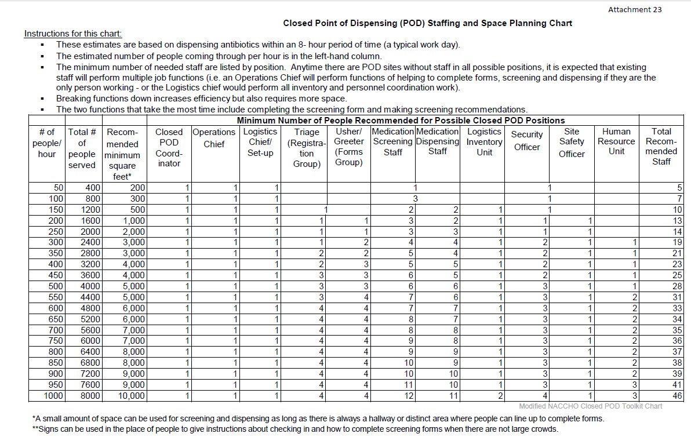
This chart is located in the Closed POD Forms Book, Attachment 25.

Determine the number of copies (screening forms, algorithms, antibiotic information sheets, etc) needed based on number of people expected to be served at Closed POD (for more details see Plan, page 6).

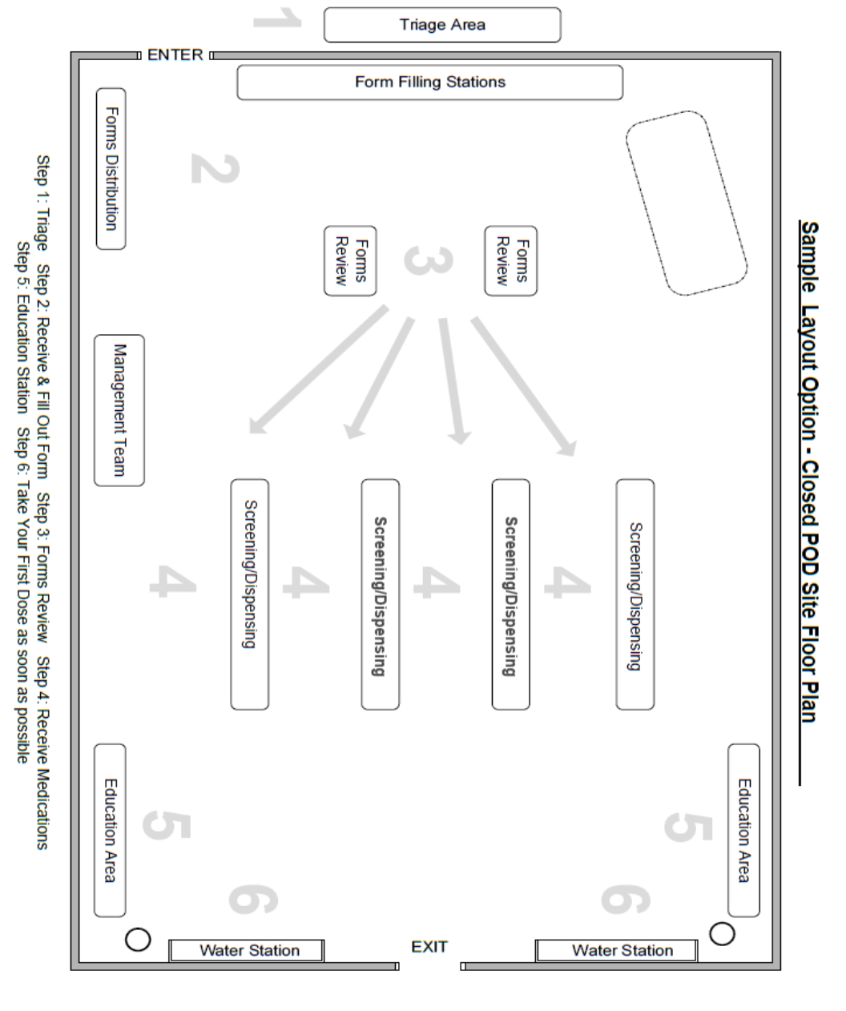
Notify staff that will be working at Closed POD when and where to report to work so they may assist in setting up tables and chairs at the Closed POD as needed. For an example of a Closed POD set-up see the diagram located below. If the Closed POD will be serving clients/residents who normally have medications administered to them by the dose, normal procedures for this may be followed after appropriate screening process is complete.

This diagram is located in the Closed POD Forms Book, Attachment 3.

General Area/Station Functions to set
up
*Not all area/stations may be used for all scenarios and some functions may be combined with others.
Triage Area: Triage area will be used to identify individuals with special needs and/or that are showing symptoms of the specific disease/agent and in need of medical treatment. Triage will also ensure that everyone who presents to the Closed POD is part of the target group.
Registration Area: Area where staff will receive any forms they will need to fill out and any other information they need to assist them while in the Closed POD.
Forms Area: Area where assistance will be provided as needed to complete forms and forms will be reviewed for completeness before going to screening.
Screening Area: Area where completed forms are screened to determine the appropriate medication for the individual(s) listed on the screening form.
Dispensing Area: Area where medication is labeled and dispensed.
Education Area: Appropriate education and/or printed materials will be provided based on scenario and treatment.
Mental/Behavioral Health Area: Area where Behavioral Health needs can be addressed if needed.
Staff Support Area: This area provides staff with the services they need during their shift. This includes food/beverage, rest areas, first aid, behavioral health and any other services deemed necessary to allow staff to perform their duties.
Supply Room: Location for storage and processing of all supplies and equipment needed to run the Closed POD.
Obtaining Medications for Closed POD
As the Closed POD is being set up, the courier will be ready to go to the LDN to pick up medications. This person’s identity, along with the make and model of their vehicle will have already been faxed or emailed to the LDN (following the initial notification). When they are dispatched to the LDN, they must bring a government issued photo ID along with the Medication Pick-up Authorization Letter (Closed POD Forms Book, Attachment 4), signed by a leader in the organization.

Section 4: Opening of Closed POD site
Once set-up is complete, and courier has returned with the medications/supplies, the Closed POD Coordinator, the Operations Chief, and the Logistics Chief should conduct a walkthrough of site to ensure everything is ready and there are no safety issues. Following the walkthrough, the Coordinator will conduct a staff briefing (see Closed POD Workforce Briefing Checklist below) and answer any questions the staff may have. When briefing is complete and all questions are answered the doors may be opened and dispensing operations may begin. Operations will continue until all persons covered in your plan have been accurately screened and given the appropriate prophylactic antibiotic along instructions. Note: all antibiotics dispensed must be labeled for the person they are intended for. See Forms Book, Attachment 22 for a Label template that can be copied and place on medication bottles. See Forms Book, Attachments 23 and 24 for labeling instructions and requirements.

Closed POD Workforce Briefing Checklist
This briefing will be conducted for all those working at Closed POD and should take no longer than 20 minutes. The Incident Commander (Closed POD Coordinator) or a delegate is responsible for conducting the briefing.
(this is a general outline, and may not be all inclusive)
Item | Subject | Completed
1 | Incident Overview (Why Closed POD plan has been activated)  - Describe the incident that precipitated the response effort  - Include information about location, population impacted  - Describe your role as a Closed POD Partner  - Use information from LPH/MDH to explain transmission risk, symptoms and treatment
2 | Scope of Operation (What has to be accomplished)  - Explain who will be served by this Closed POD  - Discuss the anticipated duration of Closed POD operations based on number of people you will serve  - Discuss tasks to be accomplished, including process to acquire medication supplies from LDN, MDH Registration forms, distribution of medication supplies
3 | Operating procedure (How this Closed POD will operate)  - Explain Closed POD set up and flow plan  - Describe each functional area of Closed POD and the purpose of it  - Identify leadership roles and who is filling what roles  - Describe process for communicating internally (among Closed POD workforce) and externally (workforce to household members)  - Describe process for breaks and shift changes
4 | Safety and Security (How Closed POD staff will be protected)  - Describe Personal Protective Equipment (PPE) requirements (if) identified by MDH/LPH  - Explain site security measures (e.g. requirement for ID)  - Identify steps Closed POD workforce should take if they observe someone who does not have a required ID  - Advise Closed POD workforce to report all suspicious activity to a supervisor
5 | Media & External Inquiries (Where to direct inquiries)  - Identify Lead Staff to whom Closed POD workforce should direct all inquiries (from media and others) about Closed POD operations, including requests made via phone or emails
6 | Job Specific Training (to explain duties in more details)  - Use job assignment and job action sheets to provide more detailed description of duties  - Explain who Closed POD workers should contact if they have questions while performing duties
7 | Other information determined at event
Section 5: Closing of Closed POD site (Demobilization)
When medications have been dispensed to all identified recipients and administration to clients is set up, Closed POD may be closed. Complete Closed POD Agency Closing Checklist (below).

Closed POD Agency Closing Checklist

Upon completion of Closed POD operation or notification of Agency Demobilization, the Incident Commander (Closed POD Coordinator) or Designee will complete the following procedures.

Item | Subject | Completed
1 | Notify Closed POD workforce of projected closing time
2 | Instruct Closed POD workforce to complete all remaining operational tasks
3 | Ensure all clients, staff and families (appropriate to your Closed POD Plan) have received medication and appropriate paperwork and instructions
4 | Notify LPH that your Closed POD operations are complete and closing
5 | Ensure unused medications are placed in secure location until they are returned to LDN/LPH
6 | Ensure all documentation has been completed including:  - Closed POD Workforce sign in/out sheet  - Inventory Tracking Sheet (Attachment 8)  - Closed POD Final Summary Form (Attachment 7)
7 | Ensure space used for Closed POD operations is cleaned up and in pre-Closed POD order
8 | Provide Closed POD workforce with final briefing including:  - Any updates from LPH or MDH  - Any anticipated follow up activities  - An opportunity to discuss things that went well and opportunities for improvement to add to Closed POD Plan
9 | Contact LPH – Closed POD Liaison to confirm procedure for returning unused medications
10 | Retain and store all completed documentation until further notice

