

City of Alexandria
Interim Report:
Mayor’s Pandemic Influenza Planning Working Group
(with appendices)

William D. Euille, Mayor
October, 2006

Acknowledgements

On the following pages is a list of the people throughout Alexandria who have participated in this planning process. They come from virtually every segment of our community, and one of the most exciting – and ultimately most beneficial – aspects of this planning process has been the wide range of participation. Some have already contributed enormous amounts of time and creativity. Others have volunteered for subject matter groups that are just beginning their most intense level of work.

Through a Center for Disease Control and Prevention grant, The George Washington University School of Public Health and Health Services has provided the services of Dr. Marina Moses, Project Leader, and Dr. John McNamara, Project Support. They have provided significant working support to many of the Subject Matter Groups.

There are remaining issues requiring attention, and many of the Groups are continuing to work as this interim report is being submitted. The generous on-going contributions of these people – and others who will join in the efforts – will help assure the City of Alexandria is ready.

Members of Mayor’s Working Group and Subject Matter Groups

Veronica Aberle, Alexandria Health Department
Carol Adcock-Stearns, City of Alexandria Information Technology
Major Tony Barrington, The Salvation Army
Christopher Bedwel, City of Alexandria General Services
Clark Beil, Virginia Department of Health
Rose Boyd, City of Alexandria Citizen Assistance
Greg Brison, Inova Alexandria
Martin Brown, Inova Alexandria Hospital
Kathy Bury, INOVA Alexandria Hospital
Lucy Caldwell, Virgnia Department of Health
John Clizbe, Alexandria Health Department
Melinda Douglas, City of Alexandria Public Defender’s Office
William D. Euille, Mayor, City of Alexandria
Michelle Evans, City of Alexandria Deputy City Manager
Francis Field MD, Assistant Chief Medical Examiner, Northern Virginia District
Craig Fifer, City of Alexandria Information Technology
Ludwig Gaines, City of Alexandria City Councilman
John Griggs, City of Alexandria Sheriff’s Office
The Honorable Donald Haddock, Alexandria Circuit Court
Dan Hanfling, Inova Hospital System
Brian Hannigan, City of Alexandria City Manager’s Office
Lori Hardin, Office of the Chief Medical Examiner, Commonwealth of Virginia
Ray Hazel, City of Alexandria Police Department
The Honorable Lisa Kemler, Alexandria Circuit Court
Kirk Kincannon, City of Alexandria Recreation Department
Elaine Lehr, Inova Alexandria Hospital
Eileen Longstreet, Senior Services of Alexandria
Rika Maeshiro, Public Health Advisory Council
JoAnn Maldonado, City of Alexandria Multicultural Services
Steve Mason, City of Alexandria City Manager’s Office
Dawn Matterness, American Red Cross
Angela Mattocks, EMS Council
Doug McCobb, City of Alexandria Transportation & Environmental Services
Derek McDaniel, ARHA
Charlie McRorie, City of Alexandria Emergency Management
Mary O’Donnell, City of Alexandria City Attorney’s Office
Raynard Owens, City Manager’s Office
Ignacio Pessoa, City of Alexandria City Attorney’s Office
Mark Penn, City of Alexandria Emergency Management
Peter Pennington, Volunteer
Jack Powers, City of Alexandria Human Services
Brad Pitzier, DASH
Jim Roberts, United Way of America, National Capital Region
Patricia Schubert, Neighborhood Assoc
Ed Semonian, City of Alexandria Circuit Court Clerk
Dibby Smith, Alexandria Health Department
Karen Snow, City of Alexandria City Attorney’s Office
Philip Smith, Residence Inn
Al Tierney, City of Alexandria Police Department
Robin Wallin, Alexandria City Public Schools
Vince Whitmore, City of Alexandria EMS
Liz Wixson, City of Alexandria Mental Health, Mental Retardation, aand Substance Abuse
Todd Wolfe, Funeral Director/DMORT III

Table of Contents
Page

- Executive Summary 1
- Interim Report 3
- Appendices – Subject Matter Reports
  - Communication with the Public A-1
  - Medical and Public Health Surge B-1
  - Isolation and Quarantine C-1
  - Fatality Management D-1
  - Alexandria Health Department E-1

Executive Summary
City of Alexandria Interim Pandemic Flu Planning Report
October, 2006

In the Fall of 2005, Mayor William Euille established a Working Group to plan for a possible influenza pandemic and its potential impact on the City of Alexandria. After a number of meetings, the Mayor’s Working Group formed several Subject Matter Groups, with the Health Department providing initial staff support. These Groups were to address specific issues such as communicating with the public, medical and public health surge, quarantine and isolation, fatality management, mass care, and continuity of services. The Subject Matter Groups reflected a range of public and private involvement, including representatives from key City Departments, the Circuit Court, neighborhood associations, non-profits, the hospital, the private medical community, volunteers, the mortuary association, the Medical Examiner’s office, business and the hospitality industry, community shelters, and others. The Alexandria City Public Schools is engaged in a parallel process.

Three key assumptions influence the work of these groups: (1) the challenge of pandemic flu or any other potential Public Health hazard is on-going and is constantly evolving, (2) potential Public Health emergencies are a challenge encompassing all elements of the City, and (3) the planning should be potentially applicable to a wide range of potential emergencies – i.e., “all hazards” in nature. This report summarizes the Subject Matter Groups’ findings and recommendations to date.

At the leading edge of issues – and crossing the work of all the Groups -- is the need to effectively and continually communicate with the public. This communication includes what to expect, how services might be impacted, what the City government is doing, and what individuals and families can do before and during a potential pandemic. Special communication challenges exist with people whose language, culture, physical attributes, or transitory stay in Alexandria make traditional methods of communication less effective. The plan includes a matrix of presentation modalities and potential forums to reach all the residents and visitors in Alexandria as well as organizations of which they are a part.

The Subject Matter Groups developed a number of innovative and quite comprehensive plans, procedures, and materials including:
- Brochures, posters, and pre-designed presentations in multiple languages and formats.
- Community Care Stations to diminish the impact of a pandemic on our medical care system with pre-hospital triage and support.
- Alternative Care Facilities to provide more medically-demanding care outside a hospital setting.
- A description of the roles, facilities, and procedures necessary to support the community if there are significantly more fatalities than usual.
- Legal and law enforcement procedures for an isolation and quarantine order with extensive involvement of the Circuit Court and legal community.
- Food, water, and medicine support for people unable to leave home.

Much has been accomplished with a solid foundation of preparedness. All groups also identified a range of “remaining issues” to be addressed that included a need for further refinement and implementation of plans, and planning for the continuity of services and infrastructure throughout the community. Staffing and financial challenges will persist, although some significant short-term financial grants have been obtained to assist.

This is an “interim” Plan in that it will continue to evolve as the work is refined and new information is acquired. As a City-wide initiative, the City can be better prepared not only for the possibility of an influenza pandemic but for other potential emergencies as well.

City of Alexandria
Interim Pandemic Flu Planning Report
October, 2006

UBackgroundU

In November, 2005, the Mayor, the City Manager, the Deputy City Manager, the Emergency Management Coordinator, and the Health Director met to begin formulating a planning process for a possible influenza pandemic. Shortly thereafter, an interim report was presented to City Council, and the Mayor initiated and convened a Mayor’s Pandemic Flu Working Group. This initial group included City officials involved in emergency planning and response and representatives from Inova Hospital. They met several times and decided to establish a number of Subject Matter Groups to focus on major topics of concern.

Most of the Subject Matter Groups have been meeting now for more than six months. More than sixty people have been engaged, representing not only City government, but also the hospital, citizen groups, neighborhoods, non-profits, business, volunteers, and others. They have generated some very comprehensive plans, often with creative ideas that have attracted interest throughout the state and the region. A Center for Disease Control and Prevention (“CDC”) grant to the Health Department made it possible for us to acquire the services of a team from George Washington University to help oversee the work of these groups. This report summarizes the much more lengthy complete reports from the groups included in Appendices.

Three key assumptions have been made in all of our planning:
- The challenge of pandemic flu or any other potential Public Health hazard is on-going and is constantly evolving – none of our planning can be static.
- Potential Public Health emergencies like a pandemic are a challenge encompassing all elements of the City.
- Excellent planning for a pandemic should strengthen our planning for virtually any kind of an emergency – the planning should be “all hazards” in nature.

UThe Subject Matter Groups U
- Communication with the Public (including Behavioral Health)
- Medical and Public Health Surge
- Isolation and Quarantine
- Fatality Management
- Liaison with Organizations
- Mass Care
- Continuity of Government and City-Wide Prioritization of Services
- Alexandria City Public Schools (formed through ACPS)
UCommunication with the PublicU

This Working Group’s plan is multi-faceted, using a comprehensive matrix of audiences and methodologies. The goal is to communicate with all people in Alexandria, with a special focus on communicating with Alexandria’s most vulnerable residents for whom traditional communications channels may be less viable. A special brochure, a number of posters to be placed around the City, and a pre-designed presentation applicable to many audiences have already been created. Sessions are being conducted by the Health Department to “train trainers” so that information can be widely disseminated.

Core Goals and Objectives
- Clearly explain and promote the Alexandria Pandemic Influenza Plan
- Provide information to the public and stakeholders to assist them in making the best possible decisions about their well-being before and during all phases of a pandemic or any other emergency.
- Establish a broad network for disseminating information.
- Provide clear, accurate messaging to all audiences.
- Communicate transparently, accurately and in a timely manner through a variety of methods to reach all audiences
Core Communications Strategy
- Unique communications for the stages of pandemic
- Multilingual and multiple distribution systems
Core Key Messages
- What the City of Alexandria is doing to reduce illness and death and minimize societal disruption
- What the general public can do
Core Methodologies
- Public forums and worksops
- Brochures (in multiple languages) and posters
- Group presentations and distributions (e.g., community meetings, businesses, associations, churches)
- MHMRSA, DHS, and Health Department distributions to clients
- City and Health Department Websites, City newsletter
- City festivals, fairs, and annual events
- Paid advertising/posters for public locales.
- Students delivering messages home
Remaining Issues
- Staffing, expand the train-the-trainer programs.
- Training: Medical Reserve Corps, pharmacy staff, workers for Community Care Sites and Alternative Care Facilities, hotline workers
- Develop materials for people with special language and physical requirements.
- Develop additional methodologies for communicating with people with limited or no access to traditional communication channels.
- Increase the capacity of the City hotline and training of hotline workers.
- Conduct a public workshop/forum
UMedical and Public Health Surge

There is the possibility that the hospital and private healthcare provider system could be overwhelmed if large numbers of people simultaneously become ill. This group was charged with evaluating and planning for this eventuality.

It is expected that many patients can be safely cared for at home. The availability of hospitalized services will be at a premium, so the focus will be made on limiting hospitalization to those truly requiring such care. The phased plan is based on Inova Alexandria Hospital’s very comprehensive plan for temporarily increasing its bed capacity in an emergency. The plan reflects strong preferences for (1) developing a spectrum of clinical care capabilities, and (2) providing truly needed hospital care in a hospital site rather than an alternative site if at all possible.
An innovative concept called Community Care Stations was developed. These are pre-hospital centers for assessment and triage located throughout the City. Individuals who think they have the flu can go to these stations for evaluation to determine whether hospitalization is needed. The Stations would be opened when the influenza pandemic is pervasive in Alexandria, and the hospital’s triage system is becoming overwhelmed. The Stations would help to keep the “worried well” out of the hospital emergency department. In most cases, individuals reporting to the CCS would be advised to continue self-care at home. They would be provided with some basic home healthcare supplies such as pain medication, a thermometer, hand sanitizer, and masks for the sick. Those individuals who met pre-determined criteria would be referred to the hospital.
Alternative Care Facilities, another kind of facility, would provide a more advanced level of care, although not as sophisticated as a hospital setting. They will be used primarily for the administration of antibiotics and IV rehydration, but would not accommodate a patient needing oxygen (an indication of a need for hospitalization). Another potential uses would be to move patients out of the hospital who need medical supervision but do not need hospital equipment. They could also be used for people who do not meet the criteria for hospitalization but are unable to manage home care.

Remaining Issues:
- Staff recruitment, training and facility identification need to be completed.
- Additional CDC funding has been acquired to support the Community Care Stations and a portion of one Alternative Care Facility, but significant additional funding will be required. Further planning is required.
- Alternative Care Facilities will require some medical professionals in attendance, and such staff will be in very short supply.
- Alternative Care Facilities raise significant potential liability issues.
- Completing communications plans which facilitate realistic patient expectations.
- Completing plans with other care facilities such as independent and assisted living facilities and with private practitioners

UIsolation and Quarantine U

Isolation – the separation of people who are already ill – will be a commonly encouraged practice in a pandemic. Quarantine – the separation of people who are not ill but have been exposed to an ill person – will be encouraged, but once a pandemic is fully occurring, quarantines are not likely to be effective. Most acts of isolation and quarantine will be voluntarily undertaken.

At the onset of a pandemic, however, there may be limited instances in which it will be important or necessary to place individuals in involuntary isolation or quarantine. Proper legal and other procedures that must be followed, and only the Commissioner of Public Health has the authority to issue such an order, but these procedures have rarely if ever been fully tested – especially under the new Virginia statutes.

The Isolation and Quarantine Subject Matter Group includes Circuit Court Judges, the Clerk of the Courts, hospital representative, the City Attorney’s office, local attorneys, City Information Technology representatives, local law enforcement, and Public Health nursing. The group has decided to test the isolation and quarantine system and procedures as a part of a state-wide pandemic drill in October. They have been coordinating their work with the Commonwealth’s Attorney General’s office as well as the Virginia Department of Health. They have already made some recommendations for possible Virginia statute and procedural changes.

A part of the plan includes establishing virtual courtrooms, allowing the potentially infectious subject person or family to remain away from the courtroom. Funding has been established to acquire the technology for one of these virtual courtrooms.

Remaining Issues
- Acquiring and testing the virtual courtroom.
- Potentially acquiring equipment to allow more than one such courtroom.
- Testing the legal and law enforcement procedures and processes, including electronic signature recognition of the Commissioner of Health’s signature.
- Identifying facilities for those challenging court orders
- Developing list of counsel to be appointed by courts for appellants.

UFatality Management

This Working Group has included the participation of a wide range of experts from mortuaries, the Office of the Chief Medical Examiner, Inova Alexandria Hospital, and an ethicist. Because the number of deaths in Alexandria due to a pandemic could well exceed the capacity of the existing system, it will be essential for all relevant City agencies and partners to work together in assisting with the management of fatalities as needed. This includes the Alexandria Health Department, the city police detective and forensic divisions, Emergency Medical Services, local mortuaries, physicians, hospitals, nursing homes, and religious leaders. The Subject Matter Group has created a very extensive plan identifying the kinds of roles that will need to be filled, as well as the other resources required.

Once a limited number of deaths have been attributed to the pandemic, the role of the Office of the Chief Medical Examiner is significantly reduced with pandemic-related deaths. The Office would continue to play its traditional consultative role, and would take the lead with any death occurring at a location under involuntary isolation or quarantine. Fundamentally, in most instances, it will be incumbent upon the deceased’s family to make necessary arrangements. The City will, however, have an important role in attempting to assure that resources and procedures are in place. These will include:
- Personnel to determine cause of death, assist with transportation, conduct mortuary activities, work in temporary facilities, and provide cemetery or crematorium services – personnel that may be in short supply.
- Procedures for dealing with transportation services if traditional means are not available.
- Identification of, and equipping, potential temporary facilities on a local or regional basis. Some possible facilities have been identified, but the necessary equipment and supplies are not in place.
- Training of first responders in what may be an extension of their traditional roles.
- Security of facilities.
- Plans for communicating with the public, especially if the situation makes it impossible for them to receive normally-expected assistance or for them to fulfill their traditional religious or cultural requirements.
- Mechanisms for providing behavioral health support.

Remaining Issues
- All of the above challenges need additional planning.
- Clear identification of who in the City has what specific responsibilities.
- Significant (currently non-existent) funding will be required to fully implement the plan.
- Individuals will need to be identified and trained in the roles described in the plan

ULiaison with Organizations

Rather than form a special Subject Matter Group, this task has been undertaken on an as-needed or as-invited basis. There has been a series of meetings with a range of organizations including small businesses, large housing complexes, neighborhood associations, a few religious organizations, and other community groups. Much work has also been done with some assisted living and similar facilities in the City.

The work being done by the Communications with the Public Subject Matter Group will be a major aid to this effort. Trainers will be taught to train others to make presentations, complementary hand-out material will be created, and presentations will be designed that can be easily applied in a variety of settings. Funding has been obtained to support the additional training, material-development, and outside support that will be required.

Remaining issues
- Continue the identification and “recruitment”, with the assistance of City leadership, of other organizational leaders and presenters
- Continue development of specialized materials and resources for targeted audiences, including persons with special needs, specific cultural groups, business organizations, and others.

UMass Care

In a pandemic, “Mass Care” is likely to be provided in ways that differ from more typical disasters. For example, traditional shelters are unnecessary. However, there are a number of potential situations in which the distribution of food, water, and other essentials may be required. This Subject Matter group has deliberately waited for the reports from other Subject Matter Groups before engaging in extensive planning. Now that the outlines of the reports have been received, this Group can begin its work more thoroughly.
- For those placed in involuntary isolation or quarantine, the City will be required to assure that they have necessary food, water, and medicine.
- For those voluntarily in isolation or quarantine, it is in the City’s best interest to make it possible for them to stay at home.
- The Community Care Stations will require some Mass Care support.
- The Alternative Care Facilities will require some Mass Care support.

UContinuity of Government and Prioritization of Services

It is an on-going process to seek to assure that essential government services continue in the face of a pandemic. Continuity of Operations (COOP) in a pandemic is both simpler and more challenging than with other potential emergencies. It is “simpler” because physical structures are not impacted. It is more challenging because essential human resources are potentially severely impacted. As general guidance, every City department must (1) prioritize and rank order all of its services, and (2) base their plans on the assumption that up to 40% of its workforce may be absent.

More broadly, it is also essential that the City prioritize all of its services – in effect, combining the inputs from all the departments. This will foster planning that could include moving people from one agency to another if necessary. In addition, while state and federal guidance will direct the overall prioritization of vaccine distribution, the City government will have to prioritize further within the broad guidance.

City government will also need to establish the decision-making process to be used if a pandemic occurs. For example, it is far preferable to determine in advance how decisions will be made, and by whom, concerning the closing of events or facilities.

Alexandria City Public Schools

The Alexandria City Public Schools are engaged in a comprehensive process of pandemic planning that includes both how, when, and if the system will deal with students and staff in a pandemic, and also how it will organize for a continuity of service with staff shortages. The report of the ACPS planning process is being generated separately.

Summary

There is no “conclusion” to the process of planning for a possible pandemic because much is unknowable until a particular strain arrives, and it is an on-going process with always more to be done. A great deal has been accomplished by a dedicated group of City staff, volunteers, and representatives of broad segments of the community.
- Plans have been created to address communicating with the public, preparing for a surge of patients exceeding the capacity of the health care system, managing the potential process of isolating and/or quarantining people, managing fatalities, managing the school system, and assuring the continuity of essential services.
- Plans of action have been submitted both to the state and federal government.
- Significant funding has been acquired that will help cover some of the future expenses.
- The plans strengthen the City’s preparations for “all hazards”.
- New working relationships have been fostered within the City that have a wealth of long-term advantages.
- Many of the plans are at a stage where they could be successfully implemented very quickly.

We also need to continue to move forward in a number of realms.
- Utilize grants from Centers for Disease Control and Urban Area Security Initiative to continue to strengthen City-wide readiness.
- A number of “communication with the public” plans need to be implemented.
- Physical settings, equipment, and staffing for “patient surge” need to be acquired.
- Lessons learned from testing the isolation and quarantine process will need to be implemented.
- The care of people staying at home presents major financial and logistical challenges.
- More work needs to be done to be ready to deal with potential fatalities.
- More outreach to community organizations needs to occur, especially focusing on the segments of our population that might be most vulnerable.
- Pockets of opportunity have been identified where additional funding could strengthen key City services.
- Planning for the continuity of City government and other essential community services will be continually on-going.
- The process and the criteria for making key City decisions in a pandemic require more deliberation.
Appendix A: Communication with the Public

Introduction

Effective and timely communication is critical before, during and after a pandemic
influenza. This report provides information about the role of communications and outlines the communication plans and all-hazards approach to public health preparedness that the City of Alexandria will use to provide timely, accurate and credible information to its staff, the public, state and federal governments, hospitals and other responding agencies.

Core Communications

The communication plan addresses a number of areas critical to successful public and stakeholder communications before, during and after a pandemic. The plan identifies core goals, objectives, strategies, key messages and audiences, key spokespersons, approval processes, media relations and evaluation common to all pandemic periods. It describes specific actions required during the pandemic alert, pandemic and post pandemic periods.
The information needs of internal, external and stakeholder audiences are assessed in each phase to prepare appropriate messages and information products, and determine strategies. Risk and crisis communications principles are incorporated in each phase.
This communication plan has been adapted from the Toronto Pandemic Influenza Plan (updated March 1, 2006) and adapted to the needs of the City of Alexandria with consideration of our partners in the community, health sectors and governments at all levels to ensure the common goal of improved readiness to protect the health of the population.

Core Goal (what we want to achieve)
• Clearly explain and promote the Alexandria Pandemic Influenza Plan
• Provide information to the public and stakeholders to assist them in making the best
possible decisions about their well-being during all phases of a pandemic

Core Objectives (how we intend to achieve our goal)
• Establish a broad network for disseminating information during all pandemic phases
• Provide clear, accurate messaging to all audiences during all pandemic phases
• Communicate transparently, accurately and in a timely manner through a variety of methods to reach all audiences

Core Communications Strategy
The pandemic communication strategy is broken down into three periods, corresponding to the phases of pandemic influenza outbreak as outlined by the WHO. The communication plan will evolve phase by phase, concurrently with the pandemic periods. Each phase or period has its own unique communications requirements. Communication products that are clearly understood, multilingual and available through multiple distribution systems will be developed for each period.

By following a phased-in approach, the communications needs of internal, external and stakeholder audiences can be anticipated and developed. A range of communication activities will be undertaken at each phase. The Pandemic phases as defined by the World Health Organization are:

• Pandemic Alert Period (phase 3, 4, 5)
• Pandemic Period (phase 6)
• Postpandemic Period

For more information or detailed definitions of the periods and the phases within the pandemic periods, please refer to the World Health Organization web site at Twww.who.int/en/T.

Core Key Messages
During a pandemic two main messages will need to be expressed:
• What the City of Alexandria is doing to reduce illness and death and minimize societal disruption
• What the public can do to reduce illness and death and minimize societal disruption
For example:
The Alexandria Health Department will continue to provide timely and helpful information and advice on how you can protect your health and what to do if you or others become ill.

Core Key Spokespersons
Each phase or period of a pandemic requires a primary spokesperson to ensure main messages are clear and aligned with those of other City divisions, governments or elected officials. The primary spokesperson for Alexandria Health Department during an Influenza Pandemic is the Health Director or designee. The Director of Communication for the City of Alexandria will coordinate media requests, verify appointed spokespersons, establish and build credibility for spokespersons and Alexandria Health Department and provide risk communications management and media training for key staff as needed. As the pandemic unfolds, key spokespersons may include the City Manager and the Mayor.

Core Information Approval Process
All Pandemic Influenza information issued by City of Alexandria will be approved by the Health Department Director or designee and the City Public Information Officer. Content development for information is the responsibility of:
• Health Department Director
• Supervisor of Communicable Disease Unit
• Health Department Emergency Planner
• Designated subject matter expert or manager
Information, key messages, backgrounders and fact sheets will be developed and pre-approved in advance whenever possible. When an emergency has been declared, the City of Alexandria information approval process will be revised based on the Incident Management System (IMS) and the requirements of the City's Emergency Operations Center (EOC).

Core Audiences
Internal to City Operations
• Mayor of Alexandria
• Members of Alexandria City Council
• City Department Directors
• City of Alexandria staff – (particularly those dealing with vulnerable populations), including Homes for the Aged, Children's Services, Schools, Daycare, Shelter, Support and Housing Administration, Social Services, Private Schools, Court Services, and those dealing with members of the general public
• Alexandria Health Department staff
• Hotline Center Staff
• Web and Internet Services
• Unions
• Human Resources, Occupational Health and Safety
• Emergency response and recovery workers

Partners
• Hospitals
• Health care professionals, including but not limited to: physicians, nurses, pharmacists,
dentists
• Community agencies and groups, e.g. homeless services, settlement and immigration
service providers, emergency shelter services, mental health agencies
• Other levels of government
• Other public health units
• Neighboring municipalities
• Police and Sheriff, Fire Departments, Emergency Medical Services
• Communication professionals in health care and other sectors
• Funeral industry
• Coroner's Office
• General Public - recognizing the varying social, cultural and linguistic needs of Alexandria's diverse communities
• Media – TV, Radio, Print, New Technology (e.g.,Internet), Multilingual
• Business, Trade & Industry
• Schools, Child Care Providers
• Colleges and Universities
• People with influenza and their caregivers
• People with chronic conditions and their caregivers
• Faith communities
• Volunteer agencies
• International community
• Visitors/tourist industry

Core Media Relations
The media will be essential to the delivery of timely information to the public during a pandemic. From school closings to hand-washing tips to health system status, news reports will be the primary source of information for the vast majority of residents. The media will also play a central role in shaping public reaction to the pandemic itself, as well as the public’s perception of how efficiently the City of Alexandria is responding to it.

The City of Alexandria will provide media with:
• A hotline phone number
• Access to credible spokespersons
• Accurate, consistent, timely and accessible information about the pandemic
• Details about what the City of Alexandria is doing (except where doing so would compromise safety and/or security)
• Information placed in context of state, regional, national, and global events
• Specific public health information about how people can protect themselves and
maintain health
• Quick response to rumors or inaccuracies
• Information that is consistent with that from federal and state governments,
hospitals and other responding agencies as appropriate

Media relations includes on-going media analysis, monitoring to identify trends and assist in determining strategy and response. In-depth analysis and evaluation will determine the degree to which communications efforts have met objectives, as will radio “Best & Worst Practices” discoveries from other pandemic flu regions/nations

Core Risk Communications
Appropriate risk communication considerations should be applied before, during and after a crisis. Effectively communicating complex, scientific or technical information can improve public responses to a serious crisis. The communication plan takes into account the following:
• Provide information that is relevant and easily understood
• Protect Alexandria credibility and reduce the chances of panic
• Don’t over-reassure
• Don’t underestimate risk
• Acknowledge uncertainty and change of circumstances
• Acknowledge people’s fears and pain
• Give people things to do to adjust to the new environment, such as how to keep in contact
• Give people a choice of actions to match their level of concern
• Promote awareness of the changed environment

Core Evaluation
Evaluation of the communications functions will improve program delivery and determine if communication is effective in meeting its objectives. The development of evaluation tools to gauge changes in attitudes, behaviors, knowledge, skills, status or levels of functions will be considered for each pandemic period. Key evaluation objectives and criteria of program success will be developed.

Evaluation activities will include monitoring of:
• Media Relations - Daily monitoring and analysis of media coverage will determine if strategy is working and if improvements are required. To facilitate lessons learned and evaluation of communications after the pandemic, copies of newspaper clippings and television/radio broadcasts will be saved. News conferences, briefings, major speeches will be taped.
• Web visits
• Hot line inquiries
- Comcast with the possibility of preemptive local edition
• Public presentations
• Requests for information

Pandemic Alert Period (Phases 3, 4, 5)

Pandemic Alert Goals
• Increase awareness of the Alexandria Pandemic Influenza Plan
• Raise awareness of the risks of pandemic influenza and the steps people can take to
minimize a pandemic influenza from spreading
• Determine, refine, prepare and test communications channels between Alexandria and its stakeholders

Pandemic Alert Objectives
• Release and promote the Alexandria Pandemic Influenza Plan and encourage
feedback
• Inform all people in Alexandria on public health preparedness, with an emphasis on vulnerable populations
• Develop social marketing campaign to encourage proactive responses and behavior
change to reduce spread of infection
• Integrate pandemic influenza communications with broader health, emergency and
corporate/divisional communications as well as federal and state communications
activities (annual influenza campaign, emergency response messages)
• Prepare audiences for imminent onset of pandemic, particularly during Phase 5

Pandemic Alert Strategies
Strategies during the pandemic alert period include using a variety of communication vehicles to raise awareness of what the Alexandria Health Department and the City of Alexandria are doing to prepare for a pandemic and what individuals, businesses and others can do to prepare.
• Dissemination of a brochure and training materials on pandemic flu preparations – a partial list of groups and organizations to be contacted is included in the Attachment (Outreach) to this report
• Presentations (and train the trainer sessions) to the public, health care workers, the Medical Reserve Corps, health care stakeholders, internal audiences, business sector in the forms of a summit
• Web site updates
• Emergency Notification System for ADH staff if required.
• Roam Secure system
• Dissemination of sector-specific Planning Guides
• Social marketing campaign on hand washing, cover your cough/sneeze, stay home when ill (to include multiple ways to disseminate information)
• City FYI, including updates from Health Director to all residents with pandemic preparedness messages possibly combined with other important health messages such as smog, sun safety, West Nile Virus, heat safety, pesticide reduction
• Possible mail or other media inserts with hand washing/cover your cough messages
• Pandemic preparedness messages included with other VDH program messages to expand reach of communications channels
• Multilingual displays on infection control procedures developed for a variety of audiences, e.g. child care, schools, workplaces
• Coordination with Alexandria Public Schools to disseminate public health preparedness information to families of students through existing communication channels (i.e., ‘back pack mail’)
• Ad campaign for major shopping malls
• Video and public service announcement on infection control procedures developed for
physicians' offices, hospitals, elevators, schools
• Video and public service announcement on infection control procedures, video billboards
• Call center recorded messaging on pandemic information
• Newspaper ad campaign
• Pandemic Hotline

Pandemic Alert Key Messages
Key messages during the Pandemic Alert Period will focus on strategies in place to prepare for a pandemic, specifically how the Alexandria Health Department and the City of Alexandria are building response capacity in all program areas. Key messages will inform the public about the situation and what they can do to protect themselves. The most effective thing you and your family may be able to do is to stay home for up to two weeks. Prepare now, “don’t forget the flu supplies.”

• The City of Alexandria is preparing for a pandemic
• All city departments have prepared pandemic response plans
• Businesses need to be prepared - we can help you plan
• You can prepare too
• Wash your hands
• Cover your cough
• Stay home if you are ill

Pandemic Alert Media Relations
The central message in the pandemic alert period focuses on planning and preparedness. The City is taking the risk of a pandemic seriously and is planning accordingly. The City website remains a source of information on the pandemic and regular influenza for reporters. The Alexandria Health Department will also work with the media to deliver its annual messages about flu shots and clinics. A dedicated pandemic influenza media hotline may be necessary. AHD staff dedicated to pandemic influenza communications and provided with the latest information would respond to calls. This would provide one-stop shopping for reporters and help ensure accurate, timely and consistent messages from AHD. A dedicated line would also free up the regular media lines for requests not related to the pandemic.

Pandemic Alert Risk Communications
During the pandemic alert period communications will focus on the following pro-active actions and strategies:
• Establish credible, trustworthy AHD spokesperson
• Consider and address each audience's needs and concerns (such as deportation)
• Prioritize development of messages for each audience
• Ensure message is free from jargon, provides realistic advice and is easy to translate
• Use clear and effective graphics and design
• Consider audience education, current subject knowledge, experience, age, language
spoken/read, cultural norms, belief systems, socio-economic status and geographical location. One size has to fit mostly all

Pandemic Alert Evaluation
Evaluation and feedback mechanisms will be built into communications vehicles whenever possible. Materials will be focus-group tested when possible. Strategies used to meet the goals and objectives will be reviewed. Overall effectiveness of communications plan will be assessed. Telephone inquiries at all call centers, web site visits, event attendance, media coverage, correspondence will be measured. A communications summary report will identify benefits, costs and program changes prior to the next phase.

Pandemic Period (Phase 6)

Pandemic Period Goals
• Reduce death and illness associated with sustained transmission of a new and virulent
strain of influenza in the general population
• Minimize societal and economic disruption
• Communicate the changing City organization during a Phase 6 pandemic period, including the activation of Emergency Operations Centers

Pandemic Period Objectives
• Clarify the roles and responsibilities concerning decision-making authority and how
decisions will be communicated
• Outline ongoing surveillance activities
• Communicate the importance of continuing with stringent infection control measures and other public health measures
• Communicate the symptoms of illness and notify health partners, the media and the public, especially seniors, long-term care providers, schools and vulnerable populations
• Announce changes in levels of City and Health Department services.

Pandemic Period Strategies
The strategy during pandemic period Phase 6 will be to assist the public in coping with the pandemic influenza. This includes an explanation of what to expect during this phase of sustained transmission in the general population, including altering behaviors and changes in services for all audiences - internal, external and stakeholders.
The internal strategy requires a clear explanation of what to expect when the Alexandria Emergency Operations Center has been activated. Details about the Incident Management System (IMS) and the roles and responsibilities of the Health Director, the Public Health Incident Manager and the Public Information and Liaison functions will have been communicated to staff and to the media.

The communications resources of all City divisions may be required to provide a comprehensive range of products and services. All divisions will be responsible to ensure residents and businesses are kept apprised of developments during the pandemic period, including any changes to the provision of City services and any major actions required. The City of Alexandria will play a critical role in delivering public information in the event of a pandemic. Hotlines serve as a primary information service on behalf of the City. Hotline capacity will be expanded during an emergency to respond to increased call volumes. The official City of Alexandria Web Site will feature a direct link to pandemic information and will be updated regularly. Stakeholder communication includes ensuring a timely exchange of information between the city departments and sharing relevant information with all stakeholders.

Potential Actions include:
• Communications to staff - voicemail, e-mail, hotline, secure intranet site for
management of overall AHD response, including staff reassignments
• Notification of reduction of services and possible alternatives (e.g. for trash collection)
• Promote official guidelines and recommendations
• Coordination of time, location, protocols for media briefings, staff
meetings, teleconferences
• Updates and information exchange with hospitals and health partners
• Update of web posting
• Posters, notifications on public buildings
• Direct mail campaign – support campaign to encourage prompt self-diagnosis
• Electronic and video billboards
• Transit messaging (Ch 70)
• Phone messaging through the City’s Emergency Notifications Service (TENS)

Pandemic Period Key Messages
Medical interventions such as vaccines and antiviral drugs will not be available for everyone. Messages will provide information about the distribution and specific things people should know or be doing to minimize risk and maintain health. For example:
• Alexandria Health Department is responsible for the distribution and administration of vaccine and antiviral medication in Alexandria. Priority groups have been established federally for the distribution of vaccine and antiviral medication
• Alexandria has a planned approach to reach the priority groups (with details on
how people can obtain vaccine or antiviral medication)
• Updated information on the number of cases (confirmed, suspected and potential)
• Identification of which government level is responsible for which key decisions, programs, services
• Self-imposed isolation information to protect people from unnecessary exposure
• Infection Control Measures continue – hand washing, "cover your cough" messages
• Business continuity messages (could include health precautions in the workplace,
screening, environmental cleaning)
• How to stay healthy at home and at work
• Self diagnosis – symptoms and prevention
• Self treatment – what to do if you or your family get sick
• When to seek medical attention - list and degree of symptoms
• How to seek medical attention - where to go, protocol on how to enter hospital or
medical center
• Caring for the seriously ill
• Death at home - what to do next
• Bereavement counseling and support messages
• Where to go for non medical help – child care, pets, food
• Assess and publicize the current impact on Alexandria, including reduction of programs
• Detailed information for health professionals
• Acknowledge and thank internal, external and key stakeholders for their efforts
and cooperation
• Advise staff on appropriate personal protection

Pandemic Period Information Approval Process
During a pandemic period, the information approval process becomes coordinated through the Emergency Management Coordinating Council. If the communication relates to Public Health issues, the Health Director or his designee is the approving authority. Approval of AHD messages is the responsibility of the AHD Incident Manager and the Health Director or designate. If the matter relates to other City services and policies, the message is to be approved by the City Public Information Officer. The responsibility for preparing and releasing information to the public falls
under the Public Information function of the Incident Management System.

Pandemic Period Audience
Particular focus and messages will be crafted for:
• People who are sick
• People who are taking care of people who are sick
• City staff
• Federal, provincial governments
• International audience
• Business community
• Hospitals
• Other health partners

Pandemic Period Media Relations
The media are a prime transmitter of communication and information. They play a critical role in setting agendas and in determining outcomes. The pace of media relations will accelerate significantly once the pandemic period begins. Messages to the public and staff, businesses and governments and the international community about the situation in the region (difficult to differentiate Alexandria from rest of region) will be delivered through the media. Examples of some of the communication products include: news releases, fact sheets, backgrounders, brochures, speaking notes, TV and radio ad scripts.

Once an emergency has been declared and the Incident Management System has been
implemented, the responsibility for the Alexandria Health Department communication strategy shifts to the Public Information function under the Public Health Incident Manager. TV briefings will be held regularly on Channel 70. Timing will depend on when state and federal conferences take place. The Health Director or designee will update the public health aspect of the pandemic’s impact on Alexandria. A communicable disease expert will be needed to provide clinical updates.

The Mayor, Health Director, EMS, Police and other agencies may be part of the media
conferences. There may be a need for joint conferences with hospitals and other agencies, such as school boards, and senior government officials. Media relations staff may be required to be on call late into the evening and possibly around the clock.

Pandemic Period Risk Communications
This period will involve a highly complex information environment. Communicating catastrophic news and helping people learn to cope with trauma and uncertainty requires attention to the following:
• Assessing the environment in which information is being introduced
• Understanding the public's attitude toward the situation
• Acknowledging and attempt to contain public anxiety, grief and distress
• Dealing with resistance to accept change
• Recognizing and acknowledging anger and frustration
• Keeping up with changes in decision making
• Addressing worry and concern

Postpandemic Period

Postpandemic Goals
• Declare end of emergency operations
• Address public health needs, including grief and post-traumatic stress counseling
• Provide information on the re-establishment of essential public health services
• Acknowledge contribution of all stakeholders and staff

Postpandemic Objectives
• Join with other stakeholders in public announcements to show comprehensive approach
• Publicly address community emotions after pandemic
• Make people aware of uncertainties associated with subsequent waves
• Prepare for transfer of responsibilities from Alexandria Emergency Operation Center
back to Alexandria Health Department
• Request and advocate for recovery assistance as required

Postpandemic Strategies
The strategy during this period is to help people move toward hope for the future through actions they can take and through the actions of all responders to the pandemic. Tactics that support the Alexandria Health Department strategy for recovery may include:
• Official announcement of end to emergency measures
• Communication to residents and staff regarding the social and economic recovery plans
• Announcements and notifications of gradual restoration of services
• Continued promotion of key health messages - infection control procedures
• Information about possible relapse
• Posters on public buildings
• Healthy City social marketing campaign with appropriate partners
• Direct mail campaign

Postpandemic Key Messages
Key messages will inform the public of plans for the gradual return of services. The focus is on recovery and rebuilding. Key messages include:
• Alexandria is recovering from the pandemic
• We are all adjusting to a changed environment
• This has been a difficult time for everyone
• Alexandria Health Department will help you and your family
• Recovery means that residents can again access some of the best public health programs
and services in the world - services are increasing
• AHD continues to implement improvements in emergency planning
• AHD is working closely with partners, stakeholders and the community to
improve capacity for community outreach after the pandemic
• AHD continues to work with businesses to help with recovery efforts
• Final death toll, other statistics
• Remembrance messaging

Postpandemic Media Relations
Once the pandemic ends, the media relations focus will shift to analysis and follow-up. Reports to the Health Director and senior government officials on the pandemic’s impact on Alexandria and the City response would be natural sources of further media interest. Recommendations for improvements, along with the associated issues of budgets and staffing, will also be a focus in this phase.

Postpandemic Risk Communications
During the postpandemic period, risk communications will focus on the significant emotional needs of those who have been most affected by the pandemic. Understanding and being sensitive to the emotional and physical impact and the permanent life changes for individuals and organizations will help shape the tone of all communication. Key messages will:
• Acknowledge failures or mistakes
• Be a role model by showing a willingness to carry on
• Help people regain a sense of control by giving them reasonable choices
• Work with the community towards solution

Postpandemic Evaluation
Evaluation of communications in the postpandemic period is an opportunity to review information about how functions and responsibilities have been carried out. It will document the progress made on meeting communications requirements and expectations during each pandemic period. An overall evaluation report will help identify effective and ineffective services, practices and approaches. By reviewing the communications strategies, tactics and actions Alexandria Health Department can develop improved service delivery and determine future objectives for other programs. The evaluation of communications will likely be part of a larger evaluation report on the pandemic
response. Evaluating the effectiveness of communications response and reviewing lessons learned will guide future actions.
Attachment

Outreach

ORGANIZATIONS (listed as of 9/15/06)

Agenda Alexandria
Alexandria Black & Hispanic Concerned Women
Alexandria Chamber of Commerce
Alexandria Chapter of the American Red Cross
Alexandria Federation of Civic Associations
Alexandria Host Lions Club
Alexandria Hotel Association
Alexandria Jaycees
Alexandria League of Women Voters
Alexandria NAACP
Alexandria Public Health Advisory Commission
Alexandria Resident Council
American Association of Retired Persons
Animal Welfare League of Alexandria
Arlandria – ANHSI
Arlandria – Arlandria Community Center/Tenants and Workers United
Bienvenidos
Casey Clinic
Community Partners for Children
Department Heads of all City Departments
DHS/Job Link/Companion Provider clients
Eisenhower Avenue Public Private Partnership
Faith Based Community
Health Department/Casey patients
Hispanic Committee of Virginia
Hopkins House
Inner City Civic Association
INOVA Alexandria Hospital
King Street Metro Enterprise Team
MHMRSA consumers
Northern Virginia Urban League
Optimist Club of Alexandria
Potomac West Business Association
Queen Street Clinic
Scout Leaders
Tenants and Workers Support Committee
West End Business Association

GROUPS (listed as of 9/15/06)

Members of the Mayor’s Pan Flu Working Groups
Parades or Events where a stand might be considered
Arlandria – General Community
Hispanic citizens – Radio: El Sol and La Mega/Newspapers: El Pregonero and La Nacion
Masonic Temple
Media
Medical Reserve Corps
Neighborhood and Homeowner Associations
Non-English speaking parents – In-home child care providers
Non-English speaking parents – Northern Virginia Family Services
Non-English speaking parents – Parents of school children
NVCC
Other non-English speaking persons – Alexandria Multicultural Coalition, Sudanese American Council, Eritrean Group, etc.
Pharmacies
Private medical community
Private Schools
Public Housing – Charles Houston Rec. Center and ARHA
Stalls and running Seminars – Alexandria Emergency Preparedness Day (Families and Businesses)
Shelter residents – Carpenters, ALIVE and ACS
Stand Farmer’s Market – Families
Stand Libraries – Various groups
Talk Agenda Arlington – Home Owners
West End – Apartment buildings (Foxchase, Landmark, Essex House, Beatley Library, etc)
West End – General Community

Appendix B: Medical and Public Health Surge
Agreed Tasks:
  - Identify specific facilities and alternative sites to be used for surge
  - Staffing plan identifying specific sources of people to staff these facilities
  - Equipment identification and specification for facilities
  - Create triage plan for (1) hospital overflow, (2) non-hospitalized medical care, (3) medical evaluation
Identification of Specific Facilities and Alternative Sites to be Used for Surge
The Medical and Public Health Surge Committee, after some discussion, came to the conclusion that setting up hospital-like facilities outside of the hospital would be very difficult and inefficient given the resources that are required. If true hospital staff and equipment are required, it is easier and more effective to utilize the hospital itself if at all possible. The committee developed the innovative concept of a Community Care Station (CCS) and Alternate Care Facilities (ACF) to address the greater needs of Alexandria. The relationship between the CCS, ACF and the hospital would be following:
Community Care
Station
Alternative Care
Facility
Hospital
Home
Home
Home

Community Care Stations
CCS’s are centers for assessment and triage, which could be established in many types of public health emergency. In the case of pandemic influenza, CCSs would be locations where those individuals who think they have the flu can go for evaluation to determine whether hospitalization is needed. They would be opened when the influenza pandemic has spread to Alexandria, and the hospital’s triage system is becoming overwhelmed. They would help to keep the “worried well” out of the hospital emergency department.
In most cases, individuals reporting to the CCS would be advised to continue self-care at home. Staff at the CCS would follow pre-established criteria for recommending hospital vs. home care, based on guidelines from the Centers for Disease Control (CDC) and the Virginia Department of Health. Each patient entering the CCS would be given a self evaluation form, available in multiple languages, to complete. They would then have the following evaluations done:
  - Vital signs (including temperature)
  - Pulse oximetry
  - Symptom assessment (symptoms will be listed on the self evaluation, and will include cough, fever, gastrointestinal symptoms, “body aches”, difficulty breathing. The symptom list will be based on CDC guidelines.)
  - Potential exposure to others who are ill with the pandemic influenza, either through travel to affected areas or local contact.
Individuals who meet certain pre-determined criteria on these evaluations, such as the need for ventilatory support or oxygen, would be advised to go to the hospital, with transportation provided if indicated. All others would be given a “Take Home Flu Kit”, which would contain instructions for self care and when to return to the CCS, a thermometer (possibly a forehead thermometer strip), some sample over-the-counter medication like acetaminophen, surgical masks to be worn by the ill person, and hand sanitizer.
Presumptive criteria for hospitalization of the individual will be based on current CDC recommendations, but will likely include:
Fever > 100.4 F.
Pulse oximetry of < 90% on room air
Evidence of dyspnea

Location of Community Care Stations:
Potential CSSs could include neighborhood pharmacies and supermarkets, such as those which provide seasonal flu shot administration. Specific sites will be determined pending further discussions with the business community. There would be multiple CSSs spread throughout the community, staffed by non-medical volunteers who have been trained in the criteria. Individual cases of influenza will be spread out over weeks to months, so it is not anticipated that large numbers of people would report to any single CSS on any given day.
Supplies & Equipment for CCS
Each site would require the following supplies and equipment:
2 Electronic thermometers and covers
table and 4 chairs
2 pulse oximeters
flu kits (disposable thermometer, tissues, hand sanitizer, surgical mask)
hand sanitizer
tissues
paper towels
disinfectant
flu prevention and care instructions
record keeping supplies
surgical masks.
Flu Kits $1.66 each. 30,000 or enough for one half of Alexandria’s households would be $50,000.
Each CCS with supplies for 4000 visits $2,000. Add 4000 flu kits and the price of a CCS is $8,500.
Alternate Care Facilities:
There will be some individuals who do not meet the criteria for hospitalization but are unable to manage home care. These could include homeless individuals, people in crowded living conditions, tourists, and people who have no family or friends to assist them. There may also be a need for people who were hospitalized with influenza who were discharged to make room in the hospital and still need some level of medical supervision (and perhaps isolation), but no longer require ventilatory or oxygen support or other acute care. Meals would be provided.
Alternate Care Facilities would be opened when the hospital is employing its surge plan, moving patients out of the hospital to make room for new admissions. The Health Director will determine if opening this type of facility is warranted, and will decide on the location of the site(s) based on a number of factors. The opening of the facilities will be dependent on adequate staff. The following sites have been identified as examples of potential Alternate Care Facilities, although their suitability and availability will be contingent on a number of factors:
- NVCC Schlessinger Center and Tyler Building
- Minnie Howard Ninth Grade School
- Bishop Ireton Catholic High School
- St. Mary’s Catholic Elementary School
- Charles Houston Recreation Center
- Mount Vernon Community Center
- Cora Kelly Recreation Center.
SUPPLYING AND STAFFING AN ALTERNATIVE CARE SITE (add reference)
Supply Options

It is unlikely that a hospital or alternative care site will have much of the equipment necessary to provide care or support patient quarantine in the event of surge. The following list provided by could be used to either augment hospital capacity or supply an alternative care site at varying levels.

Hospital Augmentation Cache – approximately $20,000*

Hospital Augmentation Cache: 50 Patients
Item | Number | Cost Each Item | Total
Disaster/surge capacity trailer | 1 | 10,000 | 10,000
Patient cots | 45 | 50 | 2250
Patient cots, with wheels, collapsible | 10 | 250 | 2500
Linens  Sheets (2 per patient + extras)  Blankets  Pillows (disposable – case of 15)  Pillow cases | 150  75  4  100 | 4.56  13.5  43.2  1.14 | 684  1012.50  172.80  114
N95 masks (case of 210) | 1 | 98 | 98
Gloves  Latex Free Exam – small (case of 1000)  Latex Free Exam – medium (case of 1000)  Latex Free Exam – large (case of 1000)  Powder Free Exam – small (case of 1000)  Powder Free Exam – medium (case of 1000)  Powder Free Exam – large (case of 1000) | 1  1  1  1  1  1 | 36  36  38.34  37.55  37.55  39 | 36  36  38.34  37.55  37.55  39
Gowns (for staff – splash resistant – case of 12) | 10 | 39 | 390
Bag-valve-mask respirators | 10 | 11 | 110
Blood pressure cuffs (manual) | 5 | 40 | 200
Stethoscopes | 10 | 35 | 350
IV Poles | 25 | 60 | 1500
TOTAL – equipment costs |  | 19646.74

This level of cache was recently funded by the Denver Health Medical Center and is being put in place as a regional resource.

Staffing Plan Identifying Specific Sources of People to Staff Facilities
Community Care Stations:
During an influenza pandemic, professional staff and volunteers will be at a premium. Public Health Nurses and volunteer professionals will be needed for monitoring those placed on home isolation and/or quarantine, and for providing vaccine as it becomes available. The hospital may also need to utilize volunteer staff as their employees fall ill. Creating CSSs to evaluate patients would effectively move flu triage out of the hospital emergency department, thereby easing some of the demand on the hospital. The committee proposes staffing the CCS with non-professional personnel, who would follow pre-established protocols in deciding who should be sent to the hospital for treatment. The volunteers would be able to consult with a health care professional, either at the hospital or the Health Department, by telephone if necessary. In addition, the committee proposes that each pharmacy or retail outlet identify a specific employee to oversee the CCS.
The committee recommends identifying a minimum of 50 individuals to staff the CCS facilities. Individuals will work between 8 – 12 hour shifts and will be identified from the following groups:
- School Parent/Teacher Associations
- Medical Reserve Corps
- AARP
- Community Associations.
- CERT
A two hour orientation session for potential staff will need to b conducted.
Alternate Care Facilities:
In order for a facility to open, the hospital management and public health will need to coordinate efforts. The level of care needed will require some hospital staff (e.g., 1 doctor and 5 nurses), who are experienced in acute illness care. The hospital-provided medical and nursing staff would take leadership of the ACF, with support provided by volunteers, both health professionals and other staff; and public health nurses as available. Opening of the Alternate Care Facilities will be dependent on adequate hospital staffing.
Action items:

- Funding sources
- Staffing and training
- Site locations and commitment of business community
- Public information plan
- Meals for patients and staff
- Identification of additional potential sites for Community Care Stations and Alternative Care Facilities

Appendix C: Isolation and Quarantine

General Information

This document outlines the City of Alexandria Health Department’s strategy for invoking and enforcing the voluntary and involuntary isolation and quarantine of diagnosed and suspected cases and contacts known or suspected of being infected with a contagious illness, or having been exposed to a communicable disease of public health threat.

Planning and Plan Maintenance - This plan will be updated minimally annually and supplemented as Federal, State and local isolation and quarantine plans and guidance evolves. Plan changes will be made based on evidence, experience and lessons learned.

Training and Exercises – The City of Alexandria Health Department and partner agencies and personnel with the responsibility of activating and implementing the Isolation and Quarantine Plan should receive initial and annual training on this plan. The plan should be exercised at least once every three years. Exercises will be planned and executed by the Alexandria Health Department.

Mission

The responsibility of the City of Alexandria Health Department in the control of a communicable disease of public health threat is to ensure that all persons who are suspected of having the disease are identified, evaluated and measures implemented as appropriate to educate on risk, control spread and insure that treatment is initiated and completed if indicated and available. Other responsibilities include performing epidemiologic investigations to identify the source or sources of infection; providing law enforcement with evidence in their investigations; informing decision makers (e.g., Office of the Mayor and City Manager, Office of Epidemiology, the Commissioner of Health, and the Governor); ensuring timely and accurate communication of disease risk and prevention information to the public; and, as ordered by the Commissioner, overseeing and monitoring patient compliance with Orders of Isolation, Orders of Quarantine, and/or Emergency Detention Orders.

Authority

In April 2004, the General Assembly and the Governor of Virginia enacted House Bill 1483 that amended Chapter 2 of Title 32.1 of the Code of Virginia to increase the Commonwealth’s ability to respond to serious public health threats to its citizens. Among the issues addressed were the specific details on the use of isolation and quarantine for the control of communicable diseases of public health threat. In November 2004, pursuant to its authority under Chapter 2 of Title 32.1 (Section 32.1-42) of the Code of Virginia to promulgate regulations and orders to prevent a potential emergency caused by a disease dangerous to the public health, the Commonwealth of Virginia Board of Health issued emergency regulations on isolation and quarantine.

The State Commissioner of Health is the executive officer for the State Board of Health with the authority of the board when it is not in session, and has the authority to require quarantine, isolation, immunization, decontamination or treatment of any individual or group of individuals when necessary to control the spread of any disease of public health importance. District Health Directors are responsible for the surveillance and investigation of illnesses of public health importance that occur in their jurisdiction. In cooperation with the State Health Commissioner, they are responsible for instituting measures for disease control, which may include implementing the quarantine and isolation orders of the State Health Commissioner.
Although the powers granted to the State Health Commissioner pursuant to Article 3.02 (Sect. 32.1-48.05 et seq.) of Chapter 2 Title 32.1 of the Code of Virginia may not be delegated to the District Health Department Director, many of the activities at the local and district level related to the control of a disease of public health threat will be overseen by the District Health Director per section C of 12VAC 5-90-40.
If a communicable disease of public health threat occurs, and exceptional circumstances are present that may make the measures under Article 3.01 inadequate to control the spread of the disease, then the provisions of Article 3.02 (including isolation and quarantine) may be implemented by the State Health Commissioner. Exceptional circumstances that may warrant implementing Article 3.02 of chapter 2 of Title 32.1 of the Code of Virginia may depend on:
- Known or suspected risk factors of the infection;
- The potential magnitude of the effect of the disease on the health and welfare of the public;
- The extent of voluntary compliance with public health recommendations;
- The experience of other areas (including states and countries) in the control of the disease; and
- Characteristics of the disease-causing organism, including:
  - Virulence
  - Routes of Transmission
  - Incubation period
  - Period of communicability
  - Degree of contact necessary for transmission
  - Minimum infectious dose
  - Efficiency of transmission by asymptomatic persons
  - Rapidity of disease spread
  - The potential for extensive disease spread\efficacy of control measures
  - The existence and availability of demonstrated effective treatment

Where these conditions exist, the provisions enable the State Health Commissioner to initiate a more rapid response to a communicable disease by:
    - Issuing orders to immediately isolate an infected or potentially infected person;
    - Issuing orders to immediately quarantine exposed or potentially exposed persons;
    - Issuing orders to isolate and/or quarantine individuals as a group through defining an “affected area” (when a State of Emergency has been declared by the Governor for the affected area)

Isolation is the restriction of movement of an individual infected with a communicable disease in order to prevent the transmission of the disease to uninfected individuals. Quarantine, a concept closely related but distinct from isolation, is the physical separation of an individual who may have been exposed to a communicable disease but who does not yet show signs or symptoms of infection, in order to prevent or limit the transmission of the communicable disease to unexposed and uninfected individuals. Isolation and/or quarantine may be recommended measures, or they may be required by the state to protect its citizens, especially when individuals fail to adequately follow disease control recommendations voluntarily.

Virginia’s Communicable Disease of Public Health Threat Regulations include the following sections of interest:

Section Points of Interest
12 VAC 5-90-20 Authority of the Board of Health to promulgate regulations to control disease.

12 VAC 5-90-40 Authority of the State Health Commissioner to require quarantine, isolation, immunization, decontamination or treatment of any individual or group of individuals to control the spread of disease.

12 VAC 5-90-90 Requirements for physicians, directors of laboratories and persons in charge of medical facilities for disease reporting.

12 VAC 5-90-100 Authority for District Health Directors to perform contact tracing for persons with communicable diseases and recommend appropriate control measures. Methods for application of Article 3.02 of the Code of Virginia if voluntary compliance or Article 3.01 are unlikely to be effective.

12 VAC 5-90-105 Methods of isolation for a communicable disease of public health threat, including application, documentation, means, delivery, enforcement, health status monitoring, essential needs and release.

12 VAC 5-90-110 Methods of quarantine for a communicable disease of public health threat, including application, documentation, means, delivery, enforcement, health status monitoring, essential needs and release.

Of note, since diseases of public health threat are a subset of communicable diseases of public health significance, some methods that are available for managing diseases of public health threat are not outlined under Article 3.02 of Chapter 2 of Title 32.1 of the Code of Virginia or in Regulations are still available for District Health Directors. These include issuing an order to appear for counseling to determine the individual’s ability and willingness to comply with a voluntary isolation or quarantine request, or an order to appear for outpatient therapy. However if these measures fail then the authority for issuing mandatory orders (e.g. orders of Isolation, Order of Quarantine, Emergency Detention Order) rests with the State Health Commissioner

The Commonwealth of Virginia State Board of Health Regulations for Disease Reporting and Control are available on-line at: Thttp://www.vdh.virginia.gov/epi/regs.aspT.

Note that the State Laws and Regulations maybe supplemented by provisions of local health codes.

II. ORGANIZATION AND ASSIGNMENT OF RESPONSIBILITIES

Isolation and Quarantine Team

In order to effectively and efficiently manage the isolation and/or quarantine of individuals infected with, or exposed to, a disease of public health threat, the City of Alexandria Health Department has chosen to establish a multi-agency, multi-disciplinary Isolation and Quarantine Team to ensure adequate planning, training and response to address a disease of public health threat emergency. Team members may be called upon to play important roles in the response during a real event. This Isolation and Quarantine Team will work with the Epidemiology Policy and Response Teams to ensure adequate planning and training to address communicable diseases of public health threat.

The Alexandria Health Department will chair the Isolation and Quarantine Team and will have the primary responsibility for communicating with other community stakeholders, including INOVA Alexandria Hospital. Members of the City of Alexandria Health Department Isolation and Quarantine Team may include:
- Alexandria Health Department staff;
- Representatives from area healthcare facilities;
- Representatives of local law enforcement;
- Representatives of local EMS;
- Local emergency management officials;
- The VDEM Regional Coordinator
- The local chapter of the American Red Cross;
- Representatives from the City of Alexandria’s Medical Reserve Corp (MRC)
- Representatives from the Community Emergency Response Team (CERT)
- Representatives from the Office of the Commonwealth’s Attorney
- Representatives from the Office of the City Attorney
- Representatives from the Alexandria Circuit Court
- Volunteer groups

III. ADMINISTRATION AND LOGISTICS

Organization of the Response

While a very small disease outbreak may be managed locally, the potential for some diseases to spread quickly and cause large numbers of casualties requires that control must be undertaken rapidly and efficiently. With rare exceptions, the Virginia Department of Health (VDH) would activate a response organization using the Incident Command System (ICS) to control and mitigate the emergency. The City of Alexandria Isolation and Quarantine Team will work with the Alexandria Health Department/VDH in controlling the emergency.

Orders of Isolation/Orders of Quarantine and Emergency Detention Orders

In the event that an individual does not comply with voluntary isolation or quarantine, or that the risk of non-compliance may pose a hazard to the public health, the Alexandria Health Director or his/her designee will work with the Office of Epidemiology to present the facts to the State Health Commissioner for preparing an Order of Isolation or an Order of Quarantine. The State Health Commissioner will consult with the Alexandria Health Director, the VDH Office of Epidemiology and other appropriate state offices in determining that voluntary isolation or quarantine was not effective. Upon finding that involuntary isolation or quarantine is necessary, the Office of Epidemiology will prepare for the State Health Commissioner’s review and signature the Order(s) of Isolation, Quarantine, and/or Emergency Detention Orders.

IV. CONCEPT OF OPERATIONS

Personnel Requirements During A DoPHT Outbreak

In the event of a disease of public health threat (DoPHT) outbreak, individuals who are placed on isolation or quarantine in their own homes will require at least daily compliance monitoring by Health Department staff. This will be accomplished by a variety of methods and will be based on the size of the outbreak and the number of individuals ordered into isolation or quarantine. Some of the general methods of compliance monitoring will include daily home visits by health department staff members or daily telephone checks, or Community Care Stations (see Medical and Public Health Surge appendix) for monitoring health status of those not sick enough to be hospitalized and for the dispensing of medication, or intermittent “drive- by” by police or a combination of above. The District Health Director will decide the methods ultimately chosen and implemented in collaboration with the Office of Epidemiology.

Planning and implementation will be flexible and scalable, in order to respond appropriately to the size and nature of the outbreak. The following general guidelines will apply, however, subject to the review and approval of the District Health Director:

Small Scale Outbreak (less than 10 isolated/quarantined patients):

  - Members of the District Health Department staff may make daily home visits and /or phone calls to monitor compliance in person or by telephone.

  - If additional staff is needed, the District Health Director will re-assign professional staff from within the Health Department or may request the Regional Epidemiologist to provide assistance to the District Epidemiologist. Additional administrative assistance will be obtained from within the department and will be used to monitor phone banks or to input data into the computer databases.

  - The AHD will activate appropriate communication systems such as a “hotline” and dedicate AHD staff/ MRC volunteers to man the phones to answer questions that the public may have regarding the disease/outbreak. The City and AHD website will be kept updated with current information for the public on prevention and self-care activities. Phone bank staff will be provided with prepared messages to present to the public with accurate information regarding the scope of the outbreak; signs and symptoms of the disease; and preventive actions the public may take to avoid exposure or contracting the disease. Blast FAX may be utilized to communicate with local physicians and Inova Alexandria Hospital.

Medium Scale Outbreak (greater than 10/less than 50 isolated or quarantined patients):

- Any staff on vacation will be recalled; all staff vacations and days off will be canceled.

- The Health Director will assess programs/patient services that must be continued during the emergency, based on the Alexandria Health Department Continuity of Operations Plan. All other programs/projects will be temporarily suspended and patients will be transferred to other agencies, turned over to an emergency/volunteer caregiver, or discharged if appropriate.

- All Health Department staff will report to their assigned workstations .

- All available staff will be assigned to one of three task force teams. Team One will coordinate and oversee monitoring of isolated/quarantined individuals. Team Two will oversee and coordinate contact tracing activities and monitoring of contacts for signs and symptoms of illness. Team Three will focus on communication and maintaining administrative services; staff the telephones, enter data, revise messages, update website and assist with the administrative/clerical duties as required. The Health Director will assign one management team/staff member to serve as the team leader for each of the three teams.

- The Health Director, or his/her designee, will hold daily meetings for team leaders and management personnel to allow updated information to be disseminated and to plan the day’s activities.

- Ancillary staff/volunteers will be utilized to assist with documentation, manning telephones and data input.

- Professional staff/volunteers will be tasked to assist the District Epidemiologist with monitoring and contact tracing activities.

- The District Health Director may request activation of the Alexandria Medical Reserve Corps (MRC) to assist Health Department staff during the DoPHT emergency. MRC personnel will be used to assist with the daily monitoring activities, which may include making home visits or telephone contact with isolated/quarantined patients or serve to open and man Community Care Stations. Mutual aid from surrounding Health Districts will be requested, if needed.

- The Health Director will request additional assistance, if required, from the VDH ECC.

Large Scale Outbreak (greater than 50 isolation/quarantine patients):

- The Health Director will activate the department’s emergency response plan.

- The Health Director, or his/her designee, will gather information and prepare to brief the VDH Office of Epidemiology and/or Commissioner of Health.

- The Health Director will request that local emergency management officials activate the City’s Emergency Operations Center which would then serve as the primary modality for intra-City department communication.

- All staff on vacation will be recalled; all staff vacations and days off will be canceled. Staff will be placed on a 24-hour workday schedule, including an overnight shift which will be planned and staffed.

- All programs/patient services will be temporarily suspended and patients may be transferred to other agencies, turned over to emergency caregivers, or discharged if appropriate.

- All Health Department staff will report to their assigned workstations.

- All available staff will be assigned into one of four task force teams. Team One will coordinate and oversee monitoring of isolated/quarantined patients and Community Care Stations if open. Team Two will oversee and coordinate contact tracing activities and monitoring of contacts for signs and symptoms of illness. Team Three will man the telephones, enter data, and assist with administrative/clerical duties as required. Team Four will work the night shift and will staff the emergency hotline overnight, complete data entry and prepare materials for the next day. The Health Director will assign one Health Department management team member to serve as the team leader for each of the four teams.

- The Health Director/ or his/her designee will hold daily briefings for team leaders and management personnel to allow updated information to be disseminated and activities coordinated.

- Ancillary staff will be utilized to assist with communications, documentation, manning telephones, website update, translation, blast fax and data input.

- Professional staff will be asked to assist the District Epidemiologist with monitoring and contact tracing activities.

- The District Health Director may request activation of the Alexandria Medical Reserve Corps to assist Health Department staff during the DoPHT emergency. The MRC personnel will be used to assist with the daily monitoring activities, which may include making home visits or telephone contact with isolated/quarantined patients or the opening and staffing of Community Care Stations.

- Mutual aid from surrounding Health, Districts, and Regional Office will be requested if needed. The Health Director will request additional personnel assistance through the VDH ECC, utilizing the VDH Emergency Mobilization Plan.

- Federal assistance requests will be made in accordance with established policy and procedure through the city’s emergency management office and Emergency Operation Centers and the Virginia Emergency Operations Center.

Isolation/Quarantine in Home or Residence

Whenever possible, individuals will be voluntarily isolated or quarantined in their homes or residence. When the individual’s residence is used as the location for isolation/quarantine, the Alexandria Health Department, through its epidemiological team, will ensure regular contact monitoring consistent with the epidemiology of the disease.

Isolation/Quarantine in Healthcare Facilities

Where involuntary isolation/quarantine of an individual is necessary, the nearest community hospital with appropriate, available isolation rooms will be used, after first contacting the hospital’s Administrator on call. The INOVA Alexandria Administrator on Call’s phone number is (703) 504-3000 and ask them to page administrator on call.

Isolation of Family Members

The isolation or quarantine of an individual may cause the separation of families or significant others. As a result, some individuals who are well and unexposed may wish to remain with the isolated or quarantined individual to provide care.
Individuals who choose to remain with persons under isolation or quarantine may do so, but should receive counseling on the potential risk, protective measures and their responsibilities, as well as contact information for the Alexandria Health Department.

Procedure For Implementing Voluntary Isolation Or Quarantine

The Alexandria Health Director or his/her designee will be notified of all confirmed or suspected DoPHT cases.

- Upon receipt of such notice the Alexandria Health Director or his/her designee will ensure that members of the Alexandria Health Department staff conduct a case follow-up as per established policy and procedure.
- The findings of the follow-up will be documented and reported to the Alexandria Health Director or his/her designee in accordance with established policy and procedure. If a DoPHT is confirmed, the Alexandria Health Director or his/her designee must be notified immediately.

- On finding that there is sufficient evidence that a case of a DoPHT may be present, the Alexandria Health Director will contact the Division of Surveillance and Investigation (DSI) of the Office of Epidemiology in the regional or central office to coordinate consultation on the case and the methods to control the disease, including the need for isolation or quarantine of the case and/or contacts and the degree of compliance expected based on what is known about the individual.

- Upon finding that there is sufficient evidence that one or more cases of a communicable disease of public health threat may be present, AHD Health Director & the Office of Epidemiology will consult with the State Health Commissioner, who will decide the level of isolation or quarantine to be invoked. At this stage the potential need for Orders of Isolation or Quarantine, and the potential need for Emergency Detention Orders, will be considered.

- Where isolation or quarantine is deemed necessary, all individuals will be asked to voluntarily accept and comply with the isolation and or quarantine decision. The Alexandria Health Director will provide a written request for voluntary isolation or quarantine to appropriate cases and/or contacts that includes specific information on the reason, the measures to be taken to prevent disease spread, the duration and location of restricted activities, the plans for monitoring the health status and compliance of the individual, as well as the potential consequences if the conditions of the request are violated. General information about isolation and quarantine may also be provided. Additional information about the disease that the individual has or may have contracted (e.g., disease-specific fact sheets) may be provided. The benefits and consequences of non-compliance with isolation or quarantine may be reviewed with the individual to facilitate understanding, including that:
- A delay in initiating isolation/quarantine could result in more individuals (including family, friends, etc) being exposed to and contracting the disease;
- Movement of the individual from place to place may be necessary (e.g., for testing, detention, hearings), thereby increasing the risk of spread of infection;
- The individual may need to be moved to an isolation or quarantine site which may be less comfortable and provide fewer amenities; and,
- A delay in treatment may result in a greater severity of long-term effects for the individual.

- The Alexandria Health Director must ensure that the individual fully understands the benefits and consequences of non-compliance. The individual’s ability to speak and understand instructions, including their comprehension of English, their reading level, the presence of a hearing, speech, or learning disability or other factor that may affect compliance will be considered. To maximize compliance, whenever possible, Alexandria Health Department staff will accommodate patient beliefs and needs in planning. Tele-interpreters, 711 Phone Service (for hearing/speech impaired), e-mail or visual education methods may be needed to promote understanding. Differences between traditional practices and expected health practices may need to be considered, but issues that are not negotiable must be clearly defined.

- If a hospitalized individual requiring isolation is too ill or otherwise unable to understand the isolation requirement, Alexandria Health Department staff should contact the appropriate medical decision maker for that patient to convey the information. The Alexandria Health Department staff should reinforce the isolation and any quarantine (e.g., for staff) requirements and instructions with the hospital infection control practitioner (ICP).

- The level of isolation or quarantine invoked will be the least restrictive measures that achieve the purpose of preventing the transmission of communicable disease. This will be discussed and decided in collaboration with the Division of Surveillance and Investigation (DSI) of the Office of Epidemiology in the regional or central office.

- In general, the preferred location for isolation/quarantine will be the individual’s place of residence, or some other residence. Isolation or quarantine in a home setting is most appropriate when:
- Hospital care or other highly skilled medical care is not needed;
- A low-to-moderate stringency of isolation/quarantine is effective in limiting spread;
- Home isolation/quarantine is acceptable to the contact and family/caregivers;
- A stable residential “home base” is available;
- Daily contact (by phone or in-person, as merited) with nursing or other VDH personnel can be maintained;
- Transport to a medical facility in a timely fashion is available, as needed.

However, not every residence will be suitable for isolation or quarantine. A home assessment may be conducted to ensure adequate resources are available to the individual.

- The District Health Director or his/her designee will document in writing the rationale for invoking isolation and quarantine and the risks associated with not invoking such action, as well as the proposed location of isolation/quarantine and forward this information, along with their request for voluntary isolation and/or quarantine to the Office of Epidemiology - DSI.

- In cases where individuals can be isolated or quarantined in their own homes, the Alexandria Health Director will ensure that the individual is monitored regularly (e.g., daily or more frequently if required) by the Alexandria Health Department epidemiological isolation and quarantine team staff for the development or progression of signs or symptoms of disease, as well as for compliance and to see that the essential needs of the individual are being met. The severity of disease, the scope of the outbreak and the number of staff available to monitor individuals under isolation/quarantine will determine the methods used to ensure compliance. These methods could include daily phone calls, physical visits, videophone calls, etc. In general, phone-based monitoring is preferable to home visits (less intrusive, more cost-effective); however, combined methods (e.g., enhancing phone-based monitoring with random home visits) may improve compliance. The Alexandria Health Director in collaboration with staff members from the Division of Surveillance and Investigation (DSI) of the Office of Epidemiology will determine the appropriate follow-up schedule for each individual. The Alexandria Health Department will work with community resources to assist individuals isolated or quarantined in their homes in obtaining the necessary assistance to meet their essential needs (food shopping, medical appointments, etc.).

- The isolation or quarantine of an individual may cause the separation of members of families or significant others. As a result, some individuals who are well and unexposed may wish to remain with the isolated or quarantined individuals to provide care. These individuals may also need to be considered as contacts, monitored appropriately and placed under quarantine. As a result, individuals who choose to remain with persons under isolation or quarantine should receive counseling on the potential risk, protective measures and their responsibilities. In addition, these individuals should receive education on the proper use of personal protective equipment and disease-specific infection control practices. Documentation should be made of their recognition of the risk of illness due to voluntary exposure and the acceptance of the potential need to be placed in quarantine or isolation as a result (as authorized by Sect. 32.1-48.07 of the Code of Virginia)

- Quarantine of premises may be ordered by the Alexandria Health Director upon provision of notice that the premises will be closed until disinfecting and/or is safe for reoccupation.

- All follow-up contacts will be documented in accordance with established policy and procedure. If Alexandria Health Department staff is unable to contact the individual or if there is an apparent non-compliance with the request for voluntary isolation or quarantine, the staff will carefully document their findings and notify the Alexandria Health Director or his/her designee immediately. In these cases the Alexandria Health Director will seek Orders of Isolation, Orders of Quarantine and/or Emergency Detention Orders to ensure compliance by the contact/case.

- All staff members who may be required to make direct visitations with the isolated/quarantined individual will receive additional information regarding the required levels of personal protective equipment that must be utilized to safely interact with the individual. Personal protective equipment supplies will be made readily available to all staff and will include but not be limited to the following: appropriate respiratory protection, eye protection, impervious gowns, examination gloves and waterless soap.

Involuntary Orders of Isolation, Quarantine or Emergency Detention Orders

Every effort will be made to convince an individual to comply with the voluntary isolation or quarantine request of the Health Director. In the event that voluntary isolation or quarantine is not effective, the Alexandria Health Director will collaborate with the Office of Epidemiology and the State Health Commissioner to obtain an Order of Isolation, Order of Quarantine. The State Health Commissioner can issue one “blanket” order of Isolation or Quarantine for a geographic area (but not for a specific building).

Procedure for Obtaining an Order of Isolation or Quarantine

  - In the event that an individual does not comply with voluntary isolation and quarantine, the Alexandria Health Director or his/her designee will work with the Central Office Division of Surveillance and Investigation to present the facts to the State Health Commissioner for preparing an Order of Isolation or an Order of Quarantine.

  - The Alexandria Health Director, in addition to informing public health staff of the need for isolation or quarantine, will also notify, as appropriate:
- Office of the City Attorney or the Office of the Commonwealth’s Attorney
- Hospitals and healthcare providers
- Emergency medical services (EMS)
- Local law enforcement (Police Department that has jurisdiction over where the individual lives, Police Department that has jurisdiction over where the individual will be isolated/quarantine [if different] and Sheriff’s Department);
- Circuit Court Clerk
- Local media

Note: The disclosure of protected health information should be done only as absolutely necessary and should be the minimum information necessary to ensure the successful delivery of the orders and the safety of the public.

  - In considering an Order, so that a complete record may be compiled, the State Health
Commissioner will require that documentation be submitted or available related to:
- The examination of the case(s) or contact(s);
- The signs and symptoms of disease in the case(s) or contact(s);
- The laboratory test results annexed to the physicians report;
- The suspicion or confirmation by a licensed physician that the individual is infected or reasonably suspected of being infected with the communicable disease of public health threat;
- The exposure, or reasonable suspicion of exposure, to a case or situation where the communicable disease of public health threat may have been acquired;
- Specific exceptional circumstances that make isolation or quarantine necessary;
- The Alexandria Health Director’s consultations (e.g., documented in the record, e-mails, etc) with the central office as to the most appropriate measure of control and that the need for isolation and quarantine is agreed upon to protect the public health;
- Attempts at gaining voluntary cooperation and the individual’s refusal, or his/her agreement to comply with isolation and quarantine and evidence of non-compliance with voluntary measures, if applicable;
- Counseling provided on the importance of complying with voluntary isolation or quarantine through direct verbal communication;
- Written communication stating the public health benefits of compliance and the consequences of non-compliance;
- Any additional steps taken by the Alexandria Health Department or other parties to support the individual’s compliance with voluntary isolation or quarantine;
- The proposed site of involuntary isolation or quarantine, as well as the methods to be used to monitor the individual and to enforce compliance; and
- Available documentation that the proposed methods are considered to be the least restrictive means available that will effectively protect the public health.

4. The Office of Epidemiology will prepare for the State Health Commissioner’s review and signature the Order of Isolation or Quarantine. This order will contain sufficient information to:
- Identify the person subject to the order;
- Identify the site of isolation or quarantine;
- Specify the date and time that the order takes effect;
- Identify the communicable disease of public health threat or the suspected communicable disease of public health threat;
- Specify the basis for the order, including the exceptional circumstances that exist and the need for isolation or quarantine to contain the transmission of the disease;
- Specify the necessary restrictions on activities, and any conditions of the order;
- Provide the duration of isolation or quarantine period, and conditions for termination of the order;
- Provide timely opportunities, if not readily available under the circumstances, for the person or persons who are subject to the order to notify employers, next of kin or legally authorized representatives and the attorneys of their choice of the situation;
- Specify the penalty or penalties that may be imposed for noncompliance with the order;
- Include a copy of § 32.1-48.010 or § 32.1-48.013 of Chapter 2 of Title 32.1 of the Code of Virginia, to inform any person or persons subject to an Order of Isolation or Quarantine (respectively) of the right to seek judicial review of the order;
- Identify persons, including health care professionals, who are authorized to enter the premises of isolation or quarantine; and
- For an Order of Isolation or Quarantine for an affected area, a clear definition of the geographic parameters.

For an Order of Isolation, the duration of effect shall be consistent with the known period of communicability of the communicable disease of public health threat or, if the course of the disease is unknown or uncertain, for a period anticipated as being consistent with the period of communicability of other similar infectious agents.

For an Order of Quarantine, the duration of effect will be consistent with the known incubation period of the communicable disease of public health threat or, if the incubation period is unknown or uncertain, for a period anticipated as being consistent with the incubation period for other similar infectious agents.

Delivery of an Order of Isolation or Quarantine

1. An employee of the Alexandria Health Department or another person so chosen by the Alexandria Health Department shall deliver the Order. The Order of Isolation or Quarantine cannot be delivered by a member of local law enforcement (either sheriff or police office) or a party to the case or a person interested in the subject matter of the case. See Va. Code ξ 8,01-925 abd 15,201704, However, law enforcement officer may serve a temporary or emergency order of detention under Va. Code ξ 37.2-808 or 809. The Order should be delivered to the individual subject to the Order (or if necessary to an adult family member or legal guardian or the responsible owner of a companion animal). Law enforcement officials may accompany person serving order. The Alexandria Health Department employee if practicable answers or appropriately refers medical questions that the subject of the order may have. The Alexandria Health Director or his/her designee will ensure that the individual serving the order and/or public health personnel are informed of the potential risk of exposure to a communicable disease and have the appropriate information and personal protective equipment necessary to safely serve the Order.

2. If necessary and practicable if the individual who is the subject of the Order does not speak English, an interpreter should accompany the person delivering the Order.

3. Upon delivery of the Order, the Order will be reviewed with the individual to the extent necessary and practicable, and he/she will be notified that he/she has the right to the following:
      - The right to appeal the Order to and have a hearing in the Alexandria Circuit Court
  - The appeal must be in writing and state the reasons that the Order is being challenged.
  - The appeal must be served on the State Health Commissioner or his/her legal representative.
  - The appeal can be filed and served by the patient
  - The appeal shall be heard by the Court within 48 hours or two business days after the appeal has been filed
  - The appeal does not stay the Order, i.e. the Order remains in place until the Court has heard the matter
      - The right to counsel
  - If the patient cannot afford counsel, the Court will appoint counsel
  - If the patient has legal counsel, then he or she will have the opportunity to contact that counsel for assistance
      - The right to participate in Court and confront all witnesses, if practicableS

4. The original Order should be given to the individual subject to the Order. A copy of the Order should be signed by the individual and maintained on file by the Health Department.

Extension of an Order of Isolation or Quarantine

      - An Order of Isolation may be extended if, in the opinion of the State Health Commissioner, the rationale for the initial Order remains valid (e.g., the individual is infected with a disease of public health threat, exceptional circumstances continue to exist, voluntary compliance is unlikely, etc.). The extension would take the form of a new Order of Isolation, and would be subject to the same process (including ex parte review, appeal, etc.) as the original Order.

      - An Order of Quarantine may need to be extended if, in the opinion of the State Health Commissioner, the rationale for the initial Order has changed (e.g., the incubation period for the disease of public health threat is found to be longer than previously known, the individual has been exposed to a new case of the communicable disease of public health threat, etc.). The extension would take the form of a new Order of Quarantine, and would be subject to the same process (including ex parte review, appeal, etc.) as the original Order.

Amendment of an Order of Isolation or Quarantine

If there is a small change to an Order, such as a change in incubation period, the Commissioner could amend the Order rather than seeking a new Order.

Communication of an Order of Isolation or Quarantine

1. If the State Health Commissioner determines that the number of persons subject to Orders are too great to make timely delivery to each person then the he/she shall cause the Orders to be communicated to the individuals in the affected areas, through print, radio, television, internet and/or other available means (e.g., reverse 911) to those affected, or other means as necessary. (Virginia Code § 32.1-48.09 (C))

2. These method(s) of communication also have to provide individuals subject to the Orders with a copy of § 32.1-48.13 or § 32.1-48.10 (as appropriate) of Chapter 2 of Title 32.1 of the Code of Virginia, and/or direct individuals to a location, a website, or publication such as a newspaper, where they may obtain this information.

Isolation or Quarantine in a Location Other Than a Private Residence

If an Order of Isolation or Quarantine specifies the place of confinement as a location other than a place of residence, such as a healthcare facility, hotel, jail, etc., then the individual subject to the order will be transported by local law enforcement to the appropriate site for admission as directed by the Order. The Alexandria Health Director or his/her designee will notify the person in charge of the facility about the health order and the anticipated arrival of the individual to be isolated or quarantined.

Placement in Isolation

Upon determining that any quarantined individual is reasonably believed to have become infected with a communicable disease of public health threat, the infected individual shall be promptly removed from quarantine and placed in isolation. This requires that an Order of Isolation be prepared and signed by the State Health Commissioner. The Alexandria Health Department will forward this information to the Office of Epidemiology as soon as possible so that an Order of Isolation can be prepared for the Commissioner’s review and signature.

Circuit Court Ex Parte Review of an Order of Isolation and Quarantine

1. As soon as practicable following the issuance of an Order of Isolation or Quarantine, the State Health Commissioner will work with the Attorney General’s OfficeTPPT to file a petition in the circuit court for the city or county in which the individual or individuals reside (or in the case of an affected area, in the circuit court of the affected jurisdiction or jurisdictions) seeking ex parte review and confirmation/extension of the orders. The Code of Virginia provides that a petition shall be filed in the circuit court where the person resides. See Va. Codeξ 32.1-48.012. However, this provision must be interpreted where the person is located, i.e. If an Alexandria resident is on vacation in Virginia Beach or Williamsburg, he/she shall be isolated or quarantined where he/she is located at time of isolation/quarantine.
The petition shall include:
- A copy of the Order or all information contained in the State Health Commissioner's Order of Isolation or Quarantine in some other format and
- A summary of the findings that the State Health Commissioner relied upon in deciding to issue the Order of Isolation or Quarantine.

Pertinent basic medical information resources should be available in the event that the judge requires further information concerning the communicable disease of public health threat.

The State Health Commissioner will consider which parts, if any, of the Order should be filed under seal to prevent public disclosure of the information that could exacerbate the public health threat or compromise a criminal investigation or national security.

- The Circuit Court shall review the Order of Isolation or Quarantine ex parte, giving due deference to the specialized expertise of the State Health Commissioner.

- Upon a finding of probable cause that isolation or quarantine is the necessary means to contain the disease, the judge shall sign the Order for Isolation or Quarantine to confirm or extend. The Order for Isolation or Quarantine shall be implemented in the least restrictive environment necessary. If the Commissioner does not meet the burden of probable cause, the Judge shall issue and/an Order to Terminate the Order of for Isolation or Quarantine if she/she wishes to vacate the Order. However, in the event the Judge issues an Order to Terminate or Vacate the Order for Isolation or quarantine, the Order shall remain in effect to allow the Commissioner to file an appeal to Circuit Court.

- The Circuit Court shall, if requested by the Alexandria Health Department, after reviewing the information submitted to it, reseal the relevant materials to the extent necessary to protect public health and safety.

- The Circuit Court clerk’s office shall follow the legally-required processes to forward a signed copy of either the confirmed Order of Isolation or Quarantine or Order to Terminate the Order of Isolation or Quarantine to the patient and the Alexandria Health Department.

Appeal of an Order of Isolation or Quarantine

1. Any individual subject to an Order of Isolation or Quarantine may file an appeal of the Order, in writing, in the circuit court for the city or county in which the individual subject to the Order resides. Individuals subject to an Order of Isolation or Quarantine applied to an affected area may file an appeal of the Order in the circuit court for the jurisdiction or jurisdictions for any affected area.

Note that the submission of an appeal of an Order of Isolation or Quarantine DOES NOT stay the order – the Order remains effective until the court renders a decision based upon the appeal.

- Upon receipt of an appeal from an Order the Circuit Court clerk’s office should either prepare service of the appeal or ensure that service considerations have been made by the individual subject to the Order on the State Health Commissioner or his legal representative.

- The Circuit Court clerk’s office may appoint counsel if needed. (See Attachment __ for a list of available counsel.)

- The Circuit Court clerk’s office may make arrangements for interpretation services to be provided, if needed.

5. The Circuit Court clerk’s office shall docket the appeal for a hearing within 48 hours of the appeal being filed. If the 48-hour period terminates on a Saturday, Sunday, or legal holiday or day on which the Court is lawfully closed, the hearing shall be held on the next day that is not a Saturday, Sunday, legal holiday or day on which the Court is lawfully closed. In extraordinary circumstances, the State Health Commissioner may request a continuance of the hearing.

- The State Health Commissioner, or his/her representative, shall submit a copy of the Order of Isolation or Quarantine together with a record of supporting documents and memoranda to the Court.

- Prior to the court hearing, the State Health Commissioner will coordinate with the Alexandria Health Director, the Health Department’s legal representative and the consulting physician to ensure that the following are properly documented and available, including:
- Information on the disease, including the agent, how it is transmitted, the known or suspected incubation period, the known or expected duration of illness and communicability, and treatment and/or prevention options;
- Evidence that demonstrates the need for the Order of Isolation or Quarantine (e.g., medical records indicating infection with the agent, documentation that voluntary isolation or quarantine failed);
- Evidence that isolation or quarantine are necessary and are in the least restrictive environment necessary to control the spread of the disease of public health threat; and
- Information demonstrating that VDH can provide or coordinate adequate care and treatment for the individual placed in isolation or quarantine.

- At an appeal hearing, expert testimony regarding the disease will be necessary. This will most likely require the involvement of Alexandria Health Department staff with knowledge of the facts. As a result, the Alexandria Health Director, as well as members of the Alexandria Health Department staff, may be required to attend the court hearing to testify to the need for isolation or quarantine of the individual. The State Health Commissioner, or his/her representative, may be required to attend the court hearing. Additional VDH staff may also need to appear in court to provide testimony that supports the need for isolation and quarantine.

Expert witness (health director or other expert witness) shall testify:
- Explain the disease;
- what causes it, how it progresses, how it is transmitted how it is cured, incubation period, how its is managed and prevented;
- review patient’s record, conclusions and recommendations (medical records are not subject to hearsay under Va. Code ξ 8.01-390)

Fact Witness (health department staff member or other ) shall testify:
- Provide evidence that voluntary compliance was unsuccessful
- That the Order of Isolation or Quarantine is the least restrictive means necessary.

- The Court may, on the motion of any party or on the Court’s own motion, consolidate the cases in a single proceeding for all appeals when there are common questions of law or fact relating to the individual claims or rights to be determined; the claims of the consolidated cases are substantially similar; and all parties to the appeals will be adequately represented in the consolidation. If a continuance is requested by the State Health Commissioner, the Court shall only grant the continuance after giving due regard to the rights of the affected individuals, the protection of public health and safety, the severity of the emergency and the availability of witnesses and evidence.

- If the State Health Commissioner desires a continuance of an appeal hearing he/she must petition the Circuit Court. The State Health Commissioner should provide specific facts as to why the request is being made and should be approved by the Court. If a continuance is requested by the State Health Commissioner, the Court shall only grant the continuance after giving due regard to the rights of the affected individuals, the protection of public health and safety, the severity of the emergency and the availability of witnesses and evidence.

- Courts shall conduct the hearings on appeals of Orders in a manner that will protect the health and safety of court personnel, counsels, witnesses and the general public. The locality shall pay for personal protection equipment for the court and city employees. The Alexandria Health Director or his/her designee will notify the Court of the necessary infection control precautions that will be needed during the hearing. Depending on the nature of the disease, the Alexandria Health Director may recommend to the Circuit Court that the hearing not take place in person. As a result, the Circuit Court may decide to use an audio- or video-linked court appearance, rather than a personal appearance. The Court must make arrangements to allow the individual subject to the Order to speak with legal counsel in private during the appearance. In addition, the Court may, for good cause shown, hold all or any portion of the hearings in camera (closed to the public) upon motion of any party or upon the Court’s own motion.

- The person appealing the Order of Isolation or Quarantine has the burden of proving that he is not properly the subject of the Order of Isolation or Quarantine.

- A de novo review of the Order of Isolation or Quarantine shall not be conducted by the Circuit Court. However, the Court shall consider the existing record and such supplemental evidence as the Court shall consider relevant.

- Upon completion of the hearing, the Court may vacate or modify the Order of Isolation or Quarantine as such applies to any and all individual or individuals who filed appeals and who are not appropriately subject to the Order of Isolation or Quarantine or confirm the Order of Isolation or Quarantine as it applies to any and all individual or individuals that such individual is appropriately subject to the Order of Isolation or Quarantine and that isolation or quarantine is being implemented in the least restrictive environment to address the public health threat effectively.

- If the appeal is not successful, and the Court finds that the individual is properly the subject of the Order of Isolation or Quarantine, the individual will continue under the conditions specified by the Order, unless modified by the Court.

- The individual has the right to file an appeal to the Supreme Court of Virginia for an expedited review. However, the individual will remain under the Order of Isolation or Quarantine for the duration of the Order or until the patient is no longer considered to be at risk of transmitting the disease to others, or of developing the disease or the Supreme Court of Virginia vacates the order. The determination of whether the individual is contagious will be made by the State Health Commissioner, in collaboration with consulting physician and the district Health Director.

- If the individual demonstrates to the Court’s satisfaction that he/she is not properly subject to the Order, then the Order will be immediately vacated and the individual shall be immediately released. However, the order to vacate the Order of Isolation or Quarantine is stayed by the filing by the State Health Commissioner of an appeal to the Supreme Court of Virginia for an expedited review.

- Upon rendering a final decision the Circuit Court shall prepare and enter an Order confirming the Order of Isolation or Quarantine or prepare an Order terminating the Order of Isolation or Quarantine.

- The Circuit Court shall reseal the relevant materials to the extent necessary to protect the public health and safety.

Appeal to the Supreme Court of Virginia

Upon filing by the State Health Commissioner of an appeal to the Supreme Court of Virginia it shall be an expedited review.
- The Brief in Opposition shall be due within 48 hours of filing the Petition or the Court may grant the Petition before the Brief in Opposition is filed.
- The Supreme Court shall act on the Petition within 72 hours of filing.
- The Court may permit oral argument.
- The Court has the authority to alter the above time frames. See Rule 5:43 of the Rules of the Supreme Court of Virginia.

Deaths Occurring at Location of Involuntary Isolation and Quarantine

If a death should occur at a location subject to involuntary isolation and quarantine, the Office of the Chief Medical Examiner would assume responsibility as a sudden and unexplained death.

VDH Release From an Order of Isolation or Quarantine

1. VDH will release cases or contacts from an Order of Isolation or Quarantine when:
- The State Health Commissioner determines that an individual or individuals no longer pose a risk of transmitting the communicable disease of public health threat to other persons. This will require a written Release of Order of Isolation/Quarantine. The determination of whether the patient is contagious will be made by the State Health Commissioner, with the collaboration from the attending physician(s), the Alexandria Health Director, and other VDH staff; or
- The Order has expired or
- The Order has been vacated by the court.

2. Under the above situations, the individual or individuals under the Order of Isolation or Quarantine shall be released immediately and receive the original copy of the Release Order. The Alexandria Health Department will maintain a copy of the release on file.

Responsibilities of the Alexandria Health Department

1. The Alexandria Health Department will be responsible for ensuring that individuals obtain the necessary assistance to meet their essential needs (food, medical appointments, etc.) if they are isolated or quarantined in a residence or non-healthcare facility, to the extent practicable. The individual under isolation or quarantine is responsible for covering the expenses related to their essential needs. The Alexandria Health Director will use partner agencies, such as the Department of Social Services; the Alexandria Medical Reserve Corps, the Community Emergency Response Team, American Red Cross, Salvation Army, volunteer agencies (e.g., fire department volunteers), taxis and other volunteers for transportation, home healthcare services, grocery stores or restaurants that deliver; other faith-based and community organizations, and or friends of the individual in meeting these essential needs.

2. The Alexandria Health Director or his/her designee will ensure that the individual subject to an Order of Isolation or Quarantine is contacted regularly (e.g. daily or more frequently if required) by Alexandria Health Department staff/MRC or other qualified organization to monitor the health and disease status to determine if such individuals require continued isolation or quarantine, alteration of their status from quarantine to isolation and their compliance with the order.

3. Members of VDH, staff of the Alexandria Health Department and the Division of Consolidated Laboratory Services (DCLS) will provide guidance on the measures that must be taken to properly decontaminate the vehicles used for transporting those under Orders of Isolation or Quarantine, using the Centers for Disease Control and Prevention Decontamination Guidelines

4. The Alexandria Health Director, or his/her designee, will serve as the Alexandria Health Department Liaison to both law enforcement and the courts. The Alexandria Health Department will ensure that local law enforcement officials and the courts have access to emergency contact information for key health department personnel and that the information is updated as necessary.

5. All patients requiring isolation and quarantine, other than home based isolation and quarantine, will be sent to the nearest hospital with available isolation/quarantine facilities for admission or to an alternate isolation or quarantine facility as determined by the Alexandria Health Director.

Hospitals in Alexandria equipped with negative pressure rooms for Respiratory Isolation include:
- INOVA Alexandria Hospital 28 Rooms

- The Alexandria Health Department will provide local law enforcement with initial training and annual updates on isolation and quarantine procedures, which may include the use of personal protective equipment, prevention of disease transmission and appropriate decontamination methods.

7. The Alexandria Health Director will also provide procedures to the maintenance personnel of the court on the methods that must be used to decontaminate the courtroom, if necessary, using the Centers for Disease Control and Prevention Decontaminations Guidelines. The maintenance personnel will be trained in the use of personal protective equipment and infectious disease decontamination methods.

Responsibilities of Law Enforcement

    - Law enforcement agencies shall mean any sheriff’s office, police department, adult or youth correctional officer, or other agency or department that employs persons who have law enforcement authority that is under the direction and control of the Commonwealth or any local government body. Law enforcement agency shall include by Order of the Governor, the Virginia National Guard. See Va. Code ξ32.1-48.06

    - Law enforcement agencies shall detain or arrest anyone who may be in violation of an order. Law enforcement shall hold patients in the least restrictive environment that can provide any required health care services.

    - Orders of Isolation or Quarantine are enforceable by law enforcement agencies.

[Note: Per §32.1-48.014 of Chapter 2 of the Code of Virginia, willful violation of or refusal to comply with a health order is a class 1 misdemeanor (with a punishment, upon conviction thereof, of not more than 12 months in jail, a fine of up to $2,500, either or both (as defined in §18.2-11(a) of the Code of Virginia)). In addition, per § 32.1-27 of Chapter 2 of the Code of Virginia an individual may also be subject to an injunction or other remedy. Any individuals violating or failing, neglecting or refusing to obey any injunction or other remedy shall be subject, in the discretion of the Court, to a civil penalty not to exceed $25,000 for each violation.]

- Upon request of the Alexandria Health Department, local law enforcement agencies that have jurisdiction in the City will assist with the delivery of, and assist with the enforcement of, an Order of Isolation, Quarantine or Emergency Detention Order. Contact names and agency phone numbers for City law enforcement agencies for the City of Alexandria Health Department are included in Appendix A of the Emergency Operations Plan.

- Every attorney for the Commonwealth shall have the duty to prosecute without delay, any violation of Chapter 32 in accordance with the penalties set forth in 32.1-27.

- Any public safety agency asked to arrest or transfer or exercise custody over one with a communicable disease or under an order of quarantine or isolation shall be informed of the potential risk of exposure to a communicable disease. Correctional facilities shall inform EMS agency of risk of exposure to a communicable disease before patient is transferred.

- Any person who becomes aware of patient’s identity because of provision of services shall keep identity confidential.

- Law enforcement officials will transport patients to and from all court proceedings and to isolation/quarantine facilities, as needed and as within their capabilities at the time. Vehicles requiring decontamination will be removed from service.

- Transportation of an individual under Orders of Isolation or Quarantine to court hearings and/or to the place of isolation or quarantine will be the responsibility of VDH or the local law enforcement agency with authority where the individual is located. However, if the location to which the individual is being transported is outside the jurisdiction of a local law enforcement agency, then appropriate law enforcement agency transfer procedures will be implemented. No individual known to be infected with any communicable disease, including any communicable disease of public health threat, or subject to an Order of Isolation or Quarantine may be refused transportation or service for that reason by an emergency medical services, law-enforcement or public safety agency.

- A transferring facility shall inform EMS crew of the patient’s condition and precautions to be taken. If a facility determines that someone with an airborne infectious disease or someone under an Order of Isolation or Quarantine was transported, the EMS agency shall be notified.

- If any person who in good faith and in the performance of his duties, acts in compliance with the law and regulations shall not be liable for any civil damages for any act or omission unless it resulted from gross negligence or willful misconduct. See also Va. Code 2.2 (volunteer immunity); 8.01-225 (Good Samaritan law, 2005 AG Opinion S-1.

(Many of the forms and documents for use during quarantine and isolation are maintained in a separate file.)
Attachment 1
ISOLATION AND QUARANTINE ALGORITHM/FLOW CHART

Outline of Steps for Isolation or Quarantine for Communicable Diseases

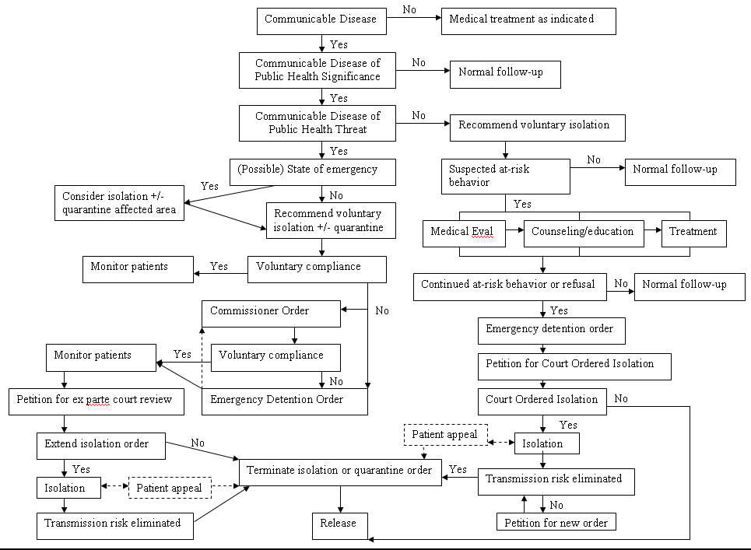

Attachment 2: Guidelines for Evaluating Homes for Isolation and Quarantine

Ideally, persons who do not require hospitalization for medical reasons should be isolated/quarantined in their homes. The home environment is less disruptive to the patient’s routine than a hospital or other community setting. However, public health staff will need to be able to:

- Contact individuals daily, or more frequently if feasible, for fever, respiratory symptoms, and other symptoms of disease, or need for additional medical care;
- Monitor compliance with isolation/quarantine through daily visits or telephone calls;
- Provide guidance to individuals if they develop additional symptoms or have other immediate needs;
- Ensure access to support services, including 1) psychological support, 2) food and water, 3) household and medical supplies, and 4) care for family members who are not in isolation/quarantine. Financial issues, such as medical leave, may also need to be considered.
- Collect data to guide ongoing decision-making including information on each person isolated/quarantined:
  - Relationship to the case-patient
  - Nature and time of exposure
  - Whether the contact was vaccinated, on antiviral prophylaxis or using PPE
  - Underlying medical conditions
  - Number of days in quarantine
  - Symptom log
  - Basic demographics
  - Compliance with quarantine

Home Isolation/Quarantine Considerations
Depending on the disease, persons who have been exposed to disease may need to stay in isolation or quarantine for a week or more. Therefore, as a result, it is important to ensure that the home environment meets the ongoing physical, mental, and medical needs of the individual. Any home being considered as an isolation/quarantine setting should be evaluated by the patient’s physician, health department official, or other appropriate person to verify its suitability. This evaluation may be performed on site by a health official or designee. However, from a practical standpoint, it may be more convenient to evaluate the residence through the administration of a questionnaire to the individual and/or the caregiver. Points to be considered in the evaluation include:

- Ability of person to monitor (or have monitored by a caregiver) their signs/symptoms
- Ability to physically separate quarantined from isolated individuals
- Availability of/access to educational materials about the disease and quarantine
- Basic utilities (water, electricity, garbage collection, and heating or air-conditioning as appropriate)
- Basic supplies (clothing, food, hand-hygiene supplies, laundry services)
- Mechanism for addressing special needs (e.g., filling prescriptions)
- Mechanism for communication, including telephone (for monitoring by health staff, reporting of symptoms, gaining access to support services, and communicating with family)
- Accessibility to healthcare workers or ambulance personnel
- Access to food and food preparation
- Access to supplies such as thermometers, fever logs, phone numbers for reporting symptoms or accessing services, and emergency numbers (these can be supplied by health authorities if necessary)
- Access to mental health and other psychological support services

Some specific issues to consider include:
Infrastructure
- Functioning telephone
- Electricity
- Heat source (e.g., gas, electric, wood, etc.)
- Potable water
- Bathroom with commode and sink
- Waste (garbage) disposal
- Sewage disposal (septic tank, community sewage line)

Accommodations
- Ability to provide a separate bedroom for the patient
- Accessible bathroom in the residence; if multiple bathrooms are available, one bathroom designated for use by the patient

Resources for patient care and support
- Primary caregiver who will remain in the residence and who is not at high risk for complications from disease
- Meal preparation
- Laundry
- Banking
- Essential shopping
- Social diversion (e.g., television, radio, internet access, reading materials)
- Masks, tissues, hand hygiene products

Additional Issues:

Room Ventilation and Patient Comfort

If the residence has a central air conditioning unit, then care must be taken to isolate air from the patient’s room from the rest of the air conditioning system. Simply closing vents (return and supply) may not accomplish this because of leakage, comfort issues, and because closing return vents will pressurize the patient's room (causing air flow out into the residence). Options include sealing the supply and return vents with polyethylene sheeting and duct tape and installing a window air conditioning unit to accommodate patient comfort needs. Alternatively, if climatic conditions permit, opening the window may be sufficient for comfort needs. It may also be appropriate to restrict the unit to the patient’s room and use alternative cooling/heating for the Caregiver. Note that residential air conditioning units are recirculating systems that merely condition (heat or cool) air.

Cleaning

The patient’s room should be cleaned at least daily and immediately after any accidents involving patient body fluids. The Caregiver should be provided and instructed to maintain a stock of disposable gloves (e.g., appropriate size nitrile gloves), respirators (surgical mask, N-95/100 respirator ), surgical masks for the patients, goggles (goggles can be cleaned and reused), and a spray bottle with disinfectant (e.g., EPA approved disinfectant or 0.5% sodium hypochlorite), as indicated by the agent. Carpet and other porous material are difficult to disinfect and all spills must be cleaned promptly and thoroughly. Linens and clothing should be bagged in the patient’s room and then washed separately. The bathroom should be cleaned (sprayed and wiped down) after use. Waste (tissue, etc.) should be sealed in the patient's room in a labeled bag and disposed of according to local public health prescribed means.

Training

Several key skills should be included as a minimum training set for the primary caregiver:

  - Techniques for infection control, including the importance of hand hygiene, room cleaning (e.g., door knobs, bathrooms, laundry, waste, etc.), and the need to minimize visits from others,
  - Recognition of signs/symptoms of infection,
  - How to respond to emergency situations,
  - Taking and recording temperature, and
  - Fit testing and training in the proper use of an N-95 or N-100 respirator for use while caring for the patient, if appropriate.

Facility-Based Isolation/Quarantine

In some cases, affected persons may not have access to an appropriate home environment. Examples include:
- travelers;
- persons living in dormitories, homeless shelters, or other group facilities; and,
- persons whose homes do not meet the minimum requirements for quarantine.

In other instances, contacts may have an appropriate home environment but may not wish to put family members at risk. In these situations, health officials should identify an appropriate community-based isolation/quarantine facility.

For additional guidance on selecting community-based facilities, see Attachment F: Isolation and Quarantine Facility Infrastructure Considerations. Additional guidance on selecting a community site is available at www.ahrq.gov/research/altsites.htm.

Form A: VIRGINIA DEPARTMENT OF HEALTH
Isolation and Quarantine Record

Date Record Started: / / |  |  | Time Record Started:

Patient Information
Patient Name: | (Last) |  | (First MI)
DOB: / /
Home Address: |  |  |  | City: |  |  |  |  | State:
County: |  | Zip:
Home Phone: ( ) - |  | Work: ( ) - |  |  |  | Mobile: ( ) -
Patient’s Current Location:
E-mail address:
Employment:
Employer:
Employer Address: |  |  |  | City: |  |  |  |  | State:
Supervisor:
Primary Language: English Other:
Translator name (if applicable):
Medical Conditions/Medications:
Immunization History:
Initial Signs/Symptoms |  |  |  |  |  |  |  | Date of Onset
 |  |  |  |  |  |  |  | / /
 |  |  |  |  |  |  |  | / /
 |  |  |  |  |  |  |  | / /
Lab/X-ray Results |  |  |  |  |  |  |  | Date
Diagnosis:
Diagnosed By: |  |  |  |  | Work Telephone: ( ) -
Treatment Initiated: |  |  |  |  | Date Initiated: / /
Or: Treatment/Immunization Refused:
Patient’s Primary Physician: |  |  |  |  | Work Telephone: ( ) -
Consultant Physician(s): |  |  |  |  | Work Telephone: ( ) -
 |  |  |  |  | Work Telephone: ( ) -
Epi-1 (Confidential Morbidity Report) Form Received: Yes No Date: / /
Has patient been notified by their Primary Care Provider? Yes No Date: / /
Completed by: |  |  |  |  |  |  | Date: / /

Public Health Consultation
Health Director Informed: Yes No | Date: / / |  | Time: : am/pm
Isolation Recommendation | Date: / /
VDH Office of Epi notified: Yes No | Date: / / |  | Time: : am/pm
Quarantine Recommendation | Date: / /
VDH Office of Epi notified: Yes No | Date: / / |  | Time: : am/pm
Synopsis of Discussion
Advised Virginia Department of Health of infected or exposed patient
Described infection (signs, symptoms, laboratory results) and/or exposure
Described efforts to have patient consent to quarantine or isolation
Offer Virginia Department of Health opportunity to examine patient
Other:
Exceptional circumstances identified:
Office of Epidemiology recommendation/Actions :
VDH Office of Epi representative: |  | Telephone: ( ) -
Completed by: |  | Date: / /

Voluntary Quarantine (if applicable)
Voluntary quarantine requested: Yes No |  | Date: / / |  |  | Time: : am/pm
Voluntary quarantine duration: days | End Date: / / |  |  | End Time: : am/pm
VDH representative:
Additional recommendations made:
Location of quarantine: Home Other residence Facility
Address of location of quarantine:
Telephone : ( ) -
Patient agrees to comply with quarantine: |  |  | Yes No Initials:
Patient provided written notice of disease, request for voluntary compliance and consequences of non-compliance? |  |  | Yes No Initials:
Patient signed voluntary health request: |  |  | Yes No Initials:
Completed by: |  |  | Date: / /

Voluntary Isolation (if applicable)
Voluntary isolation requested: Yes No |  |  |  | Date: / / |  |  |  |  | Time: : am/pm
Voluntary isolation duration: days |  |  | End Date: / / |  |  |  |  | End Time: : am/pm
VDH representative:
Additional recommendations made:
Location of quarantine: Home Other residence Facility
Address of location of quarantine:
Telephone : ( ) -
Patient agrees to comply with isolation: |  |  |  |  | Yes No Initials:
Patient provided written notice of disease, request for voluntary compliance and consequences of non-compliance? |  |  |  |  | Yes No Initials:
Patient signed voluntary health request: |  |  |  |  | Yes No Initials:
Completed by: |  |  |  |  | Date: / /
Documentation of Non-Compliance (see also ISOLATION AND QUARANTINE CONTACT LOG, below)
Date/Time | Contact Name | Synopsis of discussion |  |  |  |  | Result |  |  | Initials of Interviewer
Involuntary Isolation or Quarantine
Involuntary quarantine ordered: Yes No |  |  |  | Date: / / |  |  |  |  | Time: : am/pm
Involuntary quarantine duration: days |  |  | End Date: / / |  |  |  |  | End Time: : am/pm
VDH representative:
Additional recommendations made:
Location of quarantine: Home Other residence Facility
Address of location of quarantine:
Telephone : ( ) -
Patient agrees to comply with quarantine: |  |  |  |  |  | Yes No Initials:
Patient provided written notice of disease, request for voluntary compliance and consequences of non-compliance? |  |  |  |  |  | Yes No Initials:
Patient signed involuntary quarantine order: |  |  |  |  |  | Yes No Initials:
Completed by: |  |  |  |  |  | Date: / /

Involuntary isolation ordered: Yes No |  |  |  | Date: / / |  |  |  |  | Time: : am/pm
Involuntary isolation duration: days |  |  | End Date: / / |  |  |  |  | End Time: : am/pm
VDH representative:
Additional recommendations made:
Location of isolation: Home Other residence Facility
Address of location of isolation:
Telephone : ( ) -
Patient agrees to comply with isolation: |  |  |  |  |  | Yes No Initials:
Patient provided written notice of disease, request for voluntary compliance and consequences of non-compliance? |  |  |  |  |  | Yes No Initials:
Patient signed involuntary quarantine order: |  |  |  |  |  | Yes No Initials:
Completed by: |  |  |  |  |  | Date: / /

Emergency Detention Order
Emergency Detention Ordered: Yes No |  |  |  | Date: / / |  |  |  |  | Time: : am/pm
Location of detention: Home Other residence Facility
Address of location of detention:
Telephone : ( ) -
Order served by: |  |  |  |  | Agency:
Completed by: |  |  |  |  |  | Date: / /

Ex-Parte Hearing
Attorney Drafting Court Petition: |  |  |  |  |  |  | Telephone : ( ) -
Date of Petition: / / |  | Court Date: / / Time: : am/pm
Circuit Court Hearing Petition: |  |  |  |  |  |  | Telephone : ( ) -
Result of Hearing: | Isolation Ordered
Result of Hearing: | Quarantine Ordered
Result of Hearing: | Isolation/Quarantine Ended
Appeal of Order Termination Entered by State Health Commissioner: Yes No
Completed by: |  |  |  |  |  | Date: / /

Case Appeal
Case Appealing Order: Yes No
Case Attorney: |  |  |  |  | Telephone : ( ) -
Date Appeal Entered: / /
Circuit Court Hearing Petition: |  |  |  |  | Telephone : ( ) -
Circuit Court Hearing Date: / / Time: : am/pm
Petition served by: |  | Agency:
Result of Hearing: | Isolation Ordered
Result of Hearing: | Quarantine Ordered
Result of Hearing: | Order Modified as:
Result of Hearing: | Isolation/Quarantine Ended
Appeal of Termination Entered by State Health Commissioner: Yes No
Completed by: |  |  |  | Date: / /
Additional Notes (e.g., barriers to compliance, communications with individual, etc)
 |  |  | Date |  |  | Initials
 |  |  | / /
 |  |  | / /
 |  |  | / /

Form B: VIRGINIA DEPARTMENT OF HEALTH – CONTACT INVESTIGATION FORM
Case ID #: |  |  | Case Manager: |  |  | Phone Number: |  |  | Disease/Organism: |  |  |  | Potential Infectious Period of Case:
District: |  |  | Contact Person: |  |  |  |  |  |  |  |  |  | Start Date:
Investigation Type General: Special Site: |  |  |  |  |  |  |  |  |  |  |  |  | Stop Date:
Name of Contact  Address  Telephone Number | Date of Birth | Relation to Case  Priority |  | History of Exposure | Signs/  Symptoms  Date Contacted |  | Testing | Treatment (Prophylaxis) |  |  |  | Quarantine Date |  | If Isolated, Case ID # | Notes
 |  |  |  |  |  |  |  | Date Started |  | Date Completed |  |  |  | If Isolated, Case ID # | Notes

Form C
Name
Title
Agency
Address
Telephone
Fax
e-mail
Home Isolation/Quarantine Assessment

Person conducting assessment: |  |  | Date: / /
Patient name: |  |  | DOB: / /
Home address: |  | City/State/Zip:
Home telephone: ( ) - |  | Mobile telephone: ( ) -
E-mail:
Case classification | Date | Case ID:
□ Possible | / /
□ Probable | / /
□ Confirmed | / /

Section A. The Patient
 | Y | N
- Does the patient speak English as their primary language?
If no, what is their primary language? ___________________________
If no, does the patient need an interpreter?
- Was the patient educated about:
  - Proper hand washing?
  - Appropriate use of surgical masks and gloves?
  - Methods of taking and reading their temperature?
  - Proper handling and cleaning of soiled laundry?
  - Cleaning and disinfection of their environment?
- Does the patient have a car?
- Is the patient currently employed?
Employer:_________________________________
Job description/title: ______________________________________
  - Can the patient work from home?
  - Does the patient have paid time off for I/Q period?

Section B. The Home
 | Y | N
- Does the home have the following features:
  - Telephone?
    - Is the home phone a cell phone?
  - Internet access?
    - Does this use the patient’s only phone line?
  - Television?
  - Electricity?
  - Potable water?
  - Refrigerator?
  - Oven?
  - Microwave?
  - Heat?
  - Air conditioning?
  - Waste and sewage disposal (septic tank or sewer line)?
  - Garbage collection?
  - Is there a washer/dryer on site?
  - Enough disinfectant for I/Q period?
  - Enough laundry soap for I/Q period?
- Does the home support effective isolation by:
  - Having a separate bedroom for only the patient?
  - Having a separate air-handling system for patient areas?
  - Separate bathroom that can be used only by the patient?

Section C. Support
 | Y | N
- Are there pets in the home?
  - Can the patient take care of the pets while in I/Q?
  - Are the pets susceptible to the illness?
- Does patient need prescription refills during isolation period?
- Does the patient have access to mental health support services?
- Does patient normally require a caregiver?
  - Name of helper: __________________________
  - Helper home phone: ( ) -
  - Helper mobile phone: ( ) -
  - Helper pager: ( ) -
  - Helper email:_________________________
- Does the patient have someone who can run errands?
  - Name of helper: _________________________
  - Helper home phone: ( ) -
  - Helper mobile phone: ( ) -
  - Helper pager: ( ) -
  - Helper email:_________________________

Section D. Household Contacts
 | Y | N
- Does the patient live alone?
- Are there household members who cannot care for themselves?
    - Children?
    - Disabled adult or elderly?
- Can other household member(s) move to another household during the isolation/quarantine period?

List all current household contacts below:

Name/Relationship | Age | Stay in Home | At Risk | Needs-Comments

Section E. Recommendations

- The [Health Department] recommends:

Home isolation/quarantine.

Isolation/quarantine in an alternate facility
- Reason for not recommending home isolation/quarantine:

- Preferred alternate facility

- Disposition:

Patient agrees to adhere to isolation/quarantine recommendations

Patient refuses to adhere to isolation/quarantine recommendations

- Additional steps: Y N
  - Did patient receive Isolation/Quarantine Packet?
  - Did patient receive voluntary isolation/quarantine letter?
  - Did patient receive “Isolation Kit”?
Hand hygiene supplies (e.g., hand sanitizer
Personal protective equipment (e.g., masks, gloves)
Thermometer
Fever Log
Other: ______________________________
  - Has patient been assigned a case manager?
    - Name _________________________________

Form D: Example Voluntary Isolation Letter

30 July 2026

«Case_Name»
«Case_Address»
«Case_City»,«Case_State» «Case_Zip»

Dear «Case_Name»:

You have recently been diagnosed with «Communicable_Disease_of_Public_Health_T». The Virginia Department of Health (VDH) has declared that «Communicable_Disease_of_Public_Health_T» is dangerous to the public health. Because «Communicable_Disease_of_Public_Health_T» is contagious, strong measures must be taken to stop further spread of the disease. As a result, you are directed to follow the guidelines below from now until «End_time» on the «End_Day» of «End_Month», «End_Year» or until «Abx_Days» days after starting antimicrobial treatment. At that time, if you continue to have signs and/or symptoms of «Communicable_Disease_of_Public_Health_T», including «Signs_Sympt_DoPHT», you may need to follow the guidelines for a longer time.

Guidelines for preventing the spread of «Communicable_Disease_of_Public_Health_T» include:

1. Stay at home.

- You may leave your home only if you remain on your property and have no face-to-face contact with anyone other than members of your household.
- You may not leave your property during this isolation period for any reason, except a medical emergency. Do not go to work or school, and do not go to any public areas, including the grocery store, movie theater or mall. If you need something from outside your home, ask family, friends or neighbors who are not sick to get it for you.
- Failure to follow these instructions will place the health of others at risk. It will also result in the State Health Commissioner issuing an emergency isolation order.
- The Virginia Department of Health will be calling your home on a daily basis to check to see if anyone in your family or household is getting sick. If someone you live with or spend time with gets sick with «Signs_Sympt_DoPHT», please be sure that person’s healthcare provider is called right away. Also call the Virginia Department of Health at the number listed below.

2. Use safe practices so that your household members do not get sick.

- Before you leave the clinic or hospital, you should be given several surgical face masks to take home with you. When around other people in your home, you should wear a mask and be sure it covers your nose and mouth. Ask your health care provider to show you how to wear a face mask the correct way. If you need more surgical face masks, call your local drug store or ask your health care provider.
- Cover your mouth and nose with a tissue when you sneeze, cough or blow your nose. Put the used tissue in the garbage and remember to wash your hands immediately afterwards.
- While at home, limit your contact with those that live with you as much as possible. Sleep in a separate room, if possible, or at least in a separate bed. Avoid close contact such as kissing.
- Wash your hands for at least 15 seconds often with soap and warm water or alcohol-based hand rubs. Hand washing may be the best way to prevent others from getting sick. You should wash your hands after coughing, sneezing, blowing your nose, and going to the bathroom.
- Throw out your used tissues and face masks with your regular garbage. Do not share eating utensils (spoons, forks, cups or glasses), towels or bedding (pillows, sheets or blankets) with others. These items can be used again after routine cleaning with soap and hot water. Do not share toothbrushes, cigarettes and other tobacco products, or drinks.
- If any of your body fluids (such as secretions from your nose or mouth) get on surfaces in your home (such as door knobs or any other object that you sneeze or cough on), the surface should be washed with a household cleaner, such as bleach (1 part household bleach to 9 parts water – a 0.5% sodium hypochlorite solution). Anyone doing the cleaning should wear gloves.

3. You will be contacted by health department staff on a regular basis to follow-up on my condition, and to ensure my compliance with the above instructions.

These isolation instructions remain in effect until you are told by health department staff that you are no longer infectious to people around you. Legal action may be taken if you do not follow these instructions and knowingly expose others to infection.

4. Call your healthcare provider if your symptoms worsen.

- If your symptoms worsen, please call your healthcare provider immediately. Also, please call the health department:

Health Department: «LHD»

Telephone Number: «Contact_Tele»

Contact Name: «Staff_Contact»

- If you need to go to the doctor’s office, you should have a family member or friend drive you in a private car. Do not take public transportation (subway or bus). Please contact your doctor before you visit and tell the doctor you have been diagnosed with «Communicable_Disease_of_Public_Health_T». Wear a surgical face mask on the way to see your health care provider. You should go straight to the receptionist when you arrive so that you can be put in a private room. Try to sit away from others as much as possible.
- If you are very sick and need to call an ambulance to take you to the hospital, let the operator know that you may have «Communicable_Disease_of_Public_Health_T» when you call 911, and let the ambulance crew know when they arrive.

For more information, call your doctor or health department, or visit the Centers for Disease Control and Prevention’s website at www.cdc.gov/ . If you have questions or need help, please call «Staff_Contact» at «Contact_Tele». Additional information about «Communicable_Disease_of_Public_Health_T» is available at: www.________________. Fact sheets about this disease and the steps you should take to protect yourself and others are attached to this letter. Please take these steps to reduce the risk to yourself and others with whom you may have contact.

It is very important that you comply with this request for voluntary quarantine. Your health and the health of others depend on it. If you do not follow these instructions, the State Health Commissioner may order your compliance and may have you detained.

Thank you for your cooperation and help during this public health emergency. Attached is information about available local resources you can reach by telephone or via the Internet. Included in the attached information is a description of how your basic needs (e.g. groceries, medications) can be met while you are quarantined.

Sincerely,

«Health_Director_Name»

This letter should be modified if being delivered to the parent or guardian of dependents. The parent or guardian should be given the choice to be quarantined with the dependent. If the parent or guardian does not choose to be quarantined with the dependent, then the parent/guardian is responsible for making arrangements for the dependent’s care and appropriate level of supervision.

________________________________ Date __ ________________
Patient Signature

________________________________ Date __________________
Witness

Form

Form E: Example Voluntary Quarantine Letter

30 July 2026

«Case_Name»
«Case_Address»
«Case_City»,«Case_State» «Case_Zip»

Dear «Case_Name»:

You are suspected of having been exposed to a patient with «Communicable_Disease_of_Public_Health_T». The Virginia Department of Health (VDH) has declared that «Communicable_Disease_of_Public_Health_T» is dangerous to the public health. Because you may have been exposed to «Communicable_Disease_of_Public_Health_T», we are requesting that you quarantine yourself. Quarantine means that you should not come into contact with other people. It protects your health and the health of others.

You are directed to follow the guidelines below from now until «End_time» on the «End_Day» of «End_Month», «End_Year» or until «Abx_Days» days after starting antimicrobial treatment. We will be checking in on you and will let you know when it is safe for you to return to your normal activities. If you develop any signs and/or symptoms of «Communicable_Disease_of_Public_Health_T», including «Signs_Sympt_DoPHT», you may need further evaluation and treatment, and to follow the guidelines for a longer time.

Guidelines for preventing the spread of «Communicable_Disease_of_Public_Health_T» include:

1. Stay at home.

- You may leave your home only if you remain on your property and have no face-to-face contact with anyone other than members of your household.
- You may not leave your property during this isolation period for any reason, except a medical emergency. Do not go to work or school, and do not go to any public areas, including the grocery store, movie theater or mall. If you need something from outside your home, ask family, friends or neighbors who are not sick to get it for you.
- Failure to follow these instructions will place the health of others at risk. It will also result in the State Health Commissioner issuing an emergency isolation order.
- The Virginia Department of Health will be calling your home on a daily basis to check to see if anyone in your family or household is getting sick. If someone you live with or spend time with gets sick with «Signs_Sympt_DoPHT», please be sure that person’s healthcare provider is called right away. Also call the Virginia Department of Health at the number listed below.

- Use safe practices so people around you do not get sick.
  - You will be given masks to wear. When other people are around you, you should wear a mask to cover your nose and mouth.
  - When you are not wearing a mask, cover your mouth and nose with a tissue when you sneeze, cough, or blow your nose. Put the used tissue in the trash and wash your hands right away.
  - Wash your hands often for at least 15 seconds with soap and warm water or use an alcohol rub or gel, as directed.
  - Stay away from other people as much as possible. Do not have close contact with other people (for example, kissing or sharing food).
  - Throw out your used tissues and face masks with your trash.
  - Do not share eating utensils, glasses, towels, drinks, or toothbrushes.
  - If any of your body fluids (saliva/spit, mucous, urine, feces, or vomit ) get on surfaces (door knobs, draw pulls, etc.), someone wearing gloves should wash the surfaces with a household cleaner.

3. You will be contacted by health department staff on a regular basis to follow-up on my condition, and to ensure my compliance with the above instructions.

These quarantine instructions remain in effect until you are told by health department staff that you are no longer potentially infectious to people around you. Legal action may be taken if you do not follow these instructions and knowingly expose others.

- Call your healthcare provider if you develop any of the following symptoms: «Signs_Sympt_DoPHT».

- Also, please call the health department:

Health Department: «LHD»

Telephone Number: «Contact_Tele»

Contact Name: «Staff_Contact»

- If you need to go to the doctor’s office, you should have a family member or friend drive you in a private car. Do not take public transportation (subway or bus). Please contact your doctor before you visit and tell the doctor you may have «Communicable_Disease_of_Public_Health_T». Wear a surgical face mask on the way to see your health care provider. You should go straight to the receptionist when you arrive so that you can be put in a private room. Try to sit away from others as much as possible.
- If you are very sick and need to call an ambulance to take you to the hospital, let the operator know that you may have «Communicable_Disease_of_Public_Health_T» when you call 911, and let the ambulance crew know when they arrive.

Note: If you have not yet been exposed to «Communicable_Disease_of_Public_Health_T» but voluntarily choose to contact a person or persons under quarantine and/or isolation (e.g., to provide care), then you agree to become quarantined and follow all of the above restriction, including the use of personal protective equipment or appropriate chemoprophylaxis or vaccination. In addition, as a result of its warnings, the Virginia Department of Health assumes no liability should you become ill from exposure to a person under an order of quarantine or isolation.

For more information, call your doctor or health department, or visit the Centers for Disease Control and Prevention’s website at www.cdc.gov/ . If you have questions or need help, please call «Staff_Contact» at «Contact_Tele». Additional information about «Communicable_Disease_of_Public_Health_T» is available at: www.________________Fact sheets about this disease and the steps you should take to protect yourself and others are attached to this letter. Please take these steps to reduce the risk to yourself and others with whom you may have contact.

- It is very important that you comply with this request for voluntary quarantine. Your health and the health of others depend on it. If you do not follow these instructions, the State Health Commissioner may order your compliance and may have you detained.

Thank you for your cooperation and help during this public health emergency. Attached is information about available local resources you can reach by telephone or via the Internet. Included in the attached information is a description of how your basic needs (e.g. groceries, medications) can be met while you are quarantined.

Sincerely,

«Health_Director_Name»

This letter should be modified if being delivered to the parent or guardian of dependents. The parent or guardian should be given the choice to be quarantined with the dependent. If the parent or guardian does not choose to be quarantined with the dependent, then the parent/guardian is responsible for making arrangements for the dependent’s care and appropriate level of supervision.

________________________________ Date __ ________________
Patient Signature

________________________________ Date __________________
Witness

Form F. O R D E R OF INVOLUNTARY ISOLATION

made pursuant to the Code of Virginia,
Chapter 2 of Title 32.1, sections 32.1-48.05 through 32.1-48.1

Date: Thursday, July 30, 2026

To: «Case_Name»
«Case_Address»
«Case_City», «Case_State» «Case_Zip»
«Case_Phone»
Date of Birth: «DOB»

Re: Order #: «Order_»

THE REASONS for this ORDER are:

- «Communicable_Disease_of_Public_Health_T» is a virulent disease that is communicable from person to person and poses a risk of death or significant injury or impairment to the citizens of the Commonwealth of Virginia.

- The Virginia Department of Health has determined or has reasonable suspicion that you, having exhibited signs or symptoms that include «Signs_Symptoms», have been infected with «Disease_Agent», the cause of «Communicable_Disease_of_Public_Health_T».

- [IF EXAMINED] Having been examined by:

Dr. «Report_MD_Name»
«Report_MD_Addr»
«Report_MD_City», «Report_MD_State»

a duly licensed physician of «Report_MD_State», the said physician furnished to the undersigned (in accordance with the Regulations for Disease Reporting and Control, 12 VAC 5-90-90) a report of these findings and the results of laboratory and other tests taken to confirm a diagnosis of «Communicable_Disease_of_Public_Health_T».

- To prevent the transmission of «Communicable_Disease_of_Public_Health_T» you were requested by the District Health Director, «Health_Director_Name», on «Date_Vol_Req» at «Time_Vol_Req», to voluntarily comply with disease control measures, including isolation requirements, developed by the «LHD».

At that time, you advised the Virginia Department of Health that you were not willing or able to comply with these directions. OR

The necessary reasons for implementing an Order of Quarantine, issued to you on «Order_Quar_Date», have not changed.

OR

To prevent the transmission of «Communicable_Disease_of_Public_Health_T» you were requested by the District Health Director, «Health_Director_Name», on «Date_Vol_Req» at «Time_Vol_Req» to voluntarily comply with disease control measures, including isolation requirements, developed by the «LHD». At that time, you acknowledged receipt and willingness to comply with the appropriate precautions AND

On «Missed_Contact_Date_1» at «Missed_Contact_Time_1» an attempt was made to contact you by «Staff_Person_1_» and you were not found to be at the site of isolation. On «Missed_Contact_Date_2» at «Missed_Contact_Time_2» an attempt was again made to contact you by «Staff_Person_2» and you were again not found to be at the site of isolation. Therefore, you have failed to follow the instructions of Virginia Department of Health that you remain in isolation.

OR

On «Report_Noncompl_Date» the Virginia Department of Health was advised that on «Date_Noncompl» at «Time_of_Noncompl» you were seen at «Location_of_Noncompl». Therefore, you have failed to follow the instructions of Virginia Department of Health that you remain in isolation.

Therefore, to prevent the spread of «Communicable_Disease_of_Public_Health_T» to other persons, pursuant to the authority set forth in Part A of Section 32.1-48.05 of Article 3.02 (Quarantine and Isolation of Persons with Communicable Diseases of Public Health Threat) of Chapter 2 of Title 32.1 of the Code of Virginia, the undersigned State Health Commissioner of Virginia invokes the provisions of Article 3.02 of Chapter 2 of Title 32.1 of the Code of Virginia relating to quarantine and isolation. And therefore, you, «Case_Name» are hereby ordered to remain in isolation until VDH or its designated local public health authority has determined that you are no longer contagious with «Disease_Agent».

This public health order for your isolation shall begin on the «Day_of_Order» day of «Month_of_Order», «Year_of_Order».

Requirements of this Order:

- Immediately upon receipt of this order, confine yourself to the residence located at «Isol_Location», and isolate yourself from others until you are specifically advised by the Virginia Department of Health that you are permitted to leave your home OR you are confined to «Isol_Location». Under the circumstances, this has been determined to be the least restrictive environment that will effectively prevent further transmission of «Communicable_Disease_of_Public_Health_T» to others in the community.

- You will be required to remain in isolation at this location until «End_time» on «End_Day» day of «End_Month», «End_Year» or following «Abx_Days» days of antimicrobial therapy, or you receive a second written order from VDH that tells you the isolation is over. Until then, you may not leave the location of isolation for any reason except for emergency medical attention unless you have received prior written authorization from the Department to do so. You should not go to work, school, out-of-home childcare, church, or other public areas.

If you develop new or additional symptoms, including, but not limited to «Signs_Sympt_DoPHT» or you require medical treatment, please contact «Staff_Contact» with the VDH or its designated local health authority at «Contact_Tele». You should also telephone your primary care provider. The VDH or its designated local public health authority will determine if you should leave the isolation location for the sole purpose of seeking medical attention and will inform you of precautions you must take to protect against infecting others during the time you are outside the isolation location. Prior to seeking such medical attention in an office, clinic, ambulance or hospital, you must call and inform your healthcare providers that you are suspected of having or currently have «Communicable_Disease_of_Public_Health_T».

If emergency medical treatment is required for conditions other than those listed above (e.g., chest pain or severe accidental injury at home), you should call 911 for an ambulance. When seeking such assistance, you must inform the operator of the 911 line and the ambulance that you are under an Order of Isolation.

- You may contact by telephone, mail or e-mail any person or persons, including employers, next of kin or legally authorized representatives and/or your attorneys concerning the situation. However,

For Home Isolation: You must not come into close physical contact with anyone except the following persons:

i) Family members and other persons who reside in your home;

ii) Authorized healthcare providers;

iii) Authorized VDH staff or other persons acting on behalf of VDH; and,

iv) Such other persons as authorized by VDH.

These persons may be required to wear authorized protective equipment while in the isolation premises. VDH or its designated local public health authority will provide specific directions to such persons as needed.

If family members or other persons who reside in your home have not been issued a Home Isolation Order or a Home Quarantine Order, they may leave your home to carry on their daily routines and to assist you with any needs you may have during the period of confinement. If you live alone, or if every member of your household is under an Order of Quarantine or an Order of Isolation, you should arrange by telephone for relatives, neighbors, or friends to assist with any needs you may have during the period of confinement. These persons should not have direct contact with you.

If other persons also reside in your home, you must maintain good personal hygiene at all times, including complying with the directions contained in Attachment A, to prevent disease transmission.

If you or any other individual in your household needs food, clothing, medication or any other essential needs while this Order is in effect, please contact: «Staff_Contact» by calling «Contact_Tele».

OR

For Facility Isolation: You must not come into close physical contact with anyone except the following persons:

- Other persons who are also under similar isolation order at the isolation facility;
- Authorized healthcare providers and other staff at the isolation facility;
- Authorized VDH staff or other persons acting on behalf of VDH; and
- Such other persons as authorized by VDH.

Your daily needs, including food, shelter, and medical care, will be provided for you during the period of isolation at the isolation facility. You should bring clothing, toiletries, and other personal items, including a supply of medications with you to the isolation facility. You will have limited access to a telephone at the isolation facility. You may bring your cell phone with you should you desire to have greater access to a means of communication.

Any person entering the isolation premises without appropriate protection and without authorization from the health department may be subject to a public health order of quarantine.

- You must remain reachable by telephone at all times and answer and respond fully and truthfully to telephone calls from Department staff and other persons acting on behalf of the Department. In order to ensure that you strictly comply with this Order the Department or persons authorized by the Department may contact you by telephone on a regular basis and may carry out spot checks of your residence.

- Follow the specific advice of Virginia Department of Health. You are required to cooperate with the Department or its designated local public health authority by:

- Taking your temperature in the morning and evening and report the temperature reading to Virginia Department of Health when they call you. Report any elevation in temperature [greater or equal to 38°C (100.4°F) or any symptoms of additional signs and symptoms, including immediately by phone to Virginia Department of Health at «Contact_Tele».

- Avoiding contact with uninfected family members as much as possible. Wear a mask when you need to be in a room with other family members.

- Following the instructions for infection control (handwashing, changing and disposal of masks) provided to you by the Virginia Department of Health (see Attachment B).

- [OPTIONAL] Submit to an examination by a physician if this is necessary in the opinion of the Virginia Department of Health. Request that the physician provide a copy of his/her report of the examination to the Virginia Department of Health as soon as possible.

Attached to this order is additional useful information for you and members of your household about «Communicable_Disease_of_Public_Health_T». For more information about «Communicable_Disease_of_Public_Health_T», you may also go to the Virginia Department of Health’s web-page at www.vdh.virginia.gov, or the Centers for Disease Control and Prevention at www.cdc.gov. If you do not have access to the internet from your home, you may contact the Department at 1-«Hotline».

Remember: This public health order for your isolation shall end only at «End_time» on «End_Day» day of «End_Month», «End_Year» or following «Abx_Days» days of antimicrobial therapy, or you receive a second written order from VDH that tells you the isolation is over.

NOTICE
IT IS UNLAWFUL FOR YOU TO WILLFULLY VIOLATE, DISOBEY, OR DISREGARD THIS PUBLIC HEALTH ORDER. ANY PERSON WHO DOES SO IS GUILTY OF A CLASS 1 MISDEMEANOR AND, UPON CONVICTION THEREOF, MAY BE PUNISHED BY 12 MONTHS IN JAIL AND/OR A FINE OF UP TO $2,500 PER CODE OF VIRGINIA §§ 32.1-27 AND 32.1-48.014.
IN ADDITION, THE STATE HEALTH COMMISSIONER MAY ISSUE AN EMERGENCY DETENTION ORDER REQUIRING YOU TO BE TAKEN IMMEDIATELY INTO CUSTODY AND DETAINED FOR THE DURATION OF THE ORDER OF ISOLATION OR UNTIL THE COMMISSIONER DETERMINES THAT THE RISK OF NONCOMPLIANCE IS NO LONGER PRESENT, PER CODE OF VIRGINIA § 32.1-48.014.
In accordance with Article 3.02 of Chapter 2 of Title 32.1 of the Code of Virginia you have the right to appeal this order in the circuit court for the city or county in which you reside (see Attachment B: Notice of Process of Appeal of Any Order of Isolation). However, the filing of the appeal shall not stay the order. You have the right to legal counsel. If you are unable to afford legal counsel, then counsel will be appointed for you at government expense and you should request the appointment of counsel at this time. If you currently have legal counsel, then you have an opportunity to contact that counsel for assistance.

If you have questions regarding this order, please contact «Staff_Contact» at the Virginia Department of Health at «Contact_Tele».

Issued this «Day_Order_Issued» day of «Month_Order_Issued», «Year_of_Order1».

___________________________________
Dr. «State_Health_Commissioner»
State Health Commissioner
109 Governor Street, 13th Floor
Richmond, Virginia 23218

I have read and understand the above Order of Isolation.

___________________________________ ______/______/______
«Case_Name» Date

Attachments to this order:
Attachment A – Notice of Process of Appeal of Any Order of Isolation
Attachment B –

Signature of person serving order: ______________________________________ Date: ______

Please print name of person delivering order: _____________________________
Form G - Notice of Process of Appeal of Any Order of Isolation
In compliance with the Code of Virginia, the following notification, as excerpted from the Code of Virginia, is being provided to the subject of an Order of Isolation. If you have any questions in regards to these rights, please contact the Virginia Department of Health, or your legal representative.
“§ 32.1-48.13. Appeal of any order of isolation.
A. Any person or persons subject to an order of isolation or a court-ordered confirmation or extension of any such order pursuant to this article may file an appeal of the order of isolation in the circuit court for the city or county in which such person or persons reside or, in the case of an affected area, in the circuit court for any affected jurisdiction or jurisdictions. Any petition for appeal shall be in writing, shall set forth the grounds on which the order of isolation is being challenged vis-a-vis the subject person or persons or affected area, and shall be served upon the State Health Commissioner or his legal representative.
B. A hearing on the appeal of the order of isolation shall be held within 48 hours of the filing of the petition for appeal or, if the 48-hour period terminates on a Saturday, Sunday, legal holiday or day on which the court is lawfully closed, the hearing shall be held on the next day that is not a Saturday, Sunday, legal holiday or day on which the court is lawfully closed.
In extraordinary circumstances, for good cause shown, the Commissioner may request a continuance of the hearing, which the court shall only grant after giving due regard to the rights of the affected individuals, the protection of the public health and safety, the severity of the emergency, and the availability of witnesses and evidence.
C. Any person appealing an order of isolation shall have the burden of proving that he is not properly the subject of the order of isolation.
D. An appeal shall not stay any order of isolation.
E. Upon receiving multiple appeals of an order of isolation, the court may, on the motion of any party or on the court's own motion, consolidate the cases in a single proceeding for all appeals when (i) there are common questions of law or fact relating to the individual claims or rights to be determined; (ii) the claims of the consolidated cases are substantially similar; and (iii) all parties to the appeals will be adequately represented in the consolidation.
F. The circuit court shall not conduct a de novo review of the order of isolation; however, the court shall consider the existing record and such supplemental evidence as the court shall consider relevant. The court shall conduct the hearing on an appeal of an order of isolation in a manner that will protect the health and safety of court personnel, counsels, witnesses, and the general public and in accordance with rules of the Supreme Court of Virginia pursuant to subsection C of § 17.1-503. The court may, for good cause shown, hold all or any portion of the hearings in camera upon motion of any party or the court's own motion.
G. Upon completion of the hearing, the court may (i) vacate or modify the order of isolation as such order applies to any person who filed the appeal and who is not, according to the record and the supplemental evidence, appropriately subject to the order of isolation; (ii) vacate or modify the order of isolation as such order applies to all persons who filed an appeal and who are not, according to the record and the supplemental evidence, appropriately subject to the order of isolation; (iii) confirm the order of isolation as it applies to any person or all appealing parties upon a finding that such person or persons are appropriately subject to the order of isolation and that isolation is being implemented in the least restrictive environment to address the public health threat effectively, given the reasonably available information on effective infection control measures and the nature of the communicable disease of public health threat; or (iv) confirm the order of isolation as it applies to all persons subject to the order upon finding that all such persons are appropriately subject to the order of isolation and that isolation is being implemented in the least restrictive environment to address the public health threat effectively given the reasonably available information on effective control measures and the nature of the communicable disease of public health threat.
In any case in which the court shall vacate the order of isolation as it applies to any person who has filed a request for review of such order and who is subject to such order or as it applies to all persons seeking judicial review who are subject to such order, the person or persons shall be immediately released from isolation unless such order to vacate the isolation shall be stayed by the filing of an appeal to the Supreme Court of Virginia. Any party to the case may file an appeal of the circuit court decisions to the Supreme Court of Virginia. Parties to the case shall include any person who is subject to an order of isolation and has filed an appeal of such order with the circuit court and the State Health Commissioner.
H. Appeals of any final order of any circuit court regarding the State Health Commissioner's petition for review and confirmation or extension of an order of isolation or any appeal of an order of isolation by a person or persons who are subject to such order shall be appealable directly to the Supreme Court of Virginia, with an expedited review in accordance with the rules of the court pursuant to subsection C of § 17.1-503.
I. Appeals of any circuit court order relating to an order of isolation shall not stay any order of quarantine.
J. Persons appealing any order of isolation shall have the right to be represented by an attorney in all proceedings. If the person is unable to afford an attorney, counsel shall be appointed for the person by the circuit court for the jurisdiction in which the person or persons who are subject to the order of isolation reside or, in the case of an affected area, by the circuit court for the jurisdiction or jurisdictions for the affected area. Counsel so appointed shall be paid at a rate established by the Supreme Court of Virginia from the Commonwealth's criminal fund.”

Form H: ORDER OF INVOLUNTARY QUARANTINE

made pursuant to the Code of Virginia,
Chapter 2 of Title 32.1, sections 32.1-48.05 through 32.1-48.1

Date: Thursday, July 30, 2026

To: «Case_Name»
«Case_Address»
«Case_City», «Case_State» «Case_Zip»
«Case_Phone»
Date of Birth: «DOB»

Re: Order #: «Order_»

THE REASONS for this ORDER are:
- «Communicable_Disease_of_Public_Health_T» is a virulent disease that is communicable from person to person and poses a risk of death or significant injury or impairment to the citizens of the Commonwealth of Virginia.
- The Virginia Department of Health has determined or has reasonable suspicion that you have been exposed to «Disease_Agent», the cause of «Communicable_Disease_of_Public_Health_T», as a result of your contact with a person on or about «Date_Exposure» who has been diagnosed with «Communicable_Disease_of_Public_Health_T», and that this contact occurred during the time that the ill person may have been able to spread «Communicable_Disease_of_Public_Health_T». In addition, you may not be immune to «Disease_Agent» or you did not received preventive treatment in a timely manner or preventive treatment is not available.

OR

On «Date_Exposed_Reported» the Virginia Department of Health received a report that you had attended an event or been present in «Affected_Area» that is known or suspected to have been or the source of the transmission of «Communicable_Disease_of_Public_Health_T» – note: requires state of emergency.

  - Prior to developing recognized signs or symptoms of disease, you may be capable of transmitting «Communicable_Disease_of_Public_Health_T» to others. As a result, you should not be in contact with people who have not been exposed to «Communicable_Disease_of_Public_Health_T».

  - To prevent the transmission of «Communicable_Disease_of_Public_Health_T» you were requested by the District Health Director, «Health_Director_Name», on «Date_Vol_Req» at «Time_Vol_Req», to voluntarily comply with disease control measures, including quarantine requirements, developed by the «LHD».

At that time, you advised the Virginia Department of Health that you were not willing or able to comply with these directions. OR

To prevent the transmission of «Communicable_Disease_of_Public_Health_T» you were requested by the District Health Director, «Health_Director_Name», on «Date_Vol_Req» at «Time_Vol_Req» to voluntarily comply with disease control measures, including qurantine requirements, developed by the «LHD». At that time, you acknowledged receipt and willingness to comply with the appropriate precautions AND

On «Missed_Contact_Date_1» at «Missed_Contact_Time_1» an attempt was made to contact you by «Staff_Person_1_» and you were not found to be at the site of quarantine. On «Missed_Contact_Date_2» at «Missed_Contact_Time_2» an attempt was again made to contact you by «Staff_Person_2» and you were again not found to be at the site of quarantine. Therefore, you have failed to follow the instructions of Virginia Department of Health that you remain in quarantine.

OR

On «Report_Noncompl_Date» the Virginia Department of Health was advised that on «Date_Noncompl» at «Time_of_Noncompl» you were seen at «Location_of_Noncompl». Therefore, you have failed to follow the instructions of Virginia Department of Health that you remain in quarantine.

Therefore, to prevent the spread of «Communicable_Disease_of_Public_Health_T» to other persons, pursuant to the authority set forth in Part A of Section 32.1-48.05 of Article 3.02 (Quarantine and Isolation of Persons with Communicable Diseases of Public Health Threat) of Chapter 2 of Title 32.1 of the Code of Virginia, the undersigned State Health Commissioner of Virginia (“Commissioner”) invokes the provisions of Article 3.02 of Chapter 2 of Title 32.1 of the Code of Virginia relating to quarantine and isolation. And therefore, you, «Case_Name» are hereby ordered to remain in quarantine until VDH or its designated local public health authority has determined that you are not infected with «Disease_Agent».

This public health order for your quarantine shall begin on the «Day_of_Order» day of «Month_of_Order», «Year_of_Order».

Requirements of this Order:
- Immediately upon receipt of this order, confine yourself to the residence located at «Quar_Location», and isolate yourself from others until you are specifically advised by the Virginia Department of Health that you are permitted to leave your home OR you are confined to «Quar_Location». Under the circumstances, this has been determined to be the least restrictive environment that will effectively prevent further transmission of «Communicable_Disease_of_Public_Health_T» to others in the community.

You will be required to remain in quarantine until «End_time» on «End_Day» day of «End_Month», «End_Year» or following «Abx_Days» days of antimicrobial therapy, or you receive a second written order from VDH that tells you the quarantine is over. At this point, you would no longer be at risk of developing «Communicable_Disease_of_Public_Health_T» and spreading the disease to others in the community. Until then, you may not leave the location of quarantine for any reason except for emergency medical attention unless you have received prior written authorization from the Department to do so. You should not go to work, school, out-of-home childcare, church, or other public areas

If you develop symptoms of «Communicable_Disease_of_Public_Health_T», including, but not limited to «Signs_Sympt_DoPHT» or you require medical treatment, please contact «Staff_Contact» with the VDH or its designated local health authority at «Contact_Tele». You should also telephone your primary care provider. The VDH or its designated local public health authority will determine if you should leave the quarantine location for the sole purpose of seeking medical attention and will inform you of precautions you must take to protect against infecting others during the time you are outside the quarantine location. Prior to seeking such medical attention in an office, clinic, ambulance or hospital, you must call and inform your healthcare providers that you may have «Communicable_Disease_of_Public_Health_T».

If emergency medical treatment is required for conditions other than those listed in this paragraph (e.g. chest pain or severe accidental injury at home), you should call 911 for an ambulance. When seeking such assistance, you must inform the operator of the 911 line and the ambulance that you are under an Order of Quarantine.

- You may contact by telephone, mail or e-mail any person or persons, including employers, next of kin or legally authorized representatives and/or your attorneys concerning the situation. However,

For Home Quarantine: You must not come into close physical contact with anyone except the following persons:

i) Family members and other persons who reside in your home;

ii) Authorized healthcare providers;

iii) Authorized VDH staff or other persons acting on behalf of VDH; and,

iv) Such other persons as authorized by VDH.

These persons may be required to wear authorized protective equipment while in the quarantine premises or else may become subject to quarantine. VDH or its designated local public health authority will provide specific directions to such persons as needed.

If family members or other persons who reside in your home have not been issued a Home Quarantine Order, they may leave your home to carry on their daily routines and to assist you with any needs you may have during the period of confinement. If you live alone, or if every member of your household is under an Order of Quarantine or an Order of Isolation, you should arrange by telephone for relatives, neighbors, or friends to assist with any needs you may have during the period of confinement. These persons should not have direct contact with you.

If other persons also reside in your home, you must maintain good personal hygiene at all times, including complying with the directions contained in Attachment A, to prevent disease transmission.

If you or any other individual in your household needs food, clothing, medication or any other essential needs while this Order is in effect, please contact: [«Staff_Contact» by calling «Contact_Tele».

OR

For Facility Qurantine: You must not come into contact with anyone except the following persons:
- Other persons who are also under similar quarantine order at the facility;
- Authorized healthcare providers and other staff at the facility;
- Authorized VDH staff or other persons acting on behalf of VDH; and
- Such other persons as authorized by VDH.

Your daily needs, including food, shelter, and medical care, will be provided for you during the period of quarantine at the facility. You should bring clothing, toiletries, and other personal items with you to the quarantine facility. You will have limited access to a telephone at the quarantine facility. You may bring your cell phone with you should you desire to have greater access to a means of communication.

Any person entering the quarantine premises without appropriate protection and without authorization from the health department may themselves become subject to a public health order of quarantine

3. You must remain reachable by telephone at all times and answer and respond fully and truthfully to telephone calls from VDH staff and other persons acting on behalf of VDH. In order to ensure that you strictly comply with this Order VDH or persons authorized by VDH may contact you by telephone on a regular basis and may carry out spot checks of your residence.

4. Follow the specific advice of Virginia Department of Health. You are required to cooperate with the Department or its designated local public health authority in monitoring your condition by:

- Taking your temperature in the morning and evening and report the temperature reading to Virginia Department of Health when they call you. Repor any elevation in temperature [greater or equal to 38°C (100.4°F) or any symptoms of additional signs and symptoms, including immediately by phone to Virginia Department of Health at [Staff Telephone].

- Avoiding contact with uninfected family members as much as possible. Wear a mask when you need to be in a room with other family members.

- Following the instructions for infection control (handwashing, changing and disposal of masks) provided to you by the Virginia Department of Health (see Attachment B).

4. [OPTIONAL] Submit to an examination by a physician if this is necessary in the opinion of the Virginia Department of Health. Request that the physician provide a copy of his/her report of the examination to the Virginia Department of Health as soon as possible.

Attached to this order is additional useful information for you and members of your household about «Communicable_Disease_of_Public_Health_T». For more information about «Communicable_Disease_of_Public_Health_T», you may also go to the Virginia Department of Health’s web-page at www.vdh.virginia.gov, or the Centers for Disease Control and Prevention at www.cdc.gov. If you do not have access to the internet from your home, you may contact the Department at 1-800-«Hotline».

Remember: This public health order for your quarantine shall end only at «End_time» on «End_Day» day of «End_Month», «End_Year» or following «Abx_Days» days of antimicrobial therapy, or you receive a second written order from VDH that tells you the quarantine is over.

NOTICE
IT IS UNLAWFUL FOR YOU TO WILLFULLY VIOLATE, DISOBEY, OR DISREGARD THIS PUBLIC HEALTH ORDER. ANY PERSON WHO DOES SO IS GUILTY OF A CLASS 1 MISDEMEANOR AND, UPON CONVICTION THEREOF, MAY BE PUNISHED BY 12 MONTHS IN JAIL AND/OR A FINE OF UP TO $2,500 PER §§ 32.1-27 AND 32.1-48.014 OF THE CODE OF VIRGINIA.
IF YOU DO NOT COMPLY WITH THIS ORDER THE STATE HEALTH COMMISSIONER MAY ISSUE AN EMERGENCY DETENTION ORDER REQUIRING YOU TO BE TAKEN IMMEDIATELY INTO CUSTODY AND DETAINED FOR THE DURATION OF THE ORDER OF QUARANTINE OR ISOLATION OR UNTIL THE COMMISSIONER DETERMINES THAT THE RISK OF NONCOMPLIANCE IS NO LONGER PRESENT, PER CODE OF VIRGINIA § 32.1-48.014.
In accordance with Article 3.02 of Chapter 2 of Title 32.1 of the Code of Virginia you have the right to appeal this order in the circuit court for the city or county in which you reside (see Attachment B: Notice of Process of Appeal of Any Order of Quarantine). However, the filing of the appeal shall not stay the order. You have the right to legal counsel. If you are unable to afford legal counsel, then counsel will be appointed for you at government expense and you should request the appointment of counsel at this time. If you currently have legal counsel, then you have an opportunity to contact that counsel for assistance.

If you have questions regarding this order, please contact «Staff_Contact» at the Virginia Department of Health at «Contact_Tele».

Issued this «Day_Order_Issued» day of «Month_Order_Issued», «Year_of_Order1».

___________________________________
Dr. «State_Health_Commissioner»
State Health Commissioner
109 Governor Street, 13th Floor
Richmond, Virginia 23218

I have read and understand the above Order of Quarantine.

___________________________________ ______/______/______
«Case_Name» Date

Attachments to this order:
Attachment A – Notice of Process of Appeal of Any Order of Quarantine
Attachment B –

Signature of person serving order: ______________________________________ Date: ______

Please print name of person delivering order: _____________________________
From I - Notice of Process of Appeal of Any Order of Quarantine
In compliance with the Code of Virginia, the following notification, as excerpted from the Code of Virginia, is being provided to the subject of an Order of Quarantine. If you have any questions in regards to these rights, please contact the Virginia Department of Health, or your legal representative.
“§ 32.1-48.10. Appeal of any order of quarantine.
A. Any person or persons subject to an order of quarantine or a court-ordered extension of any such order pursuant to this article may file an appeal of the order of quarantine as such order applies to such person or persons in the circuit court for the city or county in which the subject or subjects of the order reside or the circuit court for the jurisdiction or jurisdictions for any affected area. Any petition for appeal shall be in writing, shall set forth the grounds on which the order of quarantine is being challenged vis-a-vis the subject person or persons or affected area, and shall be served upon the State Health Commissioner or his legal representative.
B. A hearing on the appeal of the order of quarantine shall be held within 48 hours of the filing of the petition for appeal or, if the 48-hour period terminates on a Saturday, Sunday, legal holiday or day on which the court is lawfully closed, the hearing shall be held on the next day that is not a Saturday, Sunday, legal holiday or day on which the court is lawfully closed.
In extraordinary circumstances, for good cause shown, the Commissioner may request a continuance of the hearing, which the court shall only grant after giving due regard to the rights of the affected individuals, the protection of the public health and safety, the severity of the emergency, and the availability of witnesses and evidence.
C. Any person appealing an order of quarantine shall have the burden of proving that he is not properly the subject of the order of quarantine.
D. The filing of an appeal shall not stay any order of quarantine.
E. Upon receiving multiple appeals of an order of quarantine that applies to a group of persons or an affected area, the court may, on the motion of any party or on the court's own motion, consolidate the cases in a single proceeding for all appeals when (i) there are common questions of law or fact relating to the individual claims or rights to be determined; (ii) the claims of the consolidated cases are substantially similar; and (iii) all parties to the appeals will be adequately represented in the consolidation.
F. The circuit court shall not conduct a de novo review of the order of quarantine; however, the court shall consider the existing record and such supplemental evidence as the court shall consider relevant. The court shall conduct the hearing on an appeal of an order of quarantine in a manner that will protect the health and safety of court personnel, counsels, witnesses, and the general public and in accordance with rules of the Supreme Court of Virginia pursuant to subsection C of § 17.1-503. The court may, for good cause shown, hold all or any portion of the hearings in camera upon motion of any party or upon the court's own motion.
G. Upon completion of the hearing, the court may (i) vacate or modify the order of quarantine as such order applies to any person who filed the appeal and who is not, according to the record and the supplemental evidence, appropriately subject to the order of quarantine; (ii) vacate or modify the order of quarantine as such order applies to all persons who filed an appeal and who are not, according to the record and the supplemental evidence, appropriately subject to the order of quarantine; (iii) confirm the order of quarantine as it applies to any person or all appealing parties upon a finding that such person or persons are appropriately subject to the order of quarantine and that quarantine is being implemented in the least restrictive environment to address the public health threat effectively, given the reasonably available information on effective control measures and the nature of the communicable disease of public health threat; or (iv) confirm the order of quarantine as it applies to all persons subject to the order upon finding that all such persons are appropriately subject to the order of quarantine and that quarantine is being implemented in the least restrictive environment to address the public health threat effectively, given the reasonably available information on effective control measures and the nature of the communicable disease of public health threat.
In any case in which the court shall vacate the order of quarantine as it applies to any person who has filed a request for review of such order and who is subject to such order or as it applies to all persons seeking judicial review who are subject to such order, the person or persons shall be immediately released from quarantine unless such order to vacate the quarantine shall be stayed by the filing of an appeal to the Supreme Court of Virginia. Any party to the case may file an appeal of the circuit court decisions to the Supreme Court of Virginia. Parties to the case shall include any person who is subject to an order of quarantine and has filed an appeal of such order with the circuit court and the State Health Commissioner.
H. Appeals of any final order of any circuit court regarding the State Health Commissioner's petition for review and confirmation or extension of an order of quarantine or any appeal of an order of quarantine by a person or persons who are subject to such order shall be appealable directly to the Supreme Court of Virginia, with an expedited review in accordance with the rules of the court pursuant to subsection C of § 17.1-503.
I. Appeals of any circuit court order relating to an order of quarantine shall not stay any order of quarantine.
J. Persons requesting judicial review of any order of quarantine shall have the right to be represented by an attorney in all proceedings. If the person is unable to afford an attorney, counsel shall be appointed for the person by the circuit court for the jurisdiction in which the person or persons who are subject to the order of quarantine reside or, in the case of an affected area, by the circuit court for the jurisdiction or jurisdictions for the affected area. Counsel so appointed shall be paid at a rate established by the Supreme Court of Virginia from the Commonwealth's criminal fund.”

From J: EMERGENCY DETENTION ORDER
made pursuant to the Code of Virginia,
Chapter 2 of Title 32.1, sections 32.1-48.05 through 32.1-48.1

Date: Thursday, July 30, 2026

To: «Case_Name»
«Case_Address»
«Case_City», «Case_State» «Case_Zip»
«Case_Phone»
Date of Birth: «DOB»

Re: Order #: «Order_»

THE REASONS for this ORDER are:

Based on my assessment of the information available, I suspect that the person(s) identified in this order pose a serious and imminent risk to the health and safety of others if not detained for purposes of isolation or quarantine.
[ ] I made the following efforts to obtain voluntary compliance, which were unsuccessful ______________________________________________________
_________________________________________________________________
__________________________________________________________________
(OR)
[ ] I have probable cause to believe that believe that the person(s) identified in this order may fail or refuse to comply with an order of quarantine or an order of isolation.
This detention order is justified because_________________________

Therefore, under the authority of Article 3.02 of Chapter 2 of Title 32.1 of the Code of Virginia, I, Dr. «State_Health_Commissioner», State Health Commissioner for Virginia, hereby orders that «Case_Name», of «Case_Address», «Case_City», be placed under an emergency detention order and transported to «Isol_Location», and there held by whatever means deemed necessary required to remain there.
Such transportation shall be carried out by the following County or State Agencies:
__________________________
__________________________
__________________________
In addition, if applicable, said agency will also serve an Order of Isolation or Quarantine on «Case_Name» and enforce the Order of Isolation or Quarantine until such time as the said agency or Officer turns over «Case_Name» to the custody of the agency having control of the place of isolation or quarantine. At that time, the agency having control of the place of isolation or quarantine shall be responsible for the care, custody and control of «Case_Name» until released by order of the State Health Commissioner or by the order of a court of competent jurisdiction; and it is further
ORDERED that the «LHD» shall appoint a liaison to the agency having custody and control of «Case_Name» and the «LHD» has designated the following liaison officer to facilitate communication between the enforcement or custodial agent and the «LHD» and spouse or relatives of «Case_Name». The liaison person for the «Case_Name» shall be:
__________________________
Name
__________________________
Title
__________________________
Address
__________________________
Office telephone No. & Ext.

The liaison from the enforcement or detention facility shall be as follows:
(I) Enforcement/Detention facility: ______________________________

__________________________
Name
__________________________
Title
__________________________
Address
__________________________
Office telephone No. & Ext.

The «LHD», may upon notice to the above agency, change the liaison person and re-assign responsibility of persons who are the presently being confined to isolation or quarantine.

By:_____________________________
Dr. «State_Health_Commissioner»
State Health Commissioner
Issued this «Day_Order_Issued» day of «Month_Order_Issued», «Year_of_Order».

NOTICE TO PERSONS DETAINED BY THIS ORDER
NOTICE: You have the right to petition the circuit court for release from isolation or quarantine in accordance with Article 3.02 of Chapter 2 of Title 32.1 of the Code of Virginia. You have the right to legal counsel. If you are unable to afford legal counsel, then counsel will be appointed for you at government expense and you should request the appointment of counsel at this time. If you currently have legal counsel, then you will have the opportunity to contact that counsel for assistance.

Form K: NOTIFICATION OF RECEIPT OF INDIVIDUAL BY POLICE OFFICER

Date: Thursday, July 30, 2026

Copy of Health Department mandate to ____________________ that «Case_Name» be held and detained in isolation/quarantine at «Isol_Location» in a secure area until further notice from a duly authorized officer of the Department of Health.
Name of patient: _______________________
Address: _______________________
Address: _______________________

Receipt of transfer patient
This _______ day of _________, 200____
at ________ am
at ________ pm
for transportation to:
____________________________________________________________________________________________________________________________________________________________mode of transport:
______________________________________________________________________________

Signature of Police Officer

Receipt of delivery of «Case_Name» to _______________________ at ______________________ for purposes of isolation or quarantine

Equipment Report – Sanitation
Date:______________________ Time____________
Place:_______________________________________
Describe santization:_____________________________________________________________
______________________________________________________________________________
______________________________
Signature of Police Officer
Form L:RELEASE FROM AN ORDER OF ISOLATION/QUARANTINE

Date: Thursday, July 30, 2026

To: «Case_Name»
«Case_Address»
«Case_City», «Case_State» «Case_Zip»
«Case_Phone»
Date of Birth: «DOB»

Re: Order #: «Order_»

- In order to control a known or suspected disease of public health threat, and pursuant to its authority set forth in Article 3.02 (Quarantine and Isolation of Persons with Communicable Diseases of Public Health Threat) of Chapter 2 of Title 32.1 of the Code of Virginia, the State Health Commissioner of Virginia issued an Order of [Isolation/Quarantine] for «Case_Name» on «Day_of_Order» day of «Month_of_Order», «Year_of_Order» as a result of the determination that he/she was suspected of having or probably having been infected «Disease_Agent», the cause of «Communicable_Disease_of_Public_Health_T».

- The State Health Commissioner now finds that «Case_Name» is not infectious with «Disease_Agent» and no longer remains a risk to the public health.

- As of the date of this Order, the State Health Commissioner hereby terminates the Emergency Detention Order and releases «Case_Name» from confinement at «Isol_Location».

Issued this [Day Detention Termination Issued] day of [Month Detention Termination Issued], [Year Detention Termination Issued].

________________________________
Dr. «State_Health_Commissioner»
State Health Commissioner
109 Governor Street, 13th Floor
Richmond, Virginia 23218

Form M: RELEASE FROM AN EMERGENCY DETENTION ORDER

Date: Thursday, July 30, 2026

To: «Case_Name»
«Case_Address»

«Case_City», «Case_State» «Case_Zip»
«Case_Phone»
Date of Birth: «DOB»

Re: Order #: «Order_»

THE REASONS for this ORDER are:

- In order to control a known or suspected disease of public health threat, and pursuant to its authority set forth in Article 3.02 (Quarantine and Isolation of Persons with Communicable Diseases of Public Health Threat) of Chapter 2 of Title 32.1 of the Code of Virginia, the State Health Commissioner of Virginia issued an Order of Emergency Detention for «Case_Name» on «Day_of_Order» day of «Month_of_Order», «Year_of_Order».

- The State Health Commissioner now finds that «Case_Name» no longer remains a risk to the public health.

- As of the date of this Order, the State Health Commissioner hereby terminates the Emergency Detention Order and releases «Case_Name» from confinement at «Isol_Location».

Issued this [Day Detention Termination Issued] day of [Month Detention Termination Issued], [Year Detention Termination Issued].

________________________________
Dr. «State_Health_Commissioner»
State Health Commissioner
109 Governor Street, 13th Floor
Richmond, Virginia 23218

Appendix D: Fatality Management

The death of a loved one can be a deeply emotional experience for family and friends. Even the discussion of how such events can be handled in a pandemic carries with it considerable emotional impact. American culture has strong beliefs and traditions regarding handling decedents with dignity and often these beliefs are enmeshed with religious beliefs. While expectations will vary, when traditional methods cannot be followed or those expectations cannot be met, family members may understandably be upset and the broader social impact can be substantial. Every effort needs to be made to make the process as sensitive, supportive, and helpful as it is possible to do – even in difficult circumstances. Failing to do so can both cause additional stress for the family and loved ones, and create a broader misunderstanding and distrust.

To those responsible for providing services when a death occurs, there is a substantial challenge in resolving the specific obstacles related to a potential increase in the number of deaths due to a pandemic. How does a nation of varied cultures, religious backgrounds, socioeconomics and values prepare for the identification and disposition of victims of pandemic influenza? Inherent in human loss and suffering are the questions: how are scarce resources best utilized, and to what end; what are the overall limitations of the disposition system; are regulatory systems equipped to handle the demands of interstate licensure; who are the key stakeholders and what are their respective roles; and, how are respect and dignity of the deceased and surviving families maintained? Critical issues such as morgue operations, body disposition, identification and all multifaceted peripheral operations must be addressed.

A significant increase in the number of deaths due to a natural disease process under non-suspicious circumstances (such as pandemic influenza or Severe Acute Respiratory Syndrome) is fundamentally the primary responsibility of the locality in which they occur, with the Office of the Chief Medical Examiner providing information and guidance. The OCME will take jurisdiction in a limited number of cases with an emerging infection is order to conduct an initial analysis. However, once this initial analysis in concluded, and it is apparent that the deaths are due to a naturally occurring disease as opposed to a catastrophic event of nature, terrorism, or deliberate man-made act of destruction, then local jurisdictions assume responsibility for the deaths locally.

Overview of the Role of the Medical Examiner:

Fatalities potentially caused by other than natural means, that is, sudden, unexpected, and violent deaths, are under the purview of the Office of the Chief Medical Examiner (OCME) in accordance with Code of Virginia &32.1-277 - &32.1-288. This includes, for example, deaths caused by bioterrorism or other acts of terrorism, catastrophic natural disasters resulting in accidental deaths, and any act potentially involving a crime.

The Office of the Chief Medical Examiner is a unit of the Virginia Department of Health. The Commonwealth is divided into four OCME districts, parallel to but independent of the local Public Health Districts, such as the City of Alexandria Health Department. The OCME District covering the Alexandria area is the Northern District Office, located at 9797 Braddock Road, Suite #100 in Fairfax, Virginia, Telephone # 703-764-4640, Fax # 703-764-4645, Satellite # 254-460-9312.

The Medical Examiner, if involved, will report to the Operations Section under the Unified Incident Management System. The Medical Examiner will work closely with Law Enforcement, Safety, and Hazmat, as required. In the Ciy of Alexandria, the OCME has approved the lower level of the parking lot behind Inova Alexandria Hospital as a potential temporary morgue located at 4320 Seminary Road, Alexandria, VA 703-504-3566. POC: Mr. Greg Brison.

To determine if avian influenza, pandemic flu, emerging infection or a bioterrorism agent has arrived in Virginia, the OCME will take jurisdiction in a limited number of cases to establish the index case in the following situations:
a. A death that meets criteria for an emerging infection and needs to be confirmed by culture of blood and tissues. This includes the first “native” cases of pandemic flu in Virginia.
b. Illness and death in a poultry worker where illness is suspected as flu to confirm flu has been contracted from poultry.
c. Any flu-like illness resulting in the death of a family member/companion of a poultry worker to prove human-to-human transmission. The worker should also be tested if not done so previously.
d. A death of a traveler from elsewhere suspicious for flu or a citizen from VA who has traveled elsewhere and has been at risk (e.g., China)
e. The first diagnosed case in a hospital that needs documentation of virus in tissue.

The Medical Examiner will assume jurisdiction over all of the deaths described in these specific scenarios based upon the Code of Virginia § 32.1-277 to 32.1-288. Remains should not be released to the next-of-kin if the death resulted from one of the scenarios listed. The Medical Examiner will release remains to the next-of-kin after investigation and examination. Otherwise, all homicides, accidents, suicides, violent and sudden and unexpected or suspicious deaths are required to be reported as usual to the local Medical Examiner who represents the Office of the Chief Medical Examiner in that locality. Deaths at locations under involuntary isolation and quarantine are included as sudden and unexplained deaths.

(Souce: VDH Pamplet: Information for Managing Pandemic Influenza Fatality Events in Virginia at http://www.vdh.virginia.gov/medexam/mass.asp)

Situation

Fatality Management

Once the Medical Examiner has confirmed a few deaths are due to a naturally occurring flu pandemic, the OCME will assist local law enforcement with victim identification issues and will assume the responsibility of certifying the cause and manner of death for those individuals who have no medical providers in Virginia. Because the number of deaths in Alexandria due to the pandemic could potentially well exceed the capacity of the existing system, it will be essential for all relevant City agencies to work together in assisting with the management of fatalities as needed. This includes the Alexandria Health Department, the city police detective and forensic divisions, Emergency Medical Services, local mortuaries, physicians, hospitals, nursing homes, and religious leaders. Therefore, the Alexandria Health Department formed focus groups in all of these areas to deal with each separate issue involved in crisis management of pandemic illness issues.

Key Assumptions for Virginia’s Pandemic Influenza Related Deaths

- TAll licensed physicians in Virginia and treating or primary care physicians are authorized to sign a death certificate provided the patient dies from natural causes.
- There will be a general lack of available physicians due to illness.
- The OCME Medico-legal system will continue to experience a “normal” case load for their jurisdiction with the possibility of an increase in accidental deaths, (due to medical complications), homicidal (due to civil unrest) and/or suicide cases.
- The Office of the Chief Medical Examiner is required to investigate/autopsy and certify deaths of persons dying “in custody” regardless of the circumstances, thus further overwhelming the OCME during a pandemic. This is also true for deaths of tourists or individuals who do not have “treating physicians” who are licensed in the Commonwealth of Virginia, therefore eligible to sign death certificates.
- All human remains will require proper identification for the issuance of a death certificate.
- Some deceased will not have primary care physicians to sign death certificates, requiring the Medical Examiner to assume jurisdiction over the deaths.
- There may be a lack of available personal protective equipment (PPE) and chemoprophylaxis to support the mortuary community.
- An increased percentage of the deaths may occur outside of a hospital or medical treatment facility; this will place additional stress on all community responders in the field.
- In most instances, the deceased will be able to be identified through traditional means (visualization by witnesses and/or fingerprinting). Some may require further investigation by Medical Examiner possibly utilizing more scientific methods such as dental, radiological, anthropological, or DNA to confirm identification.
- Federal or military assistance in fatality management may not be available to the local jurisdictions.
- The deceased may be positively identified by a certifying physician or Medical Examiner with a known cause and manner of death but next-of-kin (NOK) may not be available.
- Deaths due to influenza should not pose additional health risks to the community but there may be a real urgency for cultural and/or religious reasons.
- Behavioral health professionals, social service organizations and religious leaders will have to be educated to ensure the process is understood and can be properly communicated to the general population in their response activities
- Universal precautions and proper training for handling the deceased will be required.
- It is more important to ensure accurate and complete death investigations and identification of the dead than it is to quickly end the response.
- The time to complete fatality management in a pandemic may exceed six months to a year.
- Localities need to identify additional personnel to train (based upon the medico-legal checklist procedures previously mentioned) and to assist the Medical Examiner and police operations in death investigations (i.e. other sworn officers such as correctional officers, school truancy officers, etc.).
- Medical Examiner offices, hospitals, and funeral homes do not have robust storage capabilities. Most of these entities’ storage locations already operate at 90% capacity.
- Bodies can be stored for up to 6 months in refrigerated storage, which may provide enough time to process all bodies in accordance with jurisdictional standards and public expectations.
- Placing all remains in refrigerated storage may not be an option due to several factors, including limited gasoline to supply generators, limited maintenance personnel to repair broken units, and limited refrigeration units (as the entire nation will need the same resource).

Action Checklist

(Source: Mass Fatalities Incident Response Manual, Kirkwood Community College, Cedar Rapids, Iowa ©2000 Peter Teahen / Lisa LaDue)

Alexandria Department of Public Health

Roles: Advise personnel about appropriate PPE as part of the Incident Command/Management Safety function. Work with the Law Enforcement, EMS, and Fire Departments to assure that appropriate decontamination agents are utilized and funeral directors receive required information about PPE. Ensure all citizens are provided competent investigations into their loved ones’ deaths during a PI event. Provide support to any Family Assistance Centers with needed information. Ensure all personnel handling remains are provided needed prophylactic medications and treatment as first responders. Assure epidemiological monitoring, including any needed long-term surveillance. Assess other environmental risks. Assure locations of temporary morgues are a satisfactorily healthy environment. Assure communication between health department, hospital, and OCME. Investigate injuries/illnesses of department personnel. Assure issues of hospital and non-hospital surge and supplies are being addressed. Assist in local personnel and resources identification, including potentially activating portions of the Public Health Volunteer Corps (or Medical Reserve Corps) through the EOC in support of the OCME or City hotlines. Provide epidemiological and laboratory support networking for highly unusual or biologically suspicious cases. If disposition of remains poses a public health emergency, assure proper prevention, detection, management, and containment of disease/agent.

Vital Records: Provide appropriate personnel from Vital Statistics as needed to expedite in the completion of death certificates. Establish a voluntary “acute death reporting system” with sentinel county registrars. Report number of influenza and pneumonia deaths as a proportion of the total number of deaths by week. This system will be activated during CDC/WHO Pandemic Phase 6 for cases within the United States. Mandate pediatric influenza death reporting.

Virginia Department of Health

Roles: Review licensure process and expedite rapid licensure for surge capacity during pandemic. Reactivate inactive licenses for morticians, medical assistants, reserve corps and support staff. Permit temporary licensing of trainees and students to assist with mortuary services during a pandemic. Identify essential personnel involved in mortuary service for the Vaccine Priority Group Tier 3, which would receive pandemic influenza vaccine once it becomes available. Provide overall support to local Public Health Departments. VDH/OCME will also provide advisory role in a Pandemic Flu event to local Health Departments.

Virtual Family Assistance Communications Center (FAC)

Purpose: In a mass fatality event from pandemic flu, the City of Alexandria will work with OCME, Social Services, VDEM, Health Care Facilities, Health Care Practitioners and City Emergency Medical Services First responders(Police, Fire Dept) to manage decedent affairs. The City of Alexandria is considering plans to establish a Virtual Family Assistance Center (FAC) through the Alexandria Hotline and other communications modalities accessible to the population. This service will assume duties of assistance with location, identification and coordination with health care facilities, police, EMS issues and making death calls for residents. This will also assist residents who have concerns and questions regarding decedent affairs and assist families with communication issues in matters concerning the deceased. There may also be a role in a post pandemic or recovery phase. As much as possible, this office assures dignified, sensitive care of survivors and families

Police Investigators

Purpose: It is unknown if community infrastructure, including police department, will be compromised in a pandemic flu event by illness which causes personnel shortages. However, police have unique access to data banks, including information about missing persons that mandates a role in support of health departments. Police services need to be sought for identification, securing personal property of decedents found at site of residence, and notifying their police dispatcher following the standard operating protocol.
In most communities police are not responsible for transport of decedents. This is usually a function of EMS, Fire Department, and/or funeral homes. However, during a pandemic illness episode, the Emergency Medical System may become inundated so that transport of decedents could compromise the care of the living. Therefore, in some communities, police may be asked to assist in transport of decedents.

Responsibilities: Law enforcement and EMS providers will augment community death investigation response (refer to Appendix 3 for specific form utilized by police, fire, CERT, or other community appointed authority). Separate call in dispatch systems may be required for death reporting by private citizens to ensure life safety calls are dispatched by the most expeditious system in existence. This may require establishing virtual “Family Assistance/Patient/decedent Tracking Centers” to manage death calls and patient tracking information from medical treatment facilities and community care centers to establish a centralized data collection and dispatch point. HIPAA regulations may require accommodating additional investigative, medico-legal authorities, and EMS, as dictated by Alexandria City. Each decedent will have at least the right thumb (if present) or possibly all ten fingerprints taken which will become part of the individual case record. (Right thumbs are typically taken for driver’s licenses in states which require prints). Each decedent will have appropriate DNA exemplar (this is dependent upon the condition of the remains and the specific event) which will become part of the individual case record. Each decedent will have a facial photograph (and scene photos if found out of a hospital) and such photographs will become part of the case record. If there are decomposed remains and/or remains which, after due faith efforts have been made by hospitals, police, etc. and are still unidentified, or decedents with out-of-state physicians not licensed in Virginia, the Medical Examiner will be notified and they will become a Medical Examiner case. It may be necessary to obtain additional transport vehicles to augment the existing fleet, for example, buses with seats removed, rented cargo vans, and vehicles from funeral homes. Ensure that police have access to required pandemic flu personal protective equipment (refer to Attachment 1 for VDH PPE recommendations).

Public Information Officer (PIO)
Purpose: The Public Information Officer coordinates and disseminates Public Information pertinent to the mass fatalities incident in accordance with established guidelines and procedures.
Responsibilities: The Public Information Officer reports directly to the Emergency Operations Center (EOC) and is responsible for the collection, coordination, and dissemination of information relating to the mass fatalities operation. Advises EOC regarding public information matters · Communicates with Director of Operations and Site Officers regarding public information issues · Implements mass fatalities media release point · Establishes schedule for periodic briefings · Establishes policy on admittance of news media to effected area sites · Maintains contact with news media · Coordinates requirements for printed public information material · Coordinates timely distribution of printed public Information material · Publicizes emergency information toll-free telephone number · Updates government officials on all public information matters · Coordinates public Information material with the Public Information Officer of the comprehensive emergency response operation · Attends daily briefing with Director of Operations · Assures adherence to confidentiality standards · Assists with the completion of the final report.

Temporary Morgue Facility

Requirements:

A space for temporary storage of remains must be identified. Inova Alexandria hospital has identified space on their campus for creation of a temporary facility.

For VDH specification of temporary morgue facility:
In general, the temporary facility should offer adequate capacity, be secure, easily accessible to vehicles, have adequate ventilation, hot/cold running water, drainage, non-porous flooring, sufficient electrical capacity, refrigerated trucks, forklifts, fuel for diesel or gas generators and cooling units, communications capacity, office space, rest/debriefing areas, refreshment area, restrooms, 8000 square feet.

Personal Effects and identification issues:
Community responders called to the scene of death from suspected pandemic illness should be aware that the death may have been due to foul play. Therefore, any scene where death has occurred should initially be treated as a crime scene with preservation of evidence including personal effects as a priority. All community responders should be trained in such issues as photography, and be provided with digital cameras to assist in identification of decedents and possible crime scene investigation. If there is any indication that a crime has been committed, these are OCME cases and police must investigate. Personal effects may represent evidence of a crime and be a useful clue to police in solving a crime. Clothing and personal effects (PE) should not be separated from the body. PE may be the only clue to confirming a person’s identity. CERTS or any other groups must have training in decedent affairs and MUST leave the crime scene alone and immediately call the police. They should not touch the bodies or any thing in the scene. There should be protocols for this in the training of first responders to any scene of death. For naturally occurring PI events, the PE should be inventoried, maintained with the bodies and released to the funeral home of the family’s choice using standard procedures for collecting evidence. For more information about standard evidence procedures contact the local Medical Examiner’s Office. Any first responder to the scene of death should obtain as much information as possible from the next of kin.

Handling of Diseeased
As a rule, human remains pose no significant threat to the community (see appendix) or those who handle them provided universal precautions are observed. Planners should ensure that all personnel involved in human remains handling are properly protected by being classified as “responders” and by receiving proper immunizations and anti-viral medication as appropriate, training, and personal protective equipment.
HIPAA requires (through an exception) hospitals or other medical treatment facilities to inform persons handling the body and funeral homes if a patient died of the pandemic event or any other infectious disease. All personnel who handle pandemic related remains should utilize the recommendations of the World Health Organization for personal protective equipment when exposed to infectious agents including the H5N1 virus.

- Disposable, long-sleeved, cuffed gown (waterproof if possibly exposed to body fluids)
-  Single-layer non-sterile ambidextrous gloves which cover the cuffs of the long sleeve gown.
-  Surgical mask (a particulate respiratory if handling the body immediately after death)
- Surgical cap and face shield if splashing of body fluids is anticipated.
-  Waterproof shoe covers if required.
-  Proper hand washing is always recommended when handling remains.

Full recommendations are found on the WHO web page: Thttp://www.who.int/csr/disease/avian_influenza/guidelines/infectioncontrol1/en/index.html

Pronouncement of Death
There is no statutory requirement in Virginia for an official pronouncement of death procedure when someone dies. However, the Code of Virginia does specify who may pronounce death if a pronouncement procedure is carried out. Otherwise, the presumption is that any citizen can identify someone who is clearly dead and if there is doubt that death has occurred, will treat the person as alive. Therefore, persons who are clearly dead should not be transported to a hospital, further overwhelming an already stressed medical care system and generating an unnecessary charge for families. If there are a large number of deaths occurring out of the healthcare facilities that are attended by private physicians they may be held at a designated holding facility that can be cooled until the bodies are picked up by funeral homes and the attendees notified to sign the death certificate.

Certification of Death
Pronouncement of death and certification of death are different functions. Certification of death is the actual signing of a death certificate stating the cause of death and may only be performed by a physician licensed in Virginia or a designee. Death certificates are, by Code, to be signed and given to the funeral director within 24 hours after death. For a healthcare facility death, in the absence of an attending physician, §32.1-263C authorizes an associate physician, the chief medical officer of an institution or a pathologist who performed an autopsy on a decedent to sign the death certificate. In the event there are multiple deaths occurring over a short interval, a healthcare facility may wish to designate a single physician, familiar with the patients’ records, as responsible for expeditiously signing death certificates. If the decedent never had a physician, the OCME will assume jurisdiction and investigate the death.

Filing the Certificate of Death
VA Code § 32.1-263 directs funeral directors to file the certificate with the registrar of vital records (a component of the local health department) within 3 days and prior to final disposition of the body or removal of the remains from the Commonwealth. Communities may wish to develop an arrangement with the local registrar and funeral directors to expedite the filing of a large number of death certificates.

Identification of the Decedents

This is one of the key issues in decedent affairs and is often challenging. This is an overriding issue to prevent mistaken identity but also identity theft and fraud. The bar code system for the Northern Virginia region has proved to be very successful but requires EMS responder at the scene. In a pandemic event, it is possible that volunteer groups may be asked to go to a scene of death. It is of utmost importance to gain all information possible at the time of the death.

Personal identification of a decedent is an important function for the completion of death certificates and to return a body to the appropriate next of kin. Identification efforts are best carried out locally where the decedent is known. To secure proper identification of patients; ALL who interface with decedents are encouraged to record official personal identification information for patients who enter their systems and to maintain this information in the patient’s police report and/or medical record. If a deceased patient entered the system without official photo identification, and the identity is never established, healthcare facilities should report this person to the patient’s local police department. There is a possibility the deceased has been reported missing by a family member who can visually identify the decedent. There is no standard missing persons reporting protocol for Virginia (except for children) and each police department will have its own procedures. There is an Unidentified Person registry at the federal level in the National Crime Information Center (NCIC) that may be utilized by law enforcement if local efforts fail or the decedent is not local. Hospitals may wish to work out identification protocols with local law enforcement especially for fingerprints comparison, which is a rapid reliable method of identification. Exemplar prints for comparison may be archived in data bases such as the Central Criminal Records Exchange (CCRE) FBI, in local police data bases or recovered from the decedent’s residence, place of employment or known personal effects not attached to the body.

Decedent tracking and staging: For decedents accessed though EMS 911 dispatch:
Alexandria Office of Emergency management

The Northern Virginia area follows the “start” triage system to track patients. The tracking begins pre-hospital and continues through the healthcare system. It can easily be adapted to any situation. It is a paper system with bar coding that can be entered into a data base whenever there is time. In the ICS structure there is a documentation unit function that will be robust if needed.

The minimum information needed for personal identification is:

􀂙 First, Middle, Last Name & Suffix
􀂙 Race/Ethnicity, Color of Eyes, Hair, Height, and Weight if unidentified
􀂙 Home Address, City, State, Zip Code, & Telephone #
􀂙 Location of Death and Place Found (place of origination of the body before movement to the hospital or other facility)
􀂙 Place of Employment and Employer’s Address
􀂙 Date of Birth, Social Security Number & Age
􀂙 Next-of-Kin (or Witness) Name, Contact # & Address

For out of hospital deaths, police will use normal investigatory techniques for identifying the deceased. If after an investigation by both police and the healthcare facility, identification of a hospitalized decedent remains unclear, requiring a complete forensic examination, the police may notify the OCME for assistance. The complete report and all medical records of the deceased as well as the activities taken to secure identification are necessary for the OCME to accept the case. Additional information (ante mortem records, dental records, X-rays, fingerprints) and sampling for DNA may be required for final identification. The OCME will require assistance from the police and medical institutions for this process.

Local Medical Examiners, working under the authority of the Chief Medical Examiner, will view locally and certify the usual natural deaths and flu deaths of persons whose identity is secure but who have no attending or treating physician to certify the death. These deaths may be transported directly to a local or regional holding location for examination by a Local Medical Examiner. These local Medical Examiner cases do not need to enter overburdened hospitals or Medical Examiner District Offices.

Funeral Directors and Morticians Association

Roles: Provide education and updates on pandemic influenza to members. Assist in communication with key partners, such as the Alexandria Department of Health, City Emergency Management, the Police, Fire and EMS departments. Serve as liaison to Health Department. Provide Hispanic and non-English language speaking funeral consultation. Create ideas for a computer or virtual funeral service capability to minimize public gathering during funeral service.

Temporary Morgue Site Coordination (if temporary morgue on hospital campus)
Note: If a temporary morgue is off the hospital campus, there would be an extraordinary number of challenges. The overriding sentiment of the expert panel is to attempt to keep the morgue on the hospital campus.

This function would be a hospital responsibility in coordination with community emergency management. However, separate roles may be required in a mass fatality event. Therefore, it is suggested that a morgue site coordinator and an Office of Decedent Affairs be created for Pandemic flu mass fatality-non Medical Examiner events. This coordinator would preferably be experienced or trained in Incident Command/Emergency Management Agency or a DMORT trained/experienced coordinator, and would report directly to the hospital administrator(if morgue is on hospital campus) and function in an advisory capacity to the temporary site officers. The coordinator is responsible for on-site supervision of logistics services/oversight for security/safety at temporary sites in accordance with established guidelines and procedures. Assesses need for additional governmental/state city assistance if available.

Duties: Assesses needs for transportation services, equipment, supplies and staff at temporary Site · Assesses need for communications services, equipment, supplies and staff at temporary morgue Sites · Assigns morgue site staff to duties · Provides updates for Dept of Health · Supervises and maintains system for transportation of remains, body portions and personal effects to morgue site in cooperation with temporary morgue site coordinator · Coordinates the acquisition and distribution of supplies and equipment at temporary site · implements and supervises accounting system to track the acquisition and distribution of supplies and equipment at temporary sites · Supervises the inventory, storage, release and retrieval of equipment and supplies at temporary sites · Helps assure maintenance of equipment used at the temporary Site · Helps assure adherence to workplace safety standards · Completes daily report of site logistics activities · Provides daily report of temporary morgue sites and logistics activities to the EOC and Director of Public Health or designee · Conducts daily briefing for Director of Health Department, City of Alexandria or designee · Maintains documentation of all temporary site Logistics activities · Assures adherence to confidentiality standards · Completes final temporary morgue site logistics operations report and advises of shortage of equipment.

Morgue Site Security
A prime concern identified by the Alexandria focus group is security for any facility where remains are stored. Augmentation of hospital security during the pandemic event may need to be contemplated.
Responsibilities: The Morgue Site Security Coordinator, possibly a city Police officer with arrest authority or experienced security officer, should be trained in mass fatality response. The role reports to the hospital and city EOC and functions in an advisory capacity to the hospital management staff. The coordinator is responsible for security officers who provide on-site supervision of Security services at the temporary morgue sites in accordance with established guidelines and procedures.

Duties: Assesses needs for security services, equipment, supplies of police staff at temporary morgue sites · Assigns site security staff to duties · Provides briefing for site security staff prior to initiation of their duties · Provides on-site supervision of all site security staff · Prepares updates and daily reports to hospital emergency management office if morgue is on hospital property or to city emergency management office or EOC if temporary morgue facility is located away from hospital property. Assists hospital staff with identification issues Completes daily report of site logistics activities · Provides daily report of temporary morgue sites and logistics activities to the EOC and Chief of public health · Conducts daily briefing for Director of Health Department, Chief of Public Health, City of Alexandria or designee ·

Chaplaincy Coordinator
The CDC has identified need for cooperation/coordination with faith based groups to assist the community in a Pandemic Flu event. The Inova Alexandria Hospital presently has an excellent chaplaincy service that assists with all hospital deaths.
Responsibilities: The Chaplaincy Coordinator, preferably an emergency services Chaplain trained in mass fatalities response, reports directly to the Health Dept. and/or Emergency operations center and functions in an advisory capacity to the city emergency manager office. The Coordinator is responsible for on-site coordination of Chaplaincy services at the hospital and temporary family support areas in accordance with established guidelines and procedures. The Coordinator's office is at the hospital.
Duties: Appoints and coordinates with local churches and faith based groups to assess needs for Chaplaincy services, supplies additional staffing requirements and coordinates with temporary family support areas · Assigns site chaplaincy staff to duties · Provides briefings for public health dept and emergency operations center · Provides on-site supervision of Chaplaincy staff at temporary morgue site locations · Implements and coordinates system to provide Chaplaincy services for survivors, family members, staff and other workers at temporary Site and temporary family support areas · Assures dignified and sensitive care of survivors, family members, staff and other workers at the temporary site · Helps assure adherence to workplace safety standards · Attends daily briefing with hospital HICS -- Hospital incident command system · Completes daily report of temporary Site Chaplaincy activities · Provides daily report of temporary morgue site Chaplaincy activities to hospital and coordinates with EOC via the HICS internal system Conducts daily briefing for all site Chaplaincy staff · Maintains documentation of all Site Chaplaincy activities · Assures adherence to agreed upon confidentiality standards · Completes final temporary morgue Site Chaplaincy Operations Report.

Morgue Site Mortuary Administrator

This role is necessary to coordinate with local funeral homes

Responsibilities: The Morgue Site Mortuary Administrator, preferably a licensed funeral director, reports directly to the Morgue Site Officer. The Administrator is responsible for command supervision of reception, vital statistics, personal effects, and release coordinators, providing overall coordination of Mortuary procedures at the Morgue Site in accordance with established guidelines and procedures. The Administrator's office is located at the temporary morgue site. Hence, this would amount to the creation of an office of decedent affairs for use in the pandemic—similar to the office at Inova Fairfax Hospital.

Duties: · Appoints and supervises Morgue Site Reception Coordinator · Appoints and supervises Embalming Coordinator · Appoints and supervises Vital Statistics Coordinator · Serves as release coordinator · Supervises personal effects coordinator · Provides briefing for all Mortuary Coordinator staff · Determines system for providing reception and escort of remains at morgue Site · Determines system for monitoring decomposition in morgue of human remains in temporary morgue · Determines system to assure compliance with state vital statistics regulations · Determines system to assure accurate release of deceased · Determines system to assure accurate and secure reception, inventory and release of personal effects · Determines system to provide dignified transportation of deceased from morgue site · Assures dignified handling of remains and personal effects · Assures proper decontamination of morgue site mortuary staff · Assures adherence to workplace safety standards · Attends daily briefing with morgue site officers and hospital staff · Completes daily report of morgue site mortuary operations · Provides daily report of mortuary operations to hospital emergency manager staff · Conducts daily briefing with morgue site reception, Vital statistics, personal effects and release coordinators · Maintains documentation of all mortuary procedures · Assures adherence to confidentiality standards · Assures stress management services for volunteer morgue site mortuary staff · Completes final Morgue site mortuary operations report
Morgue Site Personal Effects Management
The identification of personal effects in a mass fatality event is of prime importance because of connection with identification and family issues. This role can be assumed by hospital management or a new position can be created or contracted for the duration of the Pandemic Flu event.
Responsibilities: The Morgue site personal effects/security manager or coordinator, preferably a law enforcement officer experienced in the documentation and storage of evidence, reports directly to the mortuary administrator. The Coordinator is responsible for supervising the receipt, collection, documentation, storage and release of personal effects at the temporary site and morgue Site in accordance with established guidelines and procedures. The Coordinator's office is located at the Morgue Site.
Duties: · Assesses needs for personal effects holding and cataloging area supplies, equipment and staff at morgue site · Assigns personal effects Staff to duties · Provides on-site supervision of all personal effects staff · Provides briefing for Personal Effects Staff prior to initiation of their duties · Coordinates personal effects collection procedures at temporary morgue Site · Implements and coordinates procedures for transfer of personal effects from Disaster Site to personal effects holding and cataloging area at morgue site · Implements and coordinates procedures for release of personal effects from holding area · Integrates activities with other Morgue Site Coordinators · Assures comprehensive documentation of collection, transfer, reception and release of personal effects · Assures secure management and inventory of personal effects · Assures accuracy and maintenance of personal effects tagging · Assures proper decontamination of personal effects staff · Assures adherence to workplace safety standards · Attends daily briefing with Morgue Site Officer/coordinator · Completes daily report of personal effects activities · Provides daily report of personal effects activities to mortuary administrator · Conducts daily briefing with personal effects staff-especially if volunteers from community utilized · Maintains documentation of all personal effects activities · Assures adherence to confidentiality standards · Completes final morgue site personal effects report
Morgue Site Health Services Coordinator
This role may be assumed by the hospital medical or nursing staff.
Responsibilities: For non Medical Examiner Cases: The Morgue Site Health Services Coordinator, preferably an American Red Cross Disaster Health Services Officer or a registered public health nurse trained in mass fatalities incident response/incident command system, reports directly to the health services administrator and functions in an advisory capacity to the morgue site officer/coordinator. The Coordinator is responsible for on-site supervision of health services at the morgue site in accordance with established guidelines and procedures. The Coordinator's office is located at the morgue site.
Duties: · Assesses needs for Physical Health services, equipment, supplies and staff at morgue site · Assigns morgue site health services staff to their duties · Provides on-site supervision of morgue site health services staff · Provides briefing for morgue site health services staff prior to initiation of their duties · Implements system for providing physical health services at morgue site · Assures security, safety and maintenance of Health equipment, medication and supplies at morgue site · Assures adherence to workplace safety standards · Attends daily briefing with morgue site officer · Completes daily report of morgue site health services activities · Provides daily report to Hospital Health Services Administrator and morgue site officer · Conducts briefings for all health services staff at morgue site · maintains documentation of all health services activities at morgue site · Assures adherence to confidentiality standards · Assures stress management services for morgue site health services staff (especially volunteer staff) · Completes final morgue site health services operations report.
Virtual Family Assistance Communications Center (FAC) Officer
Purpose: The Family Assistance Center Officer, preferably an American Red Cross Administration Officer, assists the Director of Operations by providing overall direction of the Family Assistance Center in accordance with established guidelines and procedures. This may require temporary augmentation of city EOC staffing or shift of personnel from agencies closed due to pandemic such as social services staff who have skills to interact with crisis management such as death calls.
Responsibilities: The Family Assistance Center Officers reports directly to the Alexandria City Director of Operations (EOC) and provides social service consultative services for operational support and assistance to the Family Care and Crisis Hotline Administrators. The Family Assistance Officer is located with City Administration/EOC/Hotline facility.
Family Assistance Center (FAC) Crisis Hotline Administrator
Responsibilities: The Family Assistance Center Crisis Hotline Administrator, preferably a Human Services Director with Crisis Hotline management experience, reports directly to the Alexandria City EOC. The Administrator is responsible for coordinating the Crisis Hotline services for the FAC. The Administrator's office is located at the Crisis Hotline Operations. This function should be linked to police data banks holding official missing persons lists in case of missing person’s inquiry.
Duties: · Assesses needs for equipment, supplies and staff for operation of Crisis Hotline · Assures establishment of toll free telephone number with continuous roll-over feature for Crisis Hotline · Assigns Crisis Hotline staff to duties · Provides briefing for Crisis Hotline Staff prior to initiation of their duties · Provides on-site supervision of Crisis Hotline Staff · Implements and supervises Crisis Hotline telephone intake procedures · Implements and coordinates system for screening and collecting information regarding potential family members affected by the incident · Implements and coordinates system for forwarding information from family members to the Family Care Administrator · Assures provision of authorized information regarding services available to survivors and family members affected by the incident · Integrates activities with other Family Assistance Center(FAC) coordinators · Assures dignified, sensitive care of survivors and families · Assures adherence to workplace safety standards · Attends daily briefing with FAC Officer · Completes daily report of Crisis Hotline activities · Provides daily report of Crisis Hotline activities to FAC family care administrator · Conducts daily briefing for all Crisis Hotline staff · Maintains documentation of all Crisis Hotline activities · Assures secure, confidential management of information regarding survivors and families · Assures adherence to confidentiality standards · Assures stress management services or issues addressed for Crisis Hotline Staff · Completes final Crisis Hotline Operations Report
Communications Coordination as a the responsibility of the hospital emergency management staff.
Responsibilities: The Communications Coordinator, preferably an Emergency Management Agency Director\Coordinator or American Red Cross Logistics Coordinator, reports directly to the Logistics Administrator. The Communications Coordinator is responsible for coordination of acquisition, distribution and inventory of Communication equipment for all sites in accordance with established guidelines and procedures.
Duties: Assess the needs for communication equipment and supplies staff at all sites. Assign Communication Staff to duties. Provide briefing for City Emergency Operations Center Staff. Provide supervision of communication staff. Implement and coordinate system for meeting communication needs of all sites. Coordinate the acquisition and distribution of communication equipment for the mass fatalities operation. Implement and coordinate accounting system to track the acquisition and distribution of communication equipment. Coordinate the inventory, storage, release and retrieval of all communication equipment used for the mass fatalities operation. Assure safety and maintenance of communication equipment. Assure adherence to workplace safety standards. Attend daily briefing with temporary morgue site logistics administration. Complete daily report of communication operations. Provide daily reports to Logistics Administrator. Conduct daily briefing for communication staff. Maintain documentation of all communication activities. Assure protection and preservation of communication reports. Assure adherence to confidentiality standards

Attachment 1 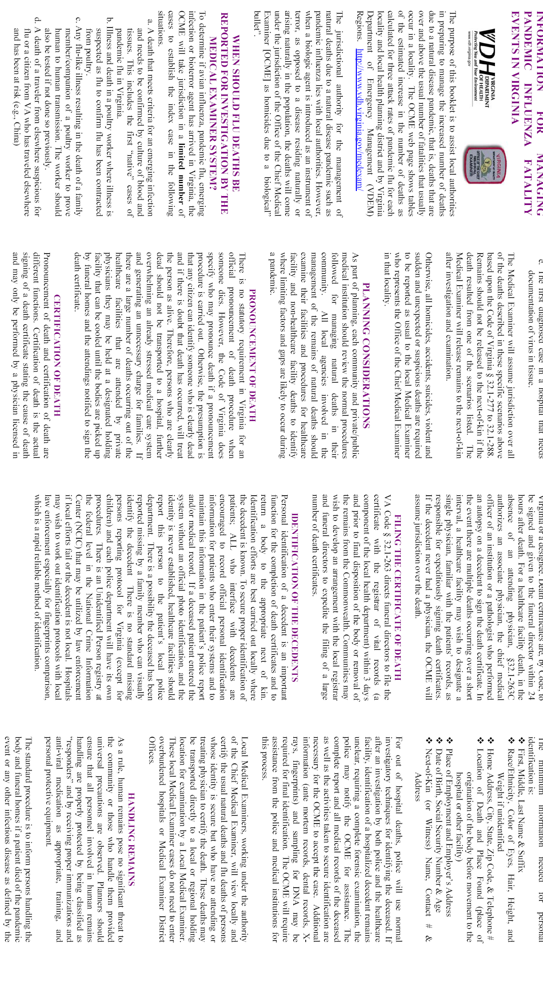
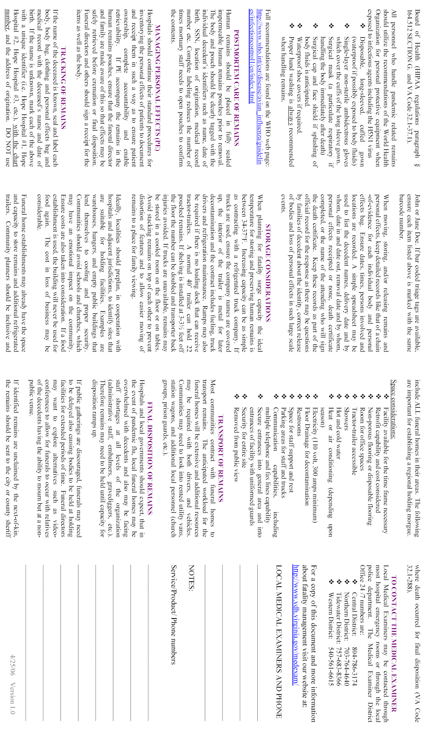
Attachment 2
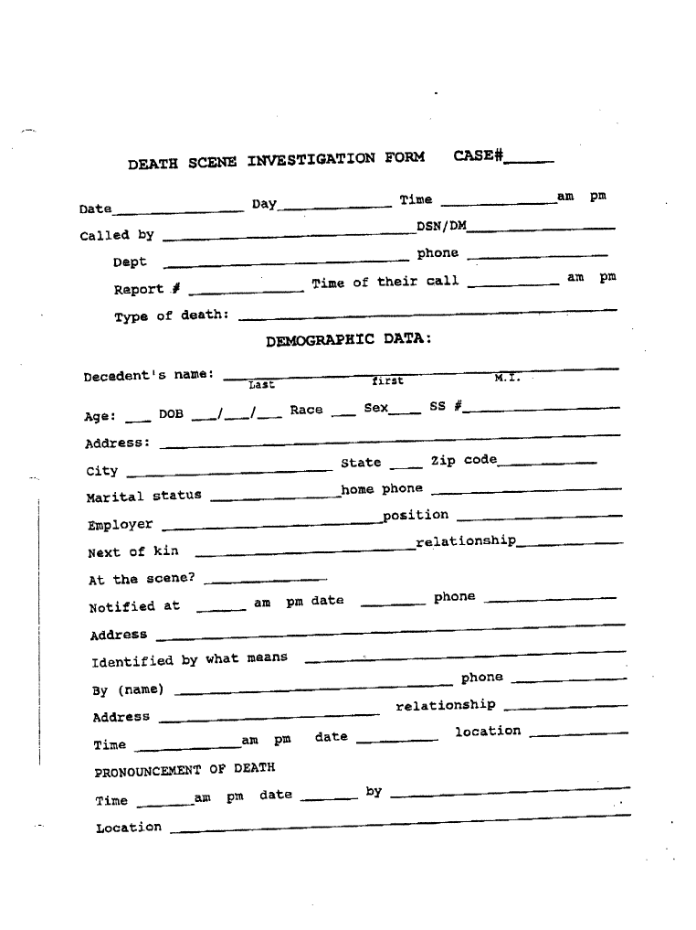
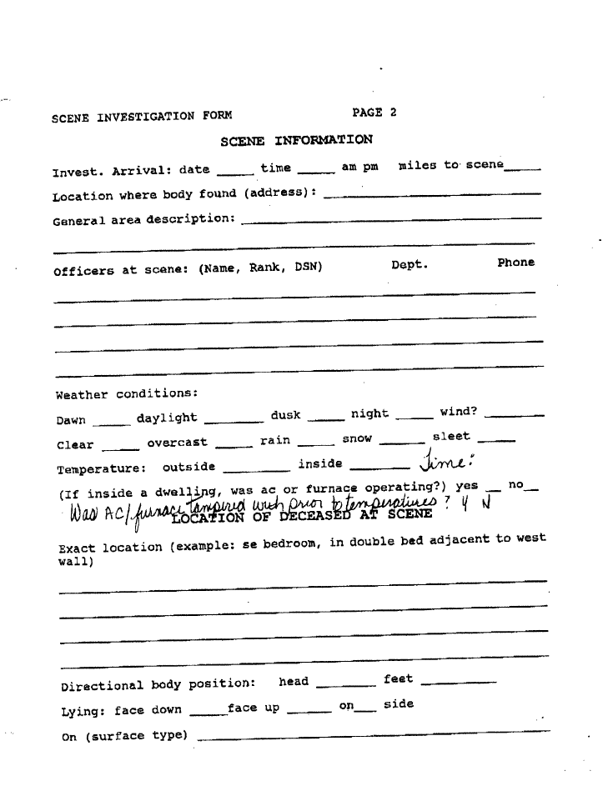
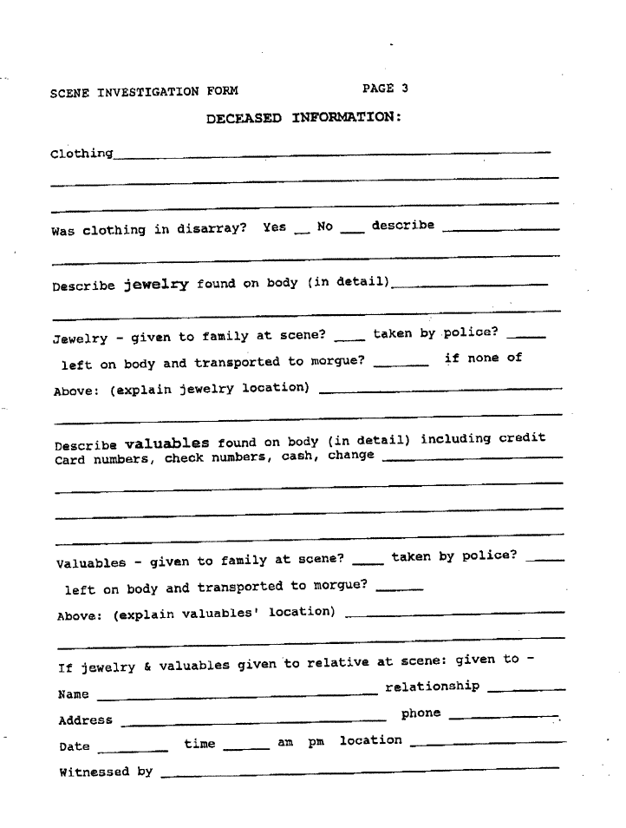

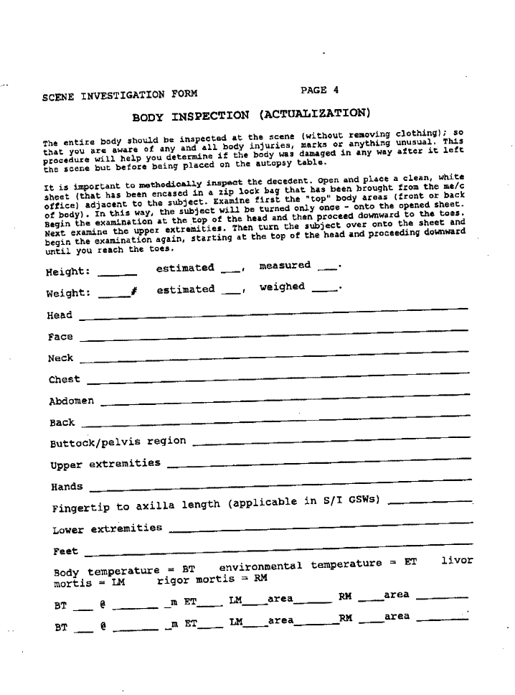
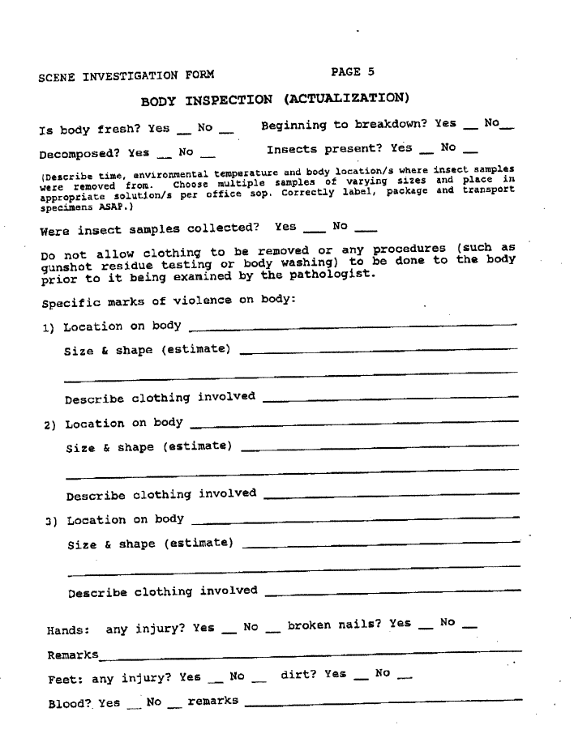
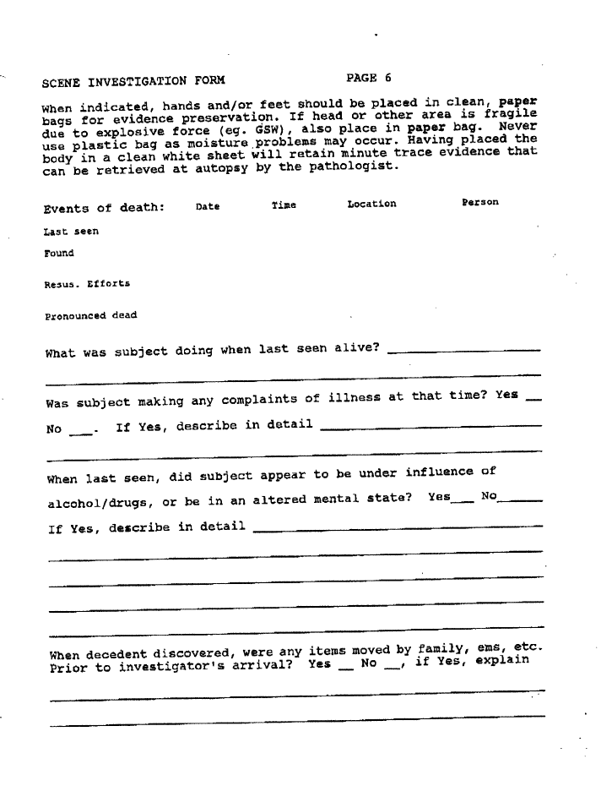
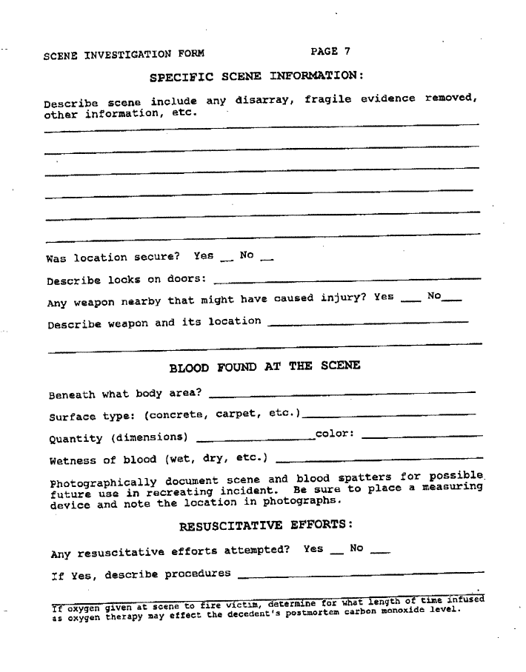
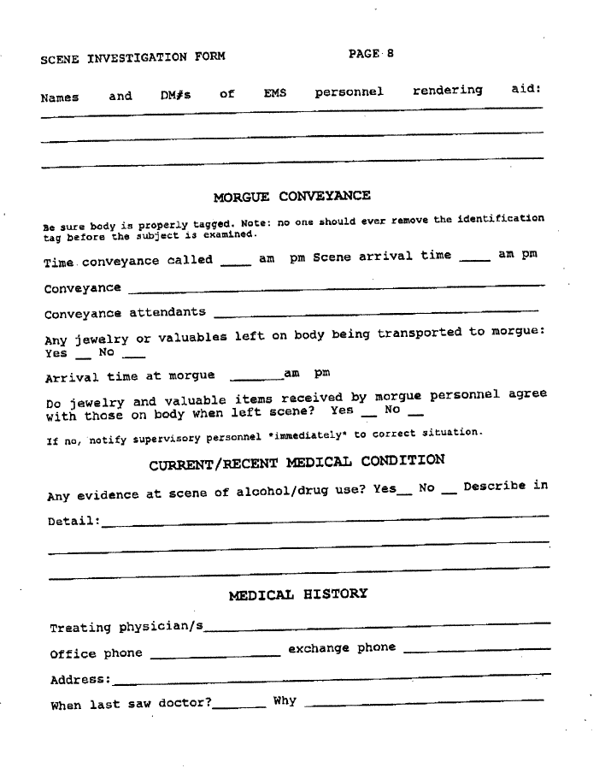
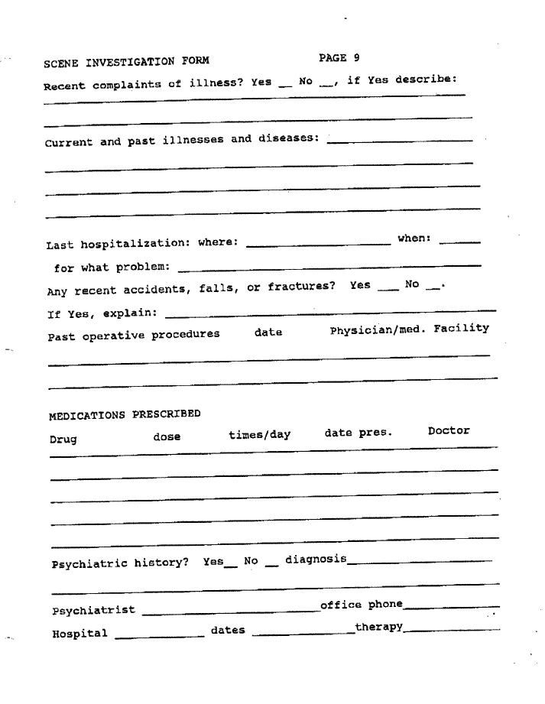
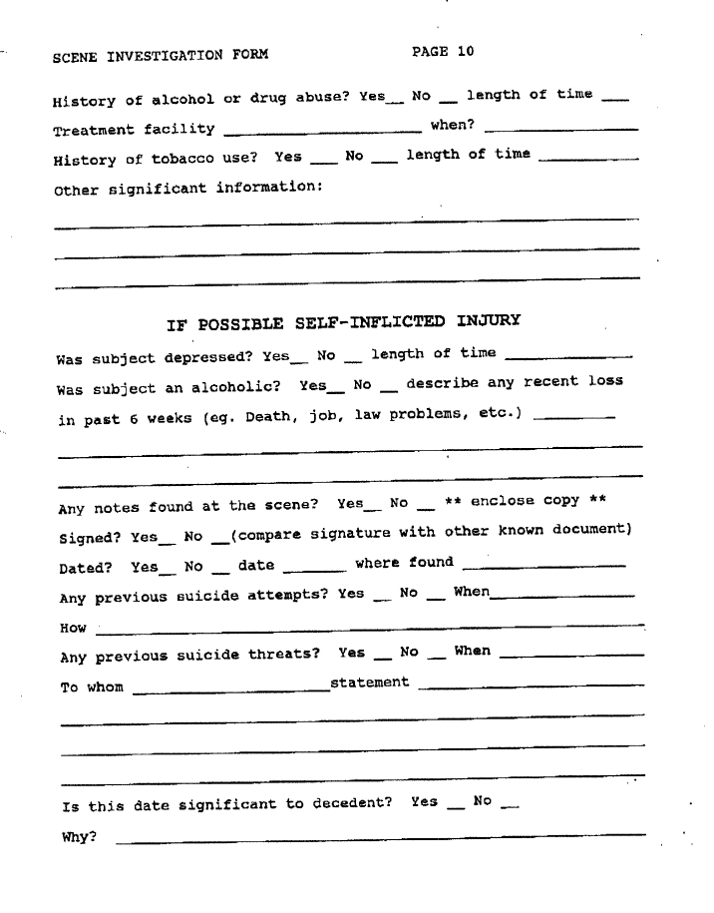
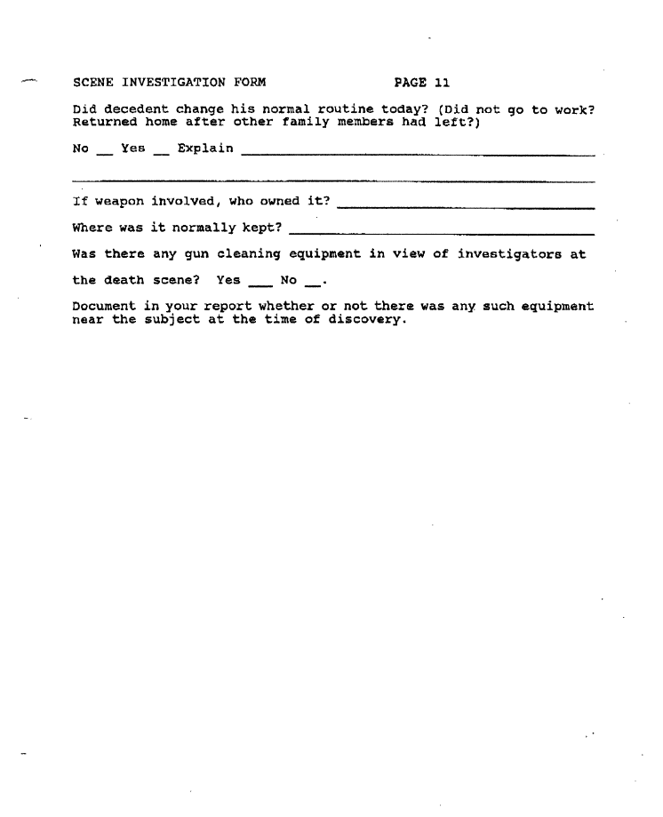

Attachment 3
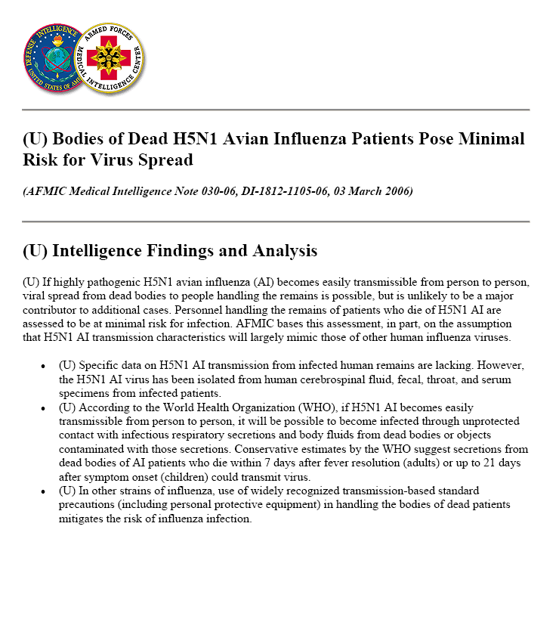
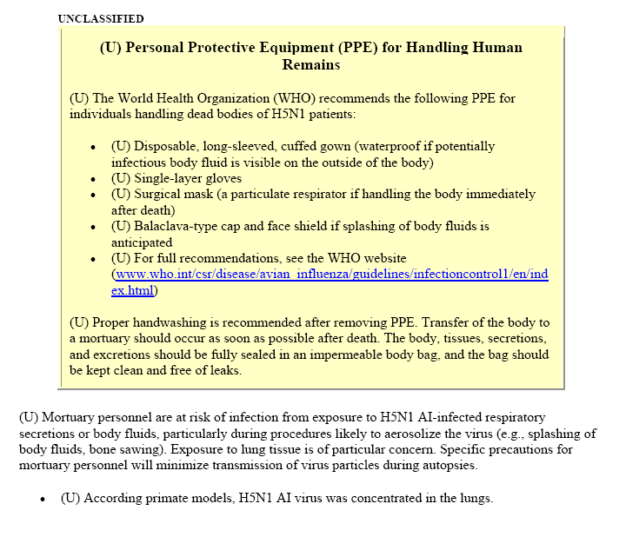
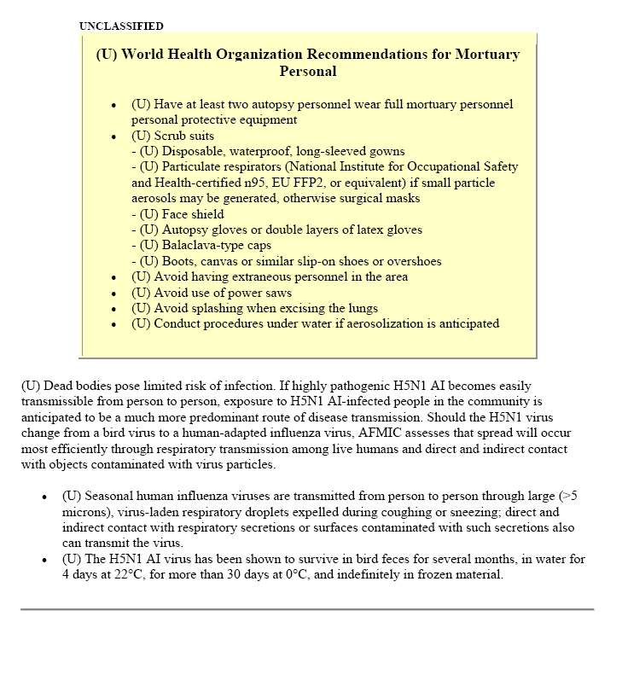

Appendix 4
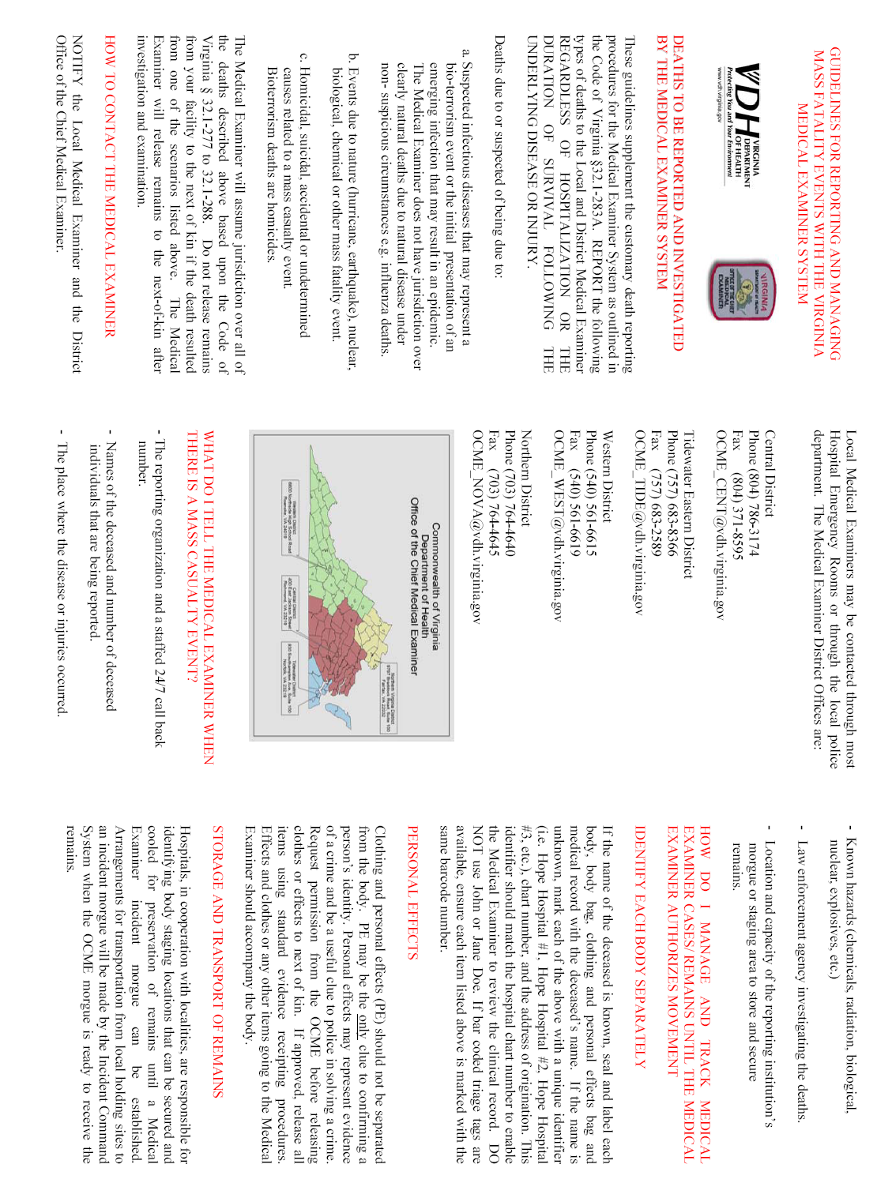

Appendix E: Alexandria Health Department
Emergency Operations Plan

(Appendix A

Attachment 5)

Pandemic Influenza

Revised 07-2006


Purpose
This attachment to the Alexandria Health Department (AHD) Emergency Operations Plan addresses the issue of potential pandemic influenza. It focuses on issues that are special to an influenza outbreak. The core Emergency Operations Plan addresses issues such as: command and control procedures, legal authority, surveillance and epidemiologic investigation procedures, medication and vaccine management, intra- and interagency coordination, hospital and emergency medical services coordination, infection control, security, communications, and education and training. While this attachment serves as a guide for specific influenza intervention activities, during a pandemic the judgment of public health leadership, based on knowledge of the specific virus, may alter the strategies that have been outlined. This attachment is consistent with the current drafts of the Virginia Department of Health pandemic plans and the National Health and Human Services Pandemic Influenza Plan published in November, 2005. Although the focus of this plan is on the Alexandria Health Department, it also includes reference to City-wide actions that are beyond the direct or singular responsibility of the Department.

The priority of the Alexandria Health Department during pandemic influenza will be to assure the continuation and delivery of essential public health services while providing for the emergency needs of the population. The Department’s responsibilities, in coordination with the Virginia Department of Health, will include surveillance, distributing vaccine and anti-virals and/or guidance to the medical community, containment strategies, public communication, assurance of psycho-social services, facilitating the process of community preparedness, and assuring the integration of the hospital and other healthcare providers in the planning process.

- Situation and Assumptions
For planning purposes, the worst-case scenario is projected. If the actual situation does not fully develop, the response can be adjusted. The following assumptions are made:
- An influenza pandemic will present a massive test of the emergency preparedness system, differentiating it from most other emergencies.
- Although pandemic influenza strains have emerged mostly from areas of Eastern Asia, variants with pandemic potential could emerge in Virginia or elsewhere in the U.S.
- Outbreaks can be expected to occur simultaneously throughout much of the U.S., preventing shifts in human and material resources that usually occur in response to other disasters. Many geographic areas within Virginia and its neighboring jurisdictions may be affected simultaneously.
- Effects on individual communities will be relatively prolonged (weeks to months) in comparison to other disasters. The pandemic could last for a year and a half.
- Due to widespread absenteeism, a pandemic will pose significant threats to human infrastructure responsible for critical health and non-health community services.
- Effective preventive and therapeutic measures (e.g., vaccines and antiviral medications) may be in short supply. Vaccine may not be available for 4 to 6 months and anti-viral supplies will be limited.
- With a surge of ill people, there may be critical shortages of health care resources such as staffed hospital beds and mechanical ventilators.
- Temporary care facilities may be needed to handle an overflow of patients from traditional healthcare facilities.
- Casey Clinic will likely be used as a facility supporting Inova Alexandria Hospital.
- There may be a significant number of fatalities leading to a shortage of morgue capacity, temporary holding sites with refrigeration for storage of bodies, and other resources.
- The Alexandria Health Department may well experience a significant shortage of staff due to illness.
- Prioritization of vaccine recipients will be required.
- Assuming that prior influenza vaccination(s) may offer some protection, even against a novel influenza variant, the annual influenza vaccination program, supplemented by pneumococcal vaccination when indicated, will remain a cornerstone of prevention.
- Surveillance of influenza disease and virus will provide information critical to an effective response.
- It is very likely that public health will take the lead in distributing influenza vaccine if it is available. The Alexandria Health Department will work in partnership with health care providers to facilitate distribution. The federal government will likely not assume the costs for purchase of vaccines, antiviral medications, and related supplies.
- The vaccine will likely be administered under an Investigational New Drug (IND) protocol.
- An effective response to pandemic influenza will require coordinated efforts of a wide variety of public and private health and non-health related organizations
- The Alexandria Medical Reserve Corps may be used to provide support for AHD staffing needs.

III. Morbidity and Mortality Projections

The CDC has developed a model for predicting estimates of the impact of deaths, hospitalizations, and outpatient visits due to pandemic influenza.TPPT The model was used to develop Alexandria-specific estimates of morbidity and mortality from pandemic influenza. Calculations were based on an Alexandria population estimate of 135,000 for the year 2005, with age groupings based on the best available Alexandria data. Twelve weeks of pandemic influenza activity were assumed with attack rates of 15%, 25% and 35%. Following VDH guidelines, it was further assumed that the (approximately) 65 family practice, internal medicine, and pediatric physicians in Alexandria could, in a pandemic, each see approximately 5 additional people per day above their normal caseload.

Although a number of variables could prove to be different than what is reflected in this model, the tables below reflect what are viewed by the CDC as quite plausible outcomes. Projected total outpatient visits are shown below across attack rates, significantly exceeding the capacity of local resources if we approached a 35% attack rate. (An attack rate of 35% in Alexandria would mean approximately 46,000 sick people).

Number of Outpatient Visits
15% Attack Rate | 25% Attack Rate | 35% Attack Rate
10,659 | 17,765 | 24,871

Projected hospitalizations were calculated using national estimates of predicted hospitalizations during a pandemic, applied to Alexandria population data. Groups at high-risk for complications of influenza infection were considered as a factor in the projections. Below are the number of projected hospitalizations by age group and attack rate. It is important to note that during an actual pandemic, both hospitalization rates and the percentage of the population at high-risk for influenza complications could vary significantly from the rates and percentages used to develop these projections. The local hospital would be significantly over capacity with just a 25% attack rate. There could be, however, more than 4,000 emergency room visits, especially if the private personal medical system breaks down.

Age Groups (years) | Number of Hospitalizations
Age Groups (years) | 15% Attack Rate | 25% Attack Rate | 35% Attack Rate
0 –18 | 7 | 11 | 15
19 – 64 | 185 | 308 | 431
65+ | 50 | 84 | 117
Total | 242 | 403 | 563

Death projections shown below were calculated using national estimates of influenza mortality from past epidemics, applied to Alexandria population data. The number of high-risk individuals in Virginia, based on the current ACIP definition of groups at high-risk for complications of influenza infection, was included as a factor in the projections. During an actual pandemic, both influenza death rates and the high-risk populations could vary significantly from the rates and percentages assumed in the projections. Some of the gravest models project as many as 800 deaths in a city the size of Alexandria.

Number of Deaths
15% Attack Rate | 25% Attack Rate | 35% Attack Rate
50 | 84 | 118

During a pandemic, public health will play an important role in the administration of influenza vaccine. In the model used here, it is assumed the Alexandria Health Department might administer approximately 10% of the total vaccine during a pandemic, although public health could be responsible for administering all vaccine doses in the state. Projections of Alexandria Health Department time needed are shown for both scenarios

Total doses required for different vaccination scenarios, assuming that a single dose is needed for each patient, are also shown. In a pandemic, two doses may be required for immunity, doubling all estimates shown in the table.

Group Receiving Vaccine | Total Vaccine Doses | Public Health Provider Time Needed (hours)
Group Receiving Vaccine | Total Vaccine Doses | 20% of doses provided | 100% of doses provided
High-risk individuals | 20,461 | 1,023 hours | 5,115 hours
Age group 20-40 years | 44,550 | 2,227 hours | 11,137 hours
Emergency/health care personnel | 1645 |  | 411 hours
40% of population | 54,000 | 2,700 hours | 13,500 hours
60% of population | 81,000 | 4,050 hours | 20,250 hours

IV. Coordination and Decision Making

Much of the overall strategy during a pandemic will be coordinated at the federal level. The Centers for Disease Control and Prevention (CDC), under the direction of the Department of Health and Human Services, will provide guidance to states on vaccine availability and distribution. The CDC will provide guidance on influenza vaccine Investigation New Drug (IND) protocols, in the event that the Food and Drug Administration has not approved the vaccine. If the vaccine is in short supply, which is likely during a pandemic, the CDC, in conjunction with advisory committees, will provide guidance for a rank order listing of priority groups for vaccination. The current prioritization is described in Supplement 2. P ^{P}The Advisory Committee of the Health and Medical Sub-panel of the Secure Virginia Panel will formulate specific procedures for the implementation of vaccine prioritization in Virginia.

All Command and Control procedures and processes will be consistent with the National Incident Management System (i.e., “NIMS-compliant”). At the Alexandria Health Department, the Nursing Manager will be responsible for the implementation of activities outlined in this attachment, under the direction of the Health Director. Substantial guidance, direction, and support will also be forthcoming from the Virginia Department of Health.

The Alexandria Health Director, the Mayor, and City Manager have also established a process for planning and decision-making in the City before and during a pandemic. Throughout this Attachment, reference will be made to these City-wide initiatives.

V. Phases of Pandemic Influenza
The influenza season in Virginia typically runs from October of one year through May of the following year. The World Health Organization (WHO) and the CDC have defined phases of pandemic influenza in order to assist with planning and response activities in states. Identification and declaration of the stages will be done at the national level.

Summary of WHO Global Pandemic Phases (WHO Global Influenza
Preparedness Plan, 2005)
Interpandemic Period (sometimes called Pre-pandemic)
Phase 1. No new influenza virus subtypes have been detected in humans. An influenza virus subtype that has caused human infection may be present in animals. If present in animals, the risk of human infection or disease is considered to be low
Phase 2. No new influenza virus subtypes have been detected in humans. However, a circulating animal influenza virus subtype poses a substantial risk of human disease.

Pandemic Alert Period
Phase 3. Sometimes called the Novel Virus Alert Stage, human infection(s) with a new subtype but no human-to-human spread or at most rare instances of spread to a close contact
Phase 4. Small cluster(s) with limited human-to-human transmission but spread is highly localized, suggesting that the virus is not well adapted to humans
Phase 5. Larger cluster(s) but human-to-human spread is still localized, suggesting that the virus is becoming increasingly better adapted to humans but may not yet be fully transmissible (substantial pandemic risk)

Pandemic Period
Phase 6. Pandemic phase: increased and sustained transmission in the general population

Postpandemic Period
Return to the Interpandemic Period (Phase 1)

Actions of the Alexandria Health Department will be based on the phase.
Throughout all phases, key issues identified in the Federal Plan include:
- What are the case definitions for suspected and confirmed cases of pandemic influenza?
- What types of epidemiologic data should be collected? (The answers may change over time, depending on the characteristics of the pandemic virus and the geographical spread of the pandemic.)
- What are the drug susceptibilities of the pandemic virus?
- What amounts of antiviral drugs are available to your state from public and private stocks?
- What amounts of pandemic influenza vaccine are available to your state from public stocks?
- Which groups of people are at greatest occupational and medical risk (i.e., what are the age-specific and occupational attack rates)? What modifications should be made to the national recommendations for distribution and use of antiviral drugs and vaccines to reflect this information?
- Which laboratory tests may be used locally for laboratory confirmation of pandemic-influenza cases? Which isolates should be sent to CDC for subtyping?
- How fast is the pandemic spreading in your area? What does local surveillance data on the number of hospitalizations and deaths suggest in regard to:
• Distribution of hospital supplies and hospital beds on a regional or statewide basis
• How fast local and regional hospital resources are being depleted
• Implementation of school closings and other community containment measures
• Situating and opening alternative care sites and quarantine facilities
• Absentee rates at hospitals and at businesses that provide essential services
• Impact of the outbreak on the public health and medical workforce
- Is anything unusual or unexpected? If so, should any modifications be made in infection control practices or in the detection or management of illness?
- Is there evidence from statistical modeling that predicts where and how fast the pandemic will spread?

Phases 1 and 2: Interpandemic (Pre-Pandemic) Period:
Health Director: Assure plans and processes are in place to coordinate effectively with the Virginia Department of Health, Health Directors in Northern Virginia and the National Capital Region, and the leadership of the City, Inova Alexandria Hospital, and the private medical community.

City-wide issues to be addressed:
- Facilities identified for:
  - Triage
  - Isolation of patients who have no substantial healthcare requirements
  - Persons for whom home isolation is indicated but who do not have access to an appropriate home setting such as travelers and homeless populations
  - Potential quarantine. See Supplement 1
  - Surge of overflow patients from hospital
- Care of people under quarantine and/or isolation.
- Fatality management
- Policy with regard to tourists
- Criteria for community containment measures
- Prioritization of people to be protected with personal protective equipment, vaccines, and anti-virals. See Supplement 2.
- Planning for City Hotline
  - Establish phone numbers
  - Identify sites and personnel
  - Develop protocols

Emergency Planner:
- Revise the Pandemic Influenza operating plan to take into account updated interim information on priority groups, projected vaccine supplies and timelines for availability, and staffing estimates.
- Conduct any necessary training for employees and Medical Reserve Corps
- With Public Information Officers, urge normal flu vaccine and especially use the “normal” season as a test of ways to deliver vaccine to special needs populations.
- Work with Inova Alexandria Hospital, City Emergency Management, the Alexandria Public School System, and the business community to identify appropriate sites to serve as triage centers, treatment centers, mass vaccination sites or as holding areas for acutely ill patients not able to be admitted to an acute care hospital. Make arrangements with owners of each facility to use the site, if necessary, to care for ill persons during a pandemic.
- Assure strong working relationship with Hospital Emergency Management.
- Assure inclusion of the Department of Mental Health, Mental Retardation, and Substance Abuse (DMHMRSA) in the planning and preparation process.
- With the City, identify facilities/resources with sufficient refrigerated storage to serve as temporary morgues. Develop a plan for management of bodies when morgue capacity has been exceeded.
- In coordination with VDH, devise a plan for local distribution and administration of public-sector vaccine.
- Review current emergency plans for mass vaccination campaigns. Include security aspects in partnership with local law enforcement authorities.
- Assure that a vaccine tracking and reporting system is in place.
- Train and prepare the Medical Reserve Corps.
- With Public Information Officers, assure public is informed of the status of plans and their nature.
- Work with local private and volunteer organizations to develop and synchronize local response to a pandemic of influenza.
- Work with business community to develop ability to quickly communicate with their employees.
- Establish working relationships with medical offices and pharmacies.

District Epidemiologist:
- Collaborate with partners to develop and maintain an inventory or count of:
  - Hospital and long-term care bed capacity
  - Intensive care unit capacity
  - Ventilators
  - Personal Protective Equipment
  - Specimen collection and transport materials
  - Sources of consumable medical supplies
  - Medical personnel who may be utilized in emergencies
  - Total healthcare workers
  - High risk outpatients
  - Children under 6 months of age
  - Critical human infrastructure “first responders” as prioritized by City
  - High risk and non-high risk people over age 64
- Educate staff about the nature and significance of pandemic influenza and the local response.
- Establish a means of rapid, two-way communication between local health department and hospital infection control specialist.
- Contact physicians to see if they would be interested in participating in the Sentinel Physician Surveillance System
- Investigate opportunities to work with hospitals, health systems, and/or physicians to analyze daily reports of influenza-like illness in patients. As part of daily surveillance, monitor hospital emergency visits and admissions for influenza-like illnesses. Discuss mechanisms for AHD to obtain data related to intensive care unit admissions and hospital deaths due to influenza during a pandemic.
- Assure system in place for reports from hospital of counts of positive influenza tests, and emergency room counts of illnesses and deaths due to acute febrile respiratory illness.
- Maintain passive surveillance utilizing influenza information received from physicians, persons in charge of medical care facilities, and directors of laboratories who are required by the Regulations for Disease Reporting and Control to report influenza cases in Virginia residents to the health department.
- As part of daily surveillance with the ESSENCE system, monitor over-the- counter purchase trends for influenza and respiratory illness products.
- Set up system with Alexandria Public Schools for report of ILI.
- Work with Emergency Planner and Environmental Health to establish tracking system with veterinary community.

Communication focus: the value of obtaining “normal” flu shots, the nature of pandemics, the possible allocation of resources, means of protecting self, family and community, the importance of compliance with recommendations, the nature of voluntary and involuntary quarantine and isolation.

Phase 3: Novel Virus Alert Phase: This stage of planning is active when a novel influenza virus has been detected in one or more humans. The general population would have little or no immunity. During this phase, a pandemic is potential but not inevitable.

Health Director will assure activation of City planning processes.

City-wide priorities will include:
- Notification of City Department Heads
- Reaching out to cultural groups
- Identification of alternate care sites
- Identification of priority people by name and/or title for vaccination and/or anti-virals. See Supplement 2.
- Implementation of hotline

Health Department staff will:
- Test the internal notification system and plan
- Review Isolation and Quarantine policies and procedures, and assure implementation of procedures as necessary. See Supplement 1.
- Begin providing information to City hotline
- Meet with DMHMRSA to coordinate planning and ensure behavioral health component to public communications and activities
- Confirm availability of potential spaces to be used for medical surge and fatalities
- Educate AHD staff and MRC about plans and actions
- Notify hospital Emergency Department and Infection Control directors, as well as local private and public partners, of novel virus alert.
- Advise health care providers and facilities of necessary steps to take if confronted with a patient with influenza
- Notify Alexandria Emergency Management Director of novel virus alert.
- Disseminate bulletins received from the CDC or state office regarding clinical, epidemiological, and virologic characteristics of variant strain.
- Work with Sentinel Providers to collect specimens for submission to DCLS in order to detect the presence of variant strains in Virginia.
- If a novel virus is identified in a resident, conduct an epidemiologic investigation and determine possible exposure source(s), risk factors, and symptoms. Identify contacts, place under surveillance for illness, and work with the laboratory to determine whether testing of contacts is appropriate.
- Collect required information
    - Number of contacts per case
    - Information on each contact
      - Relationship to patient
      - Nature and time of exposure
      - Whether the contact was vaccinated or on antivirals
      - Underlying medical conditions
  - Number of contacts that become ill
  - Number of days between onset of symptoms and reporting to health officials
- Monitor Epi-X
- Implement small-cluster containment (targeted chemoprophylaxis) as appropriate. See Supplement 3.

Communication focus: what people should do if no vaccine is available, and actions people can take to help contain the spread of the virus.

Phase 4: Pandemic Alert: This stage of planning is active when a novel virus demonstrates sustained person-to-person transmission and causes multiple influenza cases in the same geographic area.

Health Director now plays active role in establishing on-going City oversight.

City priorities are now internal decision-making processes and authorities, plans for possible containment actions, prioritization of services, and preparation for delivery of services to people in isolation and quarantine.

Health Department staff focus:
- Review pandemic influenza response plans.
- Keep staff and MRC informed
- Review Isolation and Quarantine plans (Supplement 1)
- In coordination with the state office, update hospitals, emergency medical services (EMS), local law enforcement, and local, private and public partners.
- Following guidance established by CDC, the State, and the City, ensure that people on the high priority list receive vaccine and antiviral medications, as appropriate and as available. See Supplement 2.
- Establish internal Incident Command Structure ready to be integrated into overall incident command when instituted.
- Outreach to special populations.
- Update hotline.
- Provide anti-viral guidance to appropriate healthcare personnel. Initiate individual-focused containment measures as needed, e.g.,
  - Voluntary isolation and quarantine
  - Self care and protection
  - Proper hygiene
- Key surveillance activities, which will begin during the Pandemic Alert phase and continue through the end of the Second Wave of the pandemic will include:
  - Monitoring of hospitals for influenza activity. On a daily basis, AHD staff will be in contact with emergency room staff and infection control practitioners at INOVA Alexandria Hospital to monitor influenza activity levels.. The number of emergency department visits, hospital admissions, and hospital deaths will be reviewed daily. VDH Division of Surveillance and Isolation (DSI) will be responsible for statewide planning and coordination of hospital surveillance data.
  - Analysis of daily syndromic surveillance data for flu-like illness reported from participating health systems across the state. DSI and district staff will review syndromic surveillance data daily and investigate increases in reports of influenza-like illness.
  - Coordination of information with neighboring jurisdictions. AHD District Epidemiologist, in coordination with the VDH Regional Epidemiologist, will assure information gathered is shared with neighboring jurisdictions, and that AHD receives relevant information from them.
  - Investigating cases
  - Reporting cases to Virginia Department of Health

Communication focus: increase social distance, “community shielding”, exercise caution with high-risk animals

Phase 5: Pandemic Imminent: This phase is active when a novel virus causes unusually high rates of morbidity and mortality in multiple, widespread geographic areas.
- Prepare hot-line information, including DMHMRSA in the discussion and planning.
- Notify employees and MRC of current status, and prepare to mobilize MRC.
- Finalize containment messages.
- Continue individual-focused containment – i.e., “self-shielding”
- Review plan for distribution of public sector vaccine.
- Prepare for vaccine distribution even if not immediately available.
- Enhance collection of clinical specimens and transport to the state laboratory.
- Contact private partners to review their plans for distribution and administration of private-sector vaccine.
- Finalize surveillance plans with local hospital outlining mechanisms to obtain data on: number of emergency department visits, number of hospitalizations, number of intensive care unit admissions and number of hospital deaths related to influenza.
- With City:
  - Implement community-wide containment measures as needed, e.g.,
      - Cancellation of meetings and events
      - “Snow days”
      - Isolation and quarantine of groups if plausible
  - Finalize prioritization of people for medicine distribution if available and PPE if necessary.
  - Mobilize Community Care Sites and/or Alternative Care Facilities.
  - Finalize fatality management procedures.
  - Mobilize distribution of supplies to people in isolation and quarantine, probably in conjunction with the American Red Cross.

Communication focus: self-care, family self-isolation and quarantine, what is available and what is not, containment messages (e.g., stay away from crowds, avoid hand-shaking and direct contact, stay home if sick).

Phase 6: Pandemic: During this phase, further spread of influenza to multiple continents takes place.
- Activate MRC.
- Underscore need for patient isolation and management of contacts.
- Inform staff of changes in their work assignments in response to the pandemic. Remind them of the importance of self-care.
- Review anti-viral plans and distribute as warranted and possible based on priorities. See Supplement 3.
- Coordinate use of available local resources during pandemic, including private, public, and volunteer resources.
- Assure behavioral health resources are being made available as needed.
- Report pandemic-related information, including influenza data obtained from hospitals, regularly to the VDH Division of Surveillance and Investigation (DSI).
- Assess effectiveness of local response and available local capacity.
- Revise prioritizations and administer vaccine once it becomes available. Work with hospital to monitor emergency department for influenza activity, including a review of emergency department visits, hospital admissions, and hospital deaths.
- Coordinate alternative care placements and prioritizations with hospital.
- Make certain people with special needs are receiving appropriate services.
- The Vaccine Adverse Event and Reporting System (VAERS) will be operational.
- With City:
  - Modify national prioritization of people as appropriate for Alexandria.
  - Determine event cancellation and closure announcements.
  - Establish alternative care sites.
  - Implement fatality management procedures.
  - Determine isolation and quarantine necessities, and implement them through legal channels
  - Announce policy/recommendations concerning work quarantine and office, school, and transportation closures. See Supplement 1.

Communication focus: updates and repeats of containment messages, as well as information regarding requirements for additional doses if necessary. Continue to stress self-isolation and quarantine and avoiding public gatherings. Convey consistent message concerning use of masks or other self-protective measures.

Second Wave: During this phase, epidemic activity recurs within several months following the initial wave of infection.
  - Continue all activities listed under Pandemic phase, although may scale back surveillance procedures.
  - Review, evaluate, and modify as needed, the local pandemic response.
  - Report pandemic-related information regularly to DSI.
  - Continue to vaccinate and medicate as vaccine and anti-virals become available. Distribution process may now finally be able to be mobilize.
  - Monitor resources and staffing needs.

Post-pandemic period: This phase marks the cessation of successive pandemic “waves” accompanied by the return of more typical wintertime epidemics (in the United States).
- Assure behavioral health resources are being applied.
- Assess local capacity to resume normal public health functions.
- Assess local capacity to resume normal health care delivery.
- Assess fiscal impact of pandemic response.
- Report results of assessment to local government authorities.
- Report results of assessment to state office.
- Modify the local Pandemic Influenza Response Plan based on lessons learned.

VI. Role of the Alexandria Public Health Department Laboratory

This laboratory does not have a biological safety cabinet and is unable to test samples for any novel influenza A. All testing for any novel influenza A must be done at biosafety level 2 or 3.

The laboratory staff will need to be fit tested for N-95 masks and have a supply in the lab.

If a clinician suspects a human case of infection with any novel influenza A virus, the lab will refer to information from DCLS and CDC that describes the correct sampling requirements, calling for further guidance if necessary.

Appropriate clinical specimens for virus isolation include nasal washes, nasopharyngeal aspirates, nasopharyngeal and throat swabs. Ideally, specimens should be collected within 48- 72 hours of the onset of illness.

It is important to avoid cross-contamination between specimens that can occur during collection and shipping.

The lab will have available a few influenza kits to give to AHD staff if a sample is required.

Upon receipt of a clearly labeled specimen, the lab staff will package the sample and place it in our lock box for pickup by the Central Delivery Service courier and the sample will arrive the next morning at DCLS.

Extra influenza kits and packing supplies can be delivered to the AHD Lab overnight through the Central Delivery courier.

VII. Behavioral Health

Behavioral Health is not the direct responsibility of the Alexandria Health Department, but resides within the Department of Mental Health, Mental Retardation, and Substance Abuse (DMHMRSA). AHD does, however, work closely with the City DMHMRSA, including involving them in dispensing site exercises and similar activities. As indicated in the phases of action described above, AHD will work to assure behavioral health initiatives play an important part in planning and response to health emergencies. A comprehensive discussion of the roles of behavioral health can be found in the National Pandemic Influenza Plan, Part 2, Supplement 11.

VIII. Legal considerations

A wide range of legal issues pervade much of what occurs during the planning and response to a pandemic. While again not the direct responsibility of the Alexandria Health Department, the Department will work closely with the City Attorney’s office to ensure that the City Attorney’s office and the Health Department are mutually well-informed and acting in accordance with legal requirements. A comprehensive discussion of the legal issues is covered in the National Pandemic Influenza Plan, Part 1, Appendices 1 and 2. An Isolation and Quarantine Plan has been developed separately

IX. Communications with the Public

Throughout this Plan, reference has been made to important messages that need to be communicated with the public at various stages of the potential or actual pandemic. Different kinds of messages are likely to be appropriate at different stages. A comprehensive coverage of the communications challenges and requirements for Public Information Officers (who currently are not a direct part of the Alexandria Health Department) is articulated in the National Pandemic Influenza Plan, Part 2, Supplement 10. A City-wide “Communications with the Public” plan has also been developed.
The primary communications goal of AHD during a pandemic will be to ensure a timely, accurate, and consistent flow of information as it is known at the time. Information will be relayed to health professionals by the Health Department. Information from the Health Department will primarily be delivered to the public by the City PIO and the Regional VDH PIO with support as needed by the Health Director or his designee.

Key communication activities of AHD will include:

- Identification of two spokespersons who will be responsible for addressing pandemic influenza related media concerns.
- Distribution of timely and appropriate influenza bulletins to health care providers and community partners.
- Dissemination of information about vaccine and anti-viral availability and distribution plans to community partners.
- Dissemination of the influenza vaccine information sheet to clinic patients and area health care providers.
- Communication of information about groups at high-risk for complications from influenza to health care providers and community partners.
- Dissemination of information to the general public (generally through PIOs) about issues including but not limited to the rationale for any prioritizations, the phasing in of distribution (and when and where this will occur), the importance of appropriate use of medications, the rationale for any control or containment actions, and the safe and appropriate use of various protective measures or devices. The PIO or spokesperson will be prepared to explain and defend the rationale behind these decisions.
- Assurance of effective two-way communication with non-English speaking persons, persons with disabilities, persons in the diverse Alexandria cultural groups, and any other especially vulnerable people and groups.

X. Good Health Habits

One of the most effective means of controlling a pandemic is for individuals to undertake good health habits, including routinely receiving flu shots even when a pandemic is not forecast. A challenge for the Health Department and the Communications staff will be to effectively convince people that this and other “simple” steps may be the most important and ultimately most effective action that can be taken, as contrasted with an assumption that some large-scale action by Public Health will be able to stop the pandemic from occurring (especially if vaccine is not available). Thus, messages about hand-washing, covering a cough, disposing of tissues, avoiding crowds, and other “self-containment” messages will be critical and their value can not be overemphasized.

XI. Care of Influenza Patients at Home

Given the distinct danger that the hospital and private medical care services are overwhelmed, another important public health message will be about caring for sick people at home. Most patients with pandemic influenza will be able to remain at home during the course of their illness and can be cared for by other household members. Anyone residing in a household with an influenza patient during the incubation period and illness is at risk for developing influenza. A key objective in this setting is to limit transmission of pandemic influenza within and outside the home. When care is provided by a household member, basic infection control precautions should be emphasized (e.g., segregating the ill patient, hand hygiene). Infection within the household may be minimized if a primary caregiver is designated, ideally someone who does not have an underlying condition that places them at increased risk of severe influenza disease. Although no studies have assessed the use of masks at home to decrease the spread of infection, use of surgical or procedure masks by the patient and/or caregiver during interactions may be of benefit.

Management of influenza patients
• Physically separate the patient with influenza from non-ill persons living in the home as much as possible.
• Patients should not leave the home during the period when they are most likely to be infectious to others (i.e., 5 days after onset of symptoms). When movement outside the home is necessary (e.g., for medical care), the patient should follow cough etiquette (i.e., cover the mouth and nose when coughing and sneezing) and wear surgical masks if available.

Management of other persons in the home
• Persons who have not been exposed to pandemic influenza and who are not essential for patient care or support should not enter the home while persons are actively ill with pandemic influenza.
• If unexposed persons must enter the home, they should avoid close contact with the patient.
• Persons living in the home with the pandemic influenza patient should limit contact with the patient to the extent possible; consider designating one person as the primary care provider.
• Household members should monitor closely for the development of influenza symptoms and contact a telephone hotline or medical care provider if symptoms occur.

Infection control measures in the home
• All persons in the household should carefully follow recommendations for hand hygiene (i.e., handwashing with soap and water or use of an alcohol-based hand rub) after contact with an influenza patient or the environment in which care is provided.
• Although no studies have assessed the use of masks at home to decrease the spread of infection, use of surgical or procedure masks by the patient and/or caregiver during interactions may be of benefit. The wearing of gloves and gowns is not recommended for household members providing care in the home.
• Soiled dishes and eating utensils should be washed either in a dishwasher or by hand with warm water and soap. Separation of eating utensils for use by a patient with influenza is not necessary.
• Laundry can be washed in a standard washing machine with warm or cold water and detergent. It is not necessary to separate soiled linen and laundry used by a patient with influenza from other household laundry. Care should be used when handling soiled laundry (i.e., avoid “hugging” the laundry) to avoid contamination. Hand hygiene should be performed after handling soiled laundry.
• Tissues used by the ill patient should be placed in a bag and disposed with other household waste. Consider placing a bag for this purpose at the bedside.
• Normal cleaning of environmental surfaces in the home should be followed.

XII. Infection Control in Schools and Workplaces
In schools and workplaces, infection control for pandemic influenza should focus on:
• Keeping sick students, faculty, and workers away while they are infectious – i.e., “workplace quarantine” procedures and alternatives.
• Anticipating shortages of personnel, and exploring alternative work methods such as telecommuting.
• Promoting respiratory hygiene/cough etiquette and hand hygiene as for any respiratory infection. (The benefit of wearing masks in these settings has not been established.)HS Pandemic Influenza
• School administrators and employers should ensure that materials for respiratory hygiene/cough etiquette (i.e., tissues and receptacles for their disposal) and hand hygiene are available. Educational messages and infection control guidance for pandemic influenza are available for distribution. (CDC will develop educational materials appropriate to various audiences.)

XIII. Infection Control in Healthcare Settings
The following infection control principles apply in any setting where persons with pandemic influenza might seek and receive healthcare services (e.g. hospitals, emergency departments, out-patient facilities, residential care facilities, homes). Details of how these principles may be applied in each healthcare setting are explored extensively in National Pandemic Influenza Plan, Part 2, Supplement 4.
• Limit contact between infected and non-infected persons
• Isolate infected persons (i.e., confine patients to a defined area as appropriate for the setting). Place the patient in an airborne isolation room (e.g., monitored negative air pressure in relation to the surrounding areas with 6 to 12 air changes per hour).
• Limit contact between nonessential personnel and other persons (e.g., social visitors) and patients who are ill with pandemic influenza.
• Promote spatial separation in common areas (i.e., sit or stand as far away as possible—at least 3 feet—from potentially infectious persons) to limit contact between symptomatic and non-symptomatic persons.
• Limit patient movement and transport outside the airborne isolation room to medically necessary purposes. If patient movement or transport is necessary, ensure that the patient wears a surgical mask, puts on a clean patient gown, and performs hand hygiene before leaving the room. If a mask cannot be tolerated, apply the most practical measures to contain respiratory secretions.
• Protect persons caring for influenza patients in healthcare settings from contact with the pandemic influenza virus.

Persons who must be in contact should:
• Use contact and airborne precautions, including the use of N95 respirators, when appropriate, or other fit tested respirator, at least as protective as a NIOSH-approved N-95 filtering facepiece respirator when entering the room.
• Wear gloves (gown if necessary) for contact with respiratory secretions.
• Perform hand hygiene after contact with infectious patients.
• Routinely wear eye protection when within 3 feet of patient. If splash or spray of respiratory secretions or other body fluids is likely, protect the eyes with goggles or a face shield. The face shield should fully cover the front and wrap around the side of the face. Corrective eyeglasses or contact lenses alone are not considered eye protection.
• Instruct persons who have “flu-like” symptoms to use respiratory hygiene/cough etiquette
• Promote use of masks by symptomatic persons in common areas (e.g., waiting rooms in physician offices or emergency departments) or when being transported (e.g., in emergency vehicles).

XIV. Providing Care in Non-Hospital Settings
Planning for effective delivery of care in outpatient settings is critical. Appropriate management of outpatient influenza cases will reduce progression to severe disease and thereby reduce demand for inpatient care. A system of effective outpatient management will have several components. To decrease the burden on providers and to lessen exposure of the “worried well” to persons with influenza, telephone hotlines will be established to provide advice on whether to stay home or to seek care. Most persons who seek care can be managed appropriately by outpatient providers. Health care networks may designate specific providers, offices, or clinics for patients with influenza-like illness. Nevertheless, some persons with influenza will likely present to all medical offices and clinics so that planning and preparedness is important at every outpatient care site. Supplement 5 of the National Pandemic Flu Plan provides clinical guidelines for health care providers.

Special guidelines for infection control should be in place during pandemic influenza, taking into account the likelihood that a high proportion of the population will be affected and that secondary infections are a major source of morbidity and mortality. In physician offices, standard precautions should be followed, with strict adherence to hand washing. Healthcare facilities, in addition to standard precautions, may want to consider the following:

- Staff education: Staff should be educated annually about the prevention and control of influenza, focusing on infection spread. Staff should be reminded that they can spread the virus via their hands or fomites (e.g. towels, medication cart items, etc).
- Hand washing: Hands should be washed after touching blood, body fluids, secretions, excretions, and contaminated items, whether or not gloves are worn. Hands should be washed with plain soap or detergent for at least 10-15 seconds under running water.
- Gloves: Clean, disposable gloves should be worn when touching blood, body fluids, secretions, excretions, and contaminated items. Gloves should be removed after use and before touching any non-contaminated items or touching another patient, and hands should be washed immediately with soap and water or an antiseptic hand-rub.
- Masks: Healthcare workers and visitors should wear masks when they are within three feet of the patient, and the patient should wear a mask when being transported.

Other issues to address include:
• Establish and staff telephone hotlines.
• Develop training modules, protocols and algorithms for hotline staff.
• Within health care networks, develop plans on the organization of care for influenza patients and develop materials and strategies to inform patients on care- seeking during a pandemic
• For clinics and offices, develop plans that include education, staffing, triage, infection control in waiting rooms and other areas, and communication with healthcare partners and public health authorities.

Home health care providers and organizations
These providers can provide follow-up for those managed at home, decreasing potential exposure of the public to persons who are ill and may transmit infection. In addition, they can:
- Postpone non-essential services.
- Assign providers who are not at risk for complications.
- Wear masks and institute appropriate droplet protection procedures.

Non-hospital healthcare facilities
The hospital planning recommendations in the National Pandemic Flu Plan (see S3- III.A) can serve as a model for planning in other healthcare settings, including nursing homes and other residential care facilities, and primary care health centers. All healthcare facilities should do the following:
• Create a planning team and develop a written plan.
• Establish a decision-making and coordinating structure that can be tested during the Interpandemic Period and will be activated during an influenza pandemic.
- Determine how to conduct surveillance for pandemic influenza in healthcare personnel and, for residential facilities, in the population served.
- Develop policies and procedures for managing pandemic influenza in patients and staff.
- Educate and train healthcare personnel on pandemic influenza and the healthcare facility’s response plan.
- Determine how the facility will communicate and coordinate with healthcare partners and public health authorities during a pandemic.
- Determine how the facility will communicate with patients and help educate the public regarding prevention and control measures.
- Develop a plan for procuring the supplies (e.g., personal protective equipment [PPE]) needed to manage influenza patients.
- Determine how the facility will participate in the community plan for distributing either vaccine or antiviral drugs, including possibly serving as a point of distribution and providing staff for alternative community points of distribution.
- Staff should call the health department if an increase in cases of respiratory illness is observed, especially if it is associated with an increase in hospitalizations or deaths. Maintain a heightened surveillance for febrile and respiratory illness among residents and staff.
- Staff should be assigned to work with either sick or well patients, but not circulated between both groups. Staff should not work while ill.
- Visitation should be restricted. If admissions are restricted due to an outbreak, when admissions resume, any new admissions should receive antivirals prophylactically until one week after the outbreak is over. If possible, they may begin taking the antivirals for 2-3 days prior to admission.
- Vaccinate any residents or staff who are unvaccinated. Recommend use of antiviral medications while antibodies develop.
- Separate residents taking antiviral medications for treatment from other residents.
- Monitor patients/residents for influenza and institute appropriate controls as necessary.

Alternative care sites
If an influenza pandemic causes severe illness in large numbers of people, hospital capacity might be overwhelmed. In that case, Alexandria will need to provide care in alternative sites (e.g., school gymnasiums, hotels, businesses). According to the National Plan, the selection of alternative care sites for pandemic influenza should specifically address the following infection control and patient care needs:
• Bed capacity and spatial separation of patients
• Facilities and supplies for hand hygiene
• Lavatory and shower capacity for large numbers of patients
• Food services (refrigeration, food handling, and preparation)
• Medical services
• Staffing for patient care and support services
• PPE supplies
• Cleaning/disinfection supplies
• Environmental services (linen, laundry, waste)
• Safety and Security

XV. Vaccine Management

Storage Options

The Virginia Department of Health, Division of Immunization, has six storage options in the event pandemic influenza necessitates mass vaccination:

- General Injectables and Vaccines (GIV), VDH’s private vaccine distribution contractor located in Bastian, Virginia, will handle primary distribution and storage of vaccine. The facility can be contacted at (800) 475-6475. The Division currently contracts with GIV for Vaccines For Children (VFC) vaccine distribution. An amendment to the current contract has been completed. The amendment outlines storage and shipping guidelines in the event of a pandemic. GIV will maintain minimum reserve capacity to store and ship up to 2 million doses. They have the ability to ship the vaccine to private providers, public providers, local health departments, and community health centers.

- The Virginia Department of General Services (DGS) operates a warehouse/distribution center in Eastern Henrico County. This facility will serve as the secondary location for influenza vaccine storage and distribution. The DGS facility consists of approximately 128,000 square feet of combined office and warehouse space. The warehouse has 28 bays with loading docks and a secure access refrigerated storage area. About 25,000 square feet of open space is available for unloading and repackaging. Multiple security features are in place and patch panels for telephone and fiber optic hubs are available. Division of Immunization staff trained in vaccine storage and handling would be primarily responsible for the breakdown and repackaging of vaccine. Vaccine will be shipped by a contracted vendor and can be sent via overnight delivery if necessary. For more information concerning this facility, refer to the VDH Central Region Strategic National Stockpile Plan.

- The Bureau of Pharmacy Services provides biologics and vaccines to all local health departments. The contact, the Pharmacy Director, can be reached at (804) 786-4326. The facility has limited storage capabilities (approximately 300,000 doses of influenza vaccine) but does have staff with expertise and ability to handle vaccine distribution to the local health departments.

- Tractor-trailers capable of refrigerated storage can be rented from Virginia Trailer, Inc. in Chester, Virginia. Tractor-trailers are dropped off at designated locations with a full tank of diesel gasoline. The truck runs continuously to maintain the appropriate storage temperature. Depending on the weather and the desired storage temperatures, the truck can use up to ½ gallon of fuel per hour. The trucks hold 35-100 gallons of fuel, so in the worst-case scenario, for a truck with a small tank, refueling would be necessary every 3 days. The health department would be responsible for any refueling that may be necessary. Rental fees are as follows: $85/day, $325/week, and $950/month. An extra fee of $75 for delivery and $75 for pick up is charged for sites in the Richmond area. Delivery fees are higher for locations further away. Trailer sizes range from 45-48 feet long, and are 8 feet high and 8 feet wide. Trailers are usually available with minimum notice (often same day notice), but that is not guaranteed. The telephone number is (804) 768-1000 and the contact is Frankie Davies. Virginia Trailer, Inc. is located at: 11601 Old Stage Road, Chester, VA 23836.

- Refrigerated warehouse space can be rented from Richmond Cold Storage Company, Inc. Storage is rented by palate size; a palate measures 40 by 48 inches and can be stacked up to five feet high with vaccine. The cost for palate storage is $50 to $60 dollars per month. If the storage area needs to be accessed on a frequent basis (rather than just drop off and pick up), the cost may be slightly more. Many clients share the warehouse space, so the vaccine would not have its own separate “room” and may be placed next to a palate of food. Separate rooms are available, but four to five tractor-trailer loads full of merchandise would have to be filled for it to be designated as health department space only. Minimum advanced notice is required; 24 hours should be sufficient. The corporate office for Richmond Cold Storage Company, Inc. is located at 420 North 18P^{thP} Street, Richmond, Virginia. The telephone number is (804) 644-2671, and the contact is Scott Chapman. The refrigerated warehouses are located at 5501 Corrugated Road in Henrico County and 2900 Cofer Road in Richmond City.

- Drop shipments from the vaccine manufacturer to the local health departments, if available, will serve as a final choice for vaccine storage/distribution. The storage capability of each health department varies; however, each department has some storage available now.

VDH Guidelines for Storage and Shipment

To ensure vaccine viability, influenza vaccine should be shipped and stored according to the following guidelines:

- Shipping Requirements: Influenza vaccine should be delivered in the shortest possible time. It should not be exposed to excessive temperatures. Vaccine is generally shipped in insulated containers with coolant packs.
- Condition on Arrival: Vaccine should not have been frozen. Refrigerate immediately upon arrival.
- Storage Requirements: Influenza vaccine should be refrigerated at 2° to 8°C (35° to 46°F). Do not freeze.
- Shelf Life: Vaccine is formulated for use within the current influenza season.
- Instructions for Reconstitution or Use: Shake vial vigorously before withdrawing each dose.
- Shelf Life after Opening: Vaccine is viable until outdated if not contaminated.
- Special Instructions: Rotate stock so that the shortest dated vaccine is used first. Influenza vaccine must not be frozen.

Alexandria Vaccine and Anti-viral Distribution Process

It is possible that the vaccine and anti-virals will be distributed directly to providers by the vendors; it is more likely that the Alexandria Health Department will be the recipient and will then seek to re-distribute through these providers. (Current policy is that anti-virals will NOT be used for prophylaxis.) In this instance, the Alexandria Health Department will in all likelihood receive its vaccine through the Virginia Department of Health, perhaps via the Strategic National Stockpile (especially anti-virals.) The amount received will depend on nationwide availability and is likely to start out being only a percentage of what is ultimately needed – especially because two doses may be required. It is also possible that what is received is an Investigational New Drug (IND) requiring strict control procedures.
The National Plan, and CDC guidance, make it clear that local authorities will have “major responsibilities for allocation” and distribution of vaccine and anti-virals – although extensive guidance is likely from the CDC and VDH. When, if, and as vaccine and/or anti-virals become available, the preferred distribution process is through the private medical community and other community channels. The Alexandria Health Department will use the following vehicles for distribution, in order of preference:
- Local primary health care providers
- Assisted living facilities
- Other points of care, especially with anti-virals
- Alexandria Social Services including Commission on Aging and Commission on Persons with Disabilities
- Mixed dispensing – i.e., a combination of the above and dispensing through AHD clinics
- Mass dispensing sites and/or processes

The Department will use the general model established during the flu vaccine shortage in 2004-5:
- Providers will be informed of the availability though broadcast messaging and phone calls.
- Providers will be informed how they can pick up the vaccine at the Health Department.
- Records will be maintained of the distributions.
- Individuals calling the Health Department will be told the names of providers (if permitted by the providers) who have available vaccine or medication.
This may also be the means of distribution if a limited supply is available.

If, in the judgment of the Alexandria Health Director in consultation with the Virginia Department of Health, the situation is such that the mass distribution of vaccine or medication is the most effective and efficient means of distribution, then the Emergency Operations Plan Dispensing Annex will serve as the operational document. As general overall guidance, issues addressed in this Annex include:
- Defining procedures to assure the biological safety and physical security of the vaccine within the health department.
- Identifying community partners who will work with the health department to administer vaccine to targeted populations. During the pre-pandemic stage, when possible, written agreements will be established with partners or contractors regarding administration of vaccine during a pandemic.
- Identifying backup locations and their capacity for immunization clinics (e.g. schools, community centers, churches, county/state buildings)
- Identifying contract staff and volunteers (including nurses, administrative staff, etc.) available for immunization clinics.
- Identifying extra refrigerated storage space available for influenza vaccine.

Elements of the AHD mass vaccination and treatment plan also explicitly address staffing and training, clinic layout and flow, documentation and paperwork, security, clinic supplies and equipment, transportation, vaccine storage and handling, vaccine security and tracking, disposal of needles and medical supplies, communications systems, and post clinic activities. Before the arrival of the vaccine or medication, advance training will be provided to employees and volunteers who will work in the distribution process so that we are ready to distribute when the medication arrives.
If a limited amount of vaccine or medication is received, distribution will be based on priorities recommended by the CDC (see Supplement 2) and refined by the Health Director and the City. This, in turn, would lead to a phased-in process of distribution. Very extensive record-keeping is likely to be required, especially date, number of doses, age, priority group membership, and zip code for every person receiving a vaccine or medication.

XVI. Mass Care

In a pandemic, with the emphasis on people staying in their homes if at all possible, mass patient care will primarily entail the treatment of people who ideally should be – but can’t be – treated in a hospital setting because of a lack of hospital capacity. In these situations, AHD will work consistent with the Regional VDH Surge Plan. As part of that initiative, both before and during a pandemic, AHD will work with Inova Alexandria Hospital and the City to identify alternatives. In doing so, the following are the working assumptions:
  - Inova Alexandria Hospital will seek to be self-sufficient and to be able to handle the surge for three to five days.
  - It is preferable to keep stretching hospital capacity before setting up alternative sites.
  - The Federal NDMS will be able to deploy within approximately five days. It is recognized that this assumption is tenuous in a nationwide pandemic.
  - If the Hospital is stretched beyond its physical capacity, they are unlikely to be able to provide staff support for alternative sites.
  - The Detention Center in Fairfax County is a possible surge site. Although some hospitals plan to try to provide staff support, other hospitals expect that will be impossible. Therefore, it would need to be staffed either by the NDMS or by non-hospital people including volunteers.
  - The City, the Hospital, and AHD will continue to work to identify alternative sites and means to staff them.
  - Off-site triage, the transportation of patients, and the on-going medical and non-medical support (food, etc.) of patients will all be elements for which plans must be developed.

Another kind of “mass care” – different from the traditional definition – will entail providing support to those people who are in isolation or quarantine. This could include assuring they have access to or receive food and water, that their prescriptions are refilled, etc. See Supplement 1.

- Fatality Management

The Alexandria Health Department, as a local health district, does not have direct responsibility or jurisdiction for fatality management. At the same time, the Office of the Chief Medical Examiner, under a separate reporting structure in the Virginia Department of Health, has responsibility only for deaths due to terrorism or other unexplained causes. Therefore, once a few deaths have been confirmed as due to a flu pandemic, OCME no longer has any official responsibility as the statutes are currently constituted.
Because the number of deaths in Alexandria due to the pandemic could potentially well exceed the capacity of the current system, AHD will need to work very closely with the City, local mortuaries, and others to develop a plan for dealing with these fatalities.

TP?PT The Office of the Attorney General will represent the State Health Commissioner if there are only a few cases throughout the commonwealth based on the availability of attorneys in the Attorney General=s Office. In the event of a large scale outbreak of a disease or if because of the outbreak travel is not possible for attorneys in the Office of the Attorney General, the Office of the Attorney General may appoint as special counsel county attorneys, city attorneys, town attorneys and/or private attorneys to represent the Commissioner at hearings within the respective jurisdictions.

